Over the years, many schemes have been made and are used to protect the output devices in an amplifier. These have been from basic fuses and/or current trip circuits in the power supply to elaborate electronic designs.
These are done to help protect the output transistors and hopefully stop any damage to your speakers.
Virtually any power amplifier would quickly be destroyed when in full use then a short circuit appears or occurs on the output, if there were no internal limiting. This is because the power supply can deliver a massive “short term power level” and usually much greater than the capacity of the transistors used in the output stage.
The answer is to build some form of output current limiting device to prevent damage, under a speaker short circuit or an overload condition. Otherwise, the following can occur.

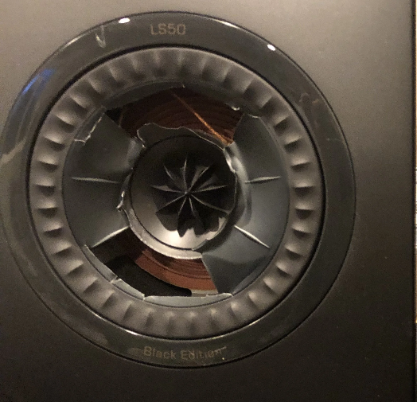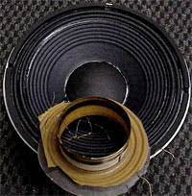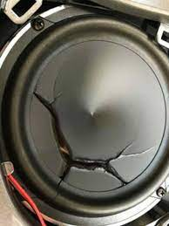

Many amplifiers will be using compound pairs of transistors, BJT’s, Darlington Types, or any combination thereof.
For these types of amplifiers, the most common technique used is known as 'V I limiting'.
When the amp is driven beyond a pre-set limit, these circuits bleed the output stage so the driver stage does not self-destruct, At this point the sound would be distorted and sound horrible. These VI limiter circuits, should always be designed to ensure that they never operate under normal conditions, including the odd 4Ω Load.

How it works:

It consists of a simple circuit using a matched pair of NPN and PNP transistors and 2 x diodes that are connected across the drive signal of the output devices and this is fed from a resistor network that senses both the voltage across and the current through them. When the combination of V and I, is more than what can be handled safely by the Amplifiers Output Transistors, the protection transistors conduct the drive signal away, enough to
prevent the output transistor’s failing. The use of a VI limiting is a good way to reduce the output transistors current, to a safe value within their SOAR Specifications or when the Amplifier is driven hard load and into distortion. It's an indirect approach and it introduces 2 other parameters which can vary a lot in commercial and DIY builds.

A The components chosen, each batch of transistors has variations in Hfe and Temperature.
(Usually Different)
B The setting points of the limiting circuit.

Ideally, you should replace the sensing resistors with trimmers, drive the amp to a peak to peak voltage and its current, into a load. Some amps specify this at a 1- or 2-Ohms just for that purpose, and then adjust the triggering points for left and right channels. This would be done using an oscilloscope…
It’s an easy and repeatable approach to monitor the voltage drop across the emitter resistors, and this approach does not depend too much on individual transistor variations.

Loudspeakers:

Loudspeakers are a 'reactive load’. That is, their “impedance” changes with frequency and more often than not, dive into a lower resistance at different frequency levels. The figure below is a good example that shows the impedance versus frequency for a simulated speaker, and as can be seen, it looks very similar to the impedance response curve you would see with many real speakers in testing results.

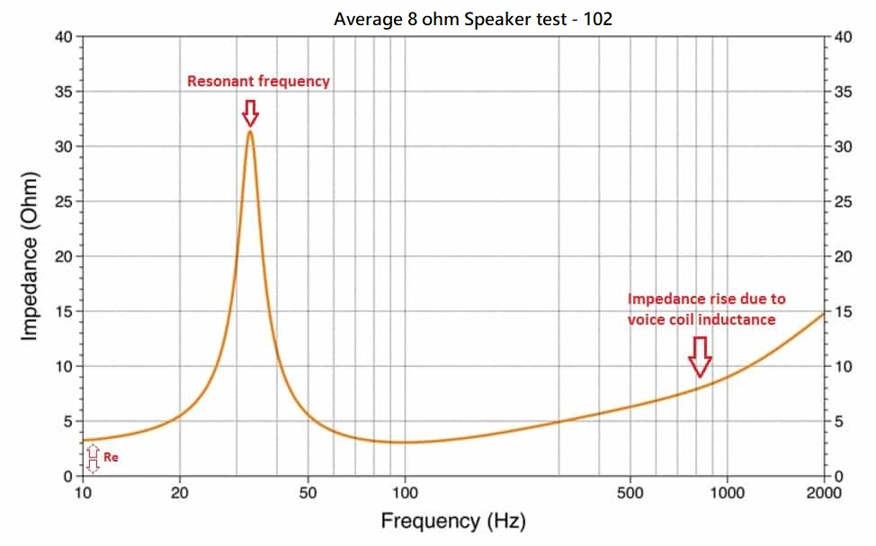
For example, a nominal 8Ω speaker in a sealed enclosure will have low resistance at DC then increase in resistance in the bass resonance region at some point. And around that frequency it will have an “impedance peak” of 10-20Ω or more. At frequencies above 500Hz to 1kHz the impedance rises doubling each octave due to the inductance of the voice coil.
Systems having tuned ports can result in double impedance peaks in the low frequency range, dropping to the 'nominal' value at two points, in the middle of the peaks and many at 60 Hz and 250Hz where the figure is often measured. An impedance that rises with increasing frequency is inductive and the opposite of capacitive.

While a loudspeaker's low frequency impedance peaks, are caused mechanically, by the back EMF generated when the moving voice coil is in operation, the load in impedance is trunked back to the amplifier that it is connected to. And this is in addition to any passive crossover networks that may be installed.
Then we have, “Some speaker manufacturers use 4-ohm designs because a 4 ohm speaker will sound louder
(2-3 dB) at a given input than an 8-ohm speaker - all else equal,” issue to contend with.
The theory is that it would give a sales advantage over the competition in A/B comparisons since the "louder" speaker is usually interpreted as sounding "better" by most listeners.

The amplifier is then required to drive its voltage and current into this “complex load” at any frequency between 20Hz and 20 Khz, and sometime at high levels without clipping or distortion.

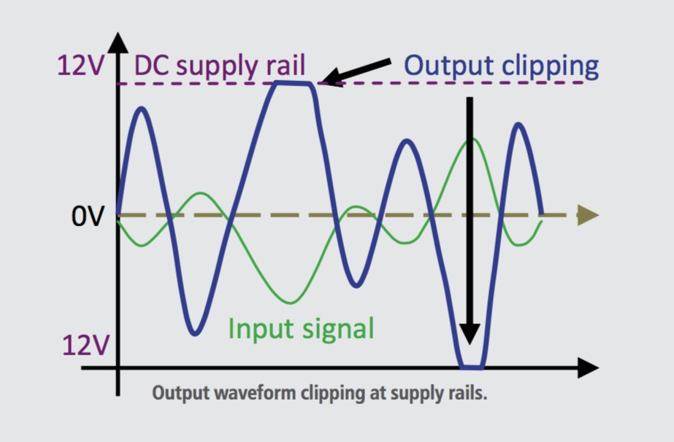
Due to increased costs and lower profits in mass production, these cost restrictions normally set the limit on how many output devices can be used. So many designs these days are sometimes unable to drive well, below a nominal 6Ω Load. If you don't like VI type limiting cutting off your peak signals, like me, just don't use them. Then we must either use more transistors or find a more robust transistor.
Many new high end designs are starting to monitor current, often using a dedicated chip.
Or we can use a circuit to trigger a relay, within a second should a fault occur.

A Better System?
In the late 1970s, the release of Hitachi's Power MOSFETs eliminated the need for VI limiting, allowing most MOSFET amplifiers to only rely on a simple “peak current limit”. The “limiting circuit” is normally set by a pair of Zener diodes across the MOSFET’s gate drive and then rely on supply rail fuses to open or “pop”, when the amp was shorted.
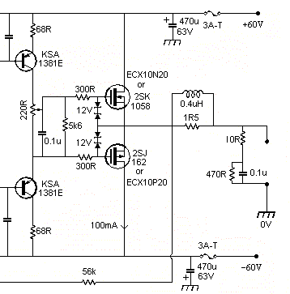
These types of amplifiers can drive virtually any loudspeaker. While amplifiers using bi-polar output transistors, even the likes of Motorola's and Toshiba’s best, are at a higher risk of failure, as most times, fuses don't blow fast enough. The ability to drive virtually any load without the need for VI limiter protection is one of the great advantages of MOSFETs. Naturally, the requirement is that there are sufficient output devices to handle the load that exists, but MOSFETs are far more tolerant of fault conditions than bipolar transistors and are not subject to a most undesirable problem known as 'secondary breakdown'.
From my take on it, I found Mosfet’s tend to be a bit warmer on the midrange similar to valves, while the bipolars are usually a little punchier down low and a bit brighter up high.
I like the sound of Bipolar Transistors over Mosfet’s….
While many people like traditional VI limiters, many others argue that these can introduce distortion during music peaks. So, short circuit/over current protection is where the biggest disagreements seem to be.

The one thing I don't understand, is why some people believe that protection circuits are optional.
Furthermore, some of the power rails in many larger solid-state amp designs are high enough (+/- 60V) to give a nasty shock, so DC protection is, IMO, mandatory.

To date, we in the industry can't even decide on the relays themselves. People argue all day about which mechanical relay they like the best, while others, now in the 21st Century, like to use SSR’s / MOSFETs in this area and apparently have good results in doing so.

For the DIY’s, a simple protection circuit can be made up easily enough to do a number of things.

A Give a few seconds delay at start up, to prevent any thumps as the circuit powers up.
B Cut out the speakers should there be a DC fault, very important.
C Cut out the speaker if the amplifier passes a thermal point (usually 70°C on Heatsink)
D The use of fuses, still pretty common for both MOSFET and Bipolar amplifiers.
I use automotive grade relays, as these are designed for high currents and spikey loads.

The Basic soft start:
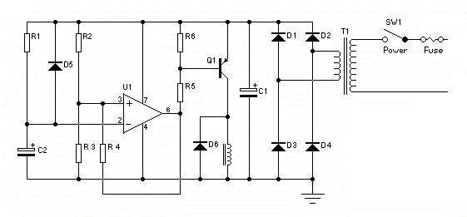
If you have +/- 12 to +/-15V available in your amplifier, op-amps can make the DC protection really easy. With one or two transistors and an op-amp, it's easy enough to do over-current trip protection too.
The Important thing with most of these circuits around, is the time it takes to switch off when a failure occurs and the quality of the relay or relays supplied. Unfortunately, many of the cheap internet deals, do not stand up to the task of reliability. Examples below are travelling on the Internet these days. I will be blunt but honest.
Price or Reliability?

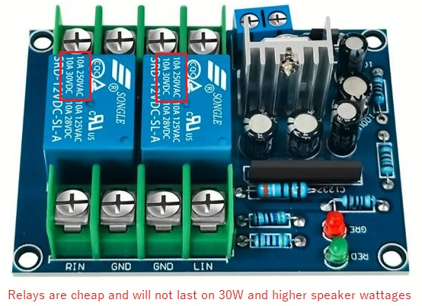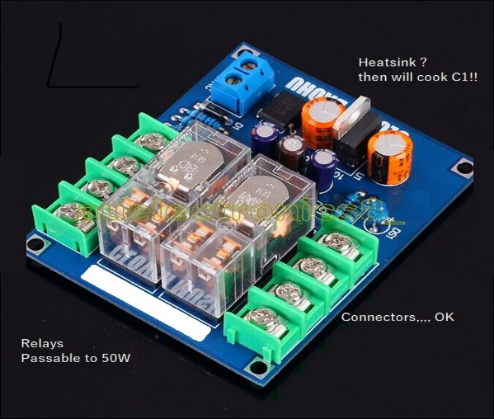
What else?

In many situations Amplifiers are also required to work in confined areas, most people do not understand that these electronic products generate heat.
Confining them to a small area and sometimes with little or no ventilation is a recipe for disaster.
Hence an additional form of protection is needed, Thermal.

Thermal Protection is another must have, especially if your amplifier is a Class A type.
These Amplifiers run hot, as their output drivers are permanently biased on.
They rely on large heatsinks to dissipate the heat generated and many will never use fans because as it is another noise that can be heard. People who use Class A, want complete silence and the purist sound from their systems!
Come in NTC’s and/or Thermal switches, these are now widely available and much cheaper. These can be added into your speaker protection circuit to turn off the relays to the speakers if/and/or when the temperature is above a given point. I usually use 75°C from heatsink tests.
Note: The transistors will be higher than 75°C. From thermal transfer losses they could be anywhere between 85-110°C depending on your heatsink size, ambient temperature and the loss between the transistor and the thermal paste/pad/drops. No amplifiers/transistors should be running hotter than this for long term reliability,

Example: My Pass F5 DIY amp runs at about 135F - 1.75A bias. That is 67°C ,
This is high but still reasonable for a Class A Amplifier. On the other hand, my D1200 runs at 15-20°C above the day’s ambient temperature. Its class A/B. The general rule here is,
“For optimal amplifier output and longevity, maintain an ambient temperature below 35°C (86°F) and heat-sink temperatures below 75°C or 167°F”.
From Experience, running electronics devices above 80°C is starting to push your luck and the products lifespan,
In Electronics, generally most capacitors run at 85°C for up to 6000-8000Hrs. Double that life when there is a 10 degree drop in temperature. So, try to use 105°C in your amplifiers and all other products, these are widely available now and much cheaper.

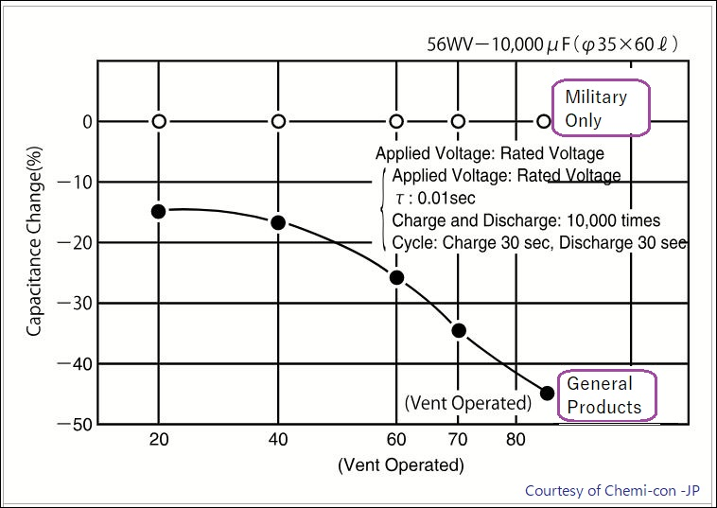

Additions:

I feel it’s a good idea to have an active circuit with a kind of visual indicator as well.
Planned to inform the user that protection is active. If a protection circuit is monitoring the output and giving you say the basic three options and different conditions, like, turn on delay, DC fault on output and over temperature, it should be possible to have a few simple Leds indicate which one is active and/or tripped.

It's not easy to I.D. every possible scenario and/or possible failure, but if look at how many threads on amplifiers, there are many half-arsed schematics and overrated voltages used in these circuits that appear on the internet.
You really need a good cut out device for use to protect your Amplifier/Speaker build.

Updated wording & spelling 2024

