Audio design has for many years relied on a very small number of integrated opamp types.

These were developed in the 60’s but they became more prominent later when the LM741 the TL072 were released and then the 5532 dominated the audio small-signal scene for many years after that.
The TL072, with its JFET inputs, was used wherever its negligible input bias currents and low cost were important. For a long time, the 5534/5532 was much more expensive than the TL072, so the latter was used wherever feasible, in an audio system, despite its inferior noise, distortion, and load-driving capabilities.

The 5534 was reserved for critical parts of the circuitry.

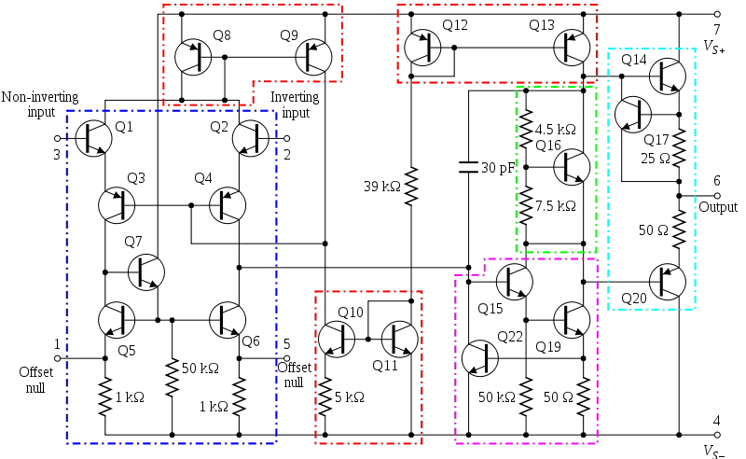

It took many years for the price of the 5534 to come down to the point where you need a very good reason not to use it for audio work.
The TL072 and the NE5532 are dual opamps while the single equivalents are TL071 and NE5534.
Dual opamps are used universally, as the package containing two opamps is usually cheaper than the package containing one, and simply because it is more popular.
There are however many other opamps, some of which can be useful, and only a selected range is covered here.
Opamp Properties: Distortion

Relatively few discussions of opamp behaviour deal with non-linear distortion, perhaps because it is a complex business. Opamp ‘accuracy’ is closely related, but the term is often applied only to DC operation.
Accuracy here is often specified in terms of bits, so ‘20-bit accuracy’ means errors not exceeding one part.
in 2 to the 20! which is -120 dB or 0.0001%.
Audio signal distortion is of course a dynamic phenomenon, very sensitive to frequency, and DC specifications are of no use at all in estimating it.
Distortion in the industry was always expressed as a ratio, but these days its quoted as a percentage, as number of decibels, or in parts per million. With the rise of digital processing, treating distortion as the quantization error arising from the use of a given number of bits has become more popular.
There are several different causes of distortion in opamps. We will now examine some of them below.

Opamp internal distortion:
This is what might be called the basic distortion produced by the opamp you have selected. Even if you avoid clipping, slew rate-limiting, and common-mode issues, opamps are not distortion free, though many types such as the 5532 and the LM4562 types have very low levels.
If distortion appears when the opamp is run with shunt feedback, to prevent common-mode voltages on the inputs, and with very light output loading, then it is probably wholly internal and there is nothing to be done about it except pick a better opamp.
If the distortion is higher than expected, the cause may be internal instability provoked by putting too much capacitive load directly on the output, or neglecting power supply decoupling.
The classic example of the latter effect is the NE5532, which shows high distortion if there is no a capacitors across the supply rails close to the package. A 100 nF or 0.1uF is usually adequate.
In Testing, there was no actual HF oscillation visible on the output with a general-purpose oscilloscope, so the problem may be instability in one of the intermediate gain stages.
Slew rate limiting distortion:
While this is essentially an overload condition, it is wholly the designer's responsibility.
If users whack up the gain until the signal is within a hair of clipping, they should still be able to assume that slew-limiting will never occur, even with aggressive material and full of high frequencies.
Arranging this is not too much of a problem. If the voltage rails are set at the usual maximum voltage, i.e. ±15 V,
then the maximum possible signal amplitude is 12.7 Vrms, ignoring the saturation voltages of the output stage. To reproduce this level of output cleanly at 20 kHz, it requires a minimum slew rate of only 2.32 V/μs.
Most opamps can do much better than this, though with the OP27 has only 2.8 V/μs, so you are sailing rather close to the edge.
The old LM741 looks as though it would be quite useless, as its limited by a 0.5 V/μs slew rate and allows a full output swing only up to 4.4 kHz.
As bad as it appears, there were audio products full of LM741s in the early 70’s. Entire mixers were built with no other active devices, and what complaints there were tended to be about noise rather than distortion.
The reason for this is that full-level signals at 20 kHz simply do not occur, and most of the energy at the HF end of the audio spectrum is well known to be much lower than that at the bass end.
This assumes that slew-limiting has an abrupt onset as level increases, rather like clipping.
This is, in general, the case.
As the input frequency rises and an opamp gets closer to slew-limiting, the input stage is working harder to supply the demands of the compensation capacitance. There is an absolute limit to the amount of current this stage can supply, and when you hit it, the distortion shoots up, much as it does when you hit the supply rails and induce voltage clipping in an amp.
Before you reach this point, the linearity may be degraded, usually but only slightly, until you get close to the limit.
It is not normally necessary to keep big margins of safety when dealing with slew-limiting, unless you are employing the usual suspects in the audio opamp world.
The LF356, TL072, the NE5532 and the LM4562, with slew rates of 12, 13, 9 and 20 V/μs respectively, you are most unlikely to suffer any slew rate non-linearity.
Selecting the right opamp:
Until recently, the NE5532 was the dominant product. It is found in almost every mixing console, and in many preamplifiers. Distortion is very low, even when driving into 600 Ω loads. Noise is very low, and the balance of voltage and current noise in the input stage is well–matched to moving-magnet phono cartridges.
In many applications now, discrete devices give no big significant advantage. 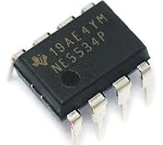
Large-quantity production and recently, slower sales, have brought the price down to a point where a powerful
reason is required to pick any other device.
The 5532 is not, however, perfect. It suffers common-mode distortion. It has high bias and offset currents at the inputs, as an inevitable result of using a bipolar input stage (for low noise) without any sort of bias-cancellation circuitry. Although The 5532 it's not actually bad, it is not in the forefront for DC accuracy,
The offset voltage spec is 0.5 mV typical, 4 mV max, compared with 3 mV typical and 6 mV max for the popular TL072.
The popularity and excellent technical performance of the NE5532 has led to it being criticised by subjectivists who have convinced themselves that they can tell opamps apart by listening to music played through them. Interesting topic that one.
The LM4562 represents a real advance on the 5532. It is however still more expensive at $4.50 presently and is not perfect. It seems to be more easily damaged by excess common mode voltages, and there is some evidence that it is more susceptible to RF modulation.
In some applications, such as low-cost mixing consoles, bipolar-style bias currents are a real nuisance because keeping them out of EQ pots to prevent scratching noises requires an inappropriate number of blocking capacitors.

There are also plenty of JFET input opamps around with negligible bias currents, but there is no obviously superior device that is the equivalent of the NE5532.
The TL072 has been used in this application for many years but its HF linearity is not first-class either and distortion across the band as it deteriorates badly as output loading increases.
However, the opamps in many EQ sections work in the shunt-feedback configuration with no CM voltage on the inputs, and this reduces the distortion considerably. When low bias currents are needed with superior performance then the OPA2134 is often a good choice, although that it is four times as expensive as the TL072.
Opamps surveyed BJT input types
In this article I look at some opamp types and examine their performance, with the NE5532 the usual basis for comparison. Some of the parts shown here are not necessarily intended as audio opamps, though others, such as the OP275 and the OPA2134, were specifically designed as such. All of these have seen a lot of use, in audio applications. I will look at Bipolar input opamps first.
The LM741 opamp 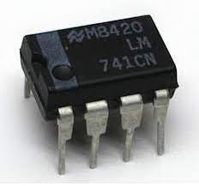
The LM741 is only included here for its historical interest. It was introduced by Fairchild in 1968 and is considered a second-generation opamp. In its day it was a most significant development, and to market, the first real practical opamp. The LM709 being first generation. The LM741 has effective short-circuit protection and internal compensation for stability at unity gain,
It was much easier to make work in a real circuit than its predecessors. It was noisy compared to using discrete circuitry, and you sometimes had to keep the output level down if slew-limiting was to be avoided, but with care it was usable in audio. Probably the last place the LM741 lingered on, was in the integrators of variable EQ filters, where neither indifferent noise performance nor poor slewing capability is a serious problem.
The NE5532/5534 opamp

The 5532 is a low-noise, low distortion bipolar dual opamp, with internal compensation for unity-gain stability. The 5534 is the single version, internally compensated for gains down to three times, and an external compensation capacitor can be added for unity-gain stability. A 18-22 pF is the usual value.
The 5532 achieves unity-gain stability by having degeneration resistors in the emitter circuits of the input transistors, to reduce the open-loop gain, and this is why it is noisier than the 5534. The common-mode range of the inputs is a healthy ±13V, with no phase inversion problems if this is exceeded.
It has a higher power consumption than the TL072, drawing approx. 4 mA per opamp section when in quiescent. The DIL version runs perceptibly warm when quiescent on ±17 V rails. The 5534/5532 has bipolar transistor input devices.
This means it gives low noise with low source resistances but draws a relatively high bias current through its input pins. The input devices are NPN, so the bias currents flow into the chip from the positive rail. If an input is fed through a significant resistance, the input pin will be more negative than ground due to the voltage-drop caused by the bias current. The inputs are connected with back-to-back diodes for reverse-voltage protection and should not be forcibly pulled to different voltages.
The 5532 is intended for linear operation and using it as a comparator is not recommended.
Its almost distortion-free, even when driving into a maximum load of 500 Ohm.
The internal circuitry has never been officially explained but appears to consist of nested Miller loops that permit high levels of internal negative feedback. The 5532 is the dual version of the 5534 and is much more commonly used than the single as it is cheaper per opamp and does not require an external compensation capacitor when used at unity gain.
The 5532/5534 is now made by several companies, and they are all not “created equal”.
Those made by Fairchild, JRC, and ON-Semi have significantly lower THD at 20 kHz and above, and we’re talking about a factor of two or three here!
These type of opamps, 5532 and 5534, require adequate power supply-decoupling if they are to remain stable otherwise, they appear to be subject to some sort of internal oscillation that degrades linearity without being visible on a normal oscilloscope. The essential requirement is that the +ve and -ve rails should be decoupled with a 100nF capacitor between them, at a distance of not more than 4-5 millimetres from the opamp.
Normally one such capacitor is fitted per package as close to it as possible. It is not necessary, and often not desirable to have two capacitors going to ground as every capacitor between a supply rail and ground carries the risk of injecting rail noise into the ground line.

The AD797 opamp 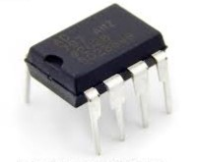

The Analog Devices, AD797 is a single opamp with very low voltage noise and distortion. It appears to have been developed primarily for the cost-no-object application of submarine sonar! but it works very effectively with normal audio – if you can afford to use it. The cost is something like 10 times that of a 5532.
There is no dual version available, so the cost ratio per opamp section is like twenty times.
It is a remarkably quiet device in terms of voltage noise, but current noise is correspondingly high due to the high currents in the input devices. Early versions appeared to be rather difficult to stabilise at HF, but the current product is no harder to apply than the 5532. Possibly there has been a design tweak, or on the other hand my impression may be wholly mistaken. The AD797 incorporates an ingenious feature for internal distortion cancellation. This is described on the manufacturer’s data sheet. And it shows that it does work and works very effectively.
The OP27 opamp.
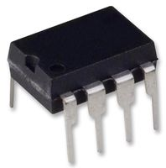
The OP27 from Analog Devices has a bipolar input, a single opamp primarily designed for low noise and DC precision. It was not intended for audio use, but in spite of this it is frequently recommended for such applications as RIAA and tape head preamps. This is unfortunate, because at first sight it appears that the OP27 is quieter than the 5534/5532, it is 3.2nV/√ Hz compared with 4nV/√ Hz for the 5534, but in practice it is usually slightly noisier. This is because the OP27 is in fact optimised for DC characteristics, and so has its input bias-current cancellation circuitry that generates a little common-mode noise. When the impedances on the two inputs are very different – which is the case in RIAA preamps – the CM noise does not cancel, and this appears to degrade the overall noise performance significantly. For a bipolar input opamp, there appears to be a high level of common-mode input distortion, enough to bury the output distortion caused by loading effects.
It is likely that this too is related to the bias-cancellation circuitry, as it does not occur in the 5532. The maximum slew rate is low compared with other opamps, being typically 2.8 V/μs. However, this is not a problem that may appear. This slew rate would allow a maximum amplitude at 20 kHz of 16 Vrms, if the supply rails permitted it.
In testing, I never encountered any particular difficulties with decoupling or stability of the OP27.

The LM4562 opamp

The LM4562 is a new breed of opamp, which first became freely available at the beginning of 2007.
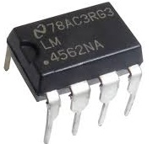
It is a true National Semiconductor product. It is a dual opamp and there is no single or quad version.
it costs twice as much as a 5532.
The input noise voltage is typically 2.7nV/√ Hz, which is substantially lower than the 4nV/√ Hz of the 5532.
For suitable applications with low source impedances this translates into a useful noise advantage of around
3.4 dB. The bias current is typically 10nA, which is very low and would normally imply that some form of
bias-cancellation, was being used.
However, in my testing I have seen no sign of excess noise, and the data sheet is completely silent on the subject. There are no details of the internal circuitry released and for good reason of “do not copy” and quite probably never will be. It is not as fussy about decoupling as the 5532, with 100nF across the supply rails close to the package should ensure and HF stability issues.
The slew rate is typically ±20 V/μs, which makes it twice as quick as the 5532.
In the first THD graph I plotted, it showed the LM4562 working at a closed-loop gain of 2.2 times in shunt feedback mode, at a high level of 10 Vrms. The top of the THD scale was at 0.001%, something you will not see with anyi have surveyed. The no-load trace is barely distinguishable from the output, and even with a heavy 500 Ω load driven at 10 Vrms there is only a very small amount of extra THD, reaching 0.0007% at 20 kHz.
This is a remarkable property of the LM4562.
It is much more resistant to common-mode distortion than the 5532. At 10 Vrms and 10 kHz, with a 10 kΩ source resistance the 5532 generated 0.0014% THD which is very low but the LM4562 gives 0.00046% under the same conditions.
I strongly suspect that the LM4562 has a more sophisticated input stage than the 5532, probably incorporating some form of cascoding to minimise the effects of common-mode voltages.
It has taken an unbelievably long time – nearly 30 years – for a better audio opamp than the 5532 to come along, but at last it has happened. The LM4562 is superior in just about every parameter.

JFET input types
Opamps with JFET inputs tend to have higher voltage noise and lower current noise than BJT input types, and therefore give a better noise performance with high source resistances. Their very low bias currents often allow circuitry to be simplified.

The TL072 opamp
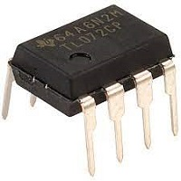
The TL072 is one of the most popular opamps, having very high-impedance inputs, with effectively zero bias and offset currents. The JFET input devices give their best noise performance at medium impedances, in the range 1 kΩ–10 kΩ. It has a modest power consumption at typically 1.4 mA per opamp section, which is significantly less than the 5532.
The slew rate is higher than for the 5532, at 13 V/μs against 9 V/μs. The TL072 is a dual opamp. There is a single version called the TL071 which has offset null pins. However, the TL072 is not THD free in the way the 5532 is.
In audio usage, distortion depends primarily upon how heavily the output is loaded. The maximum loading is a trade-off between quality and circuit economy, and I would put 2kΩ as the lower limit. This opamp is not the first choice for audio use unless the near-zero bias currents (which allow circuit economies by making blocking capacitors unnecessary), the low price, or the modest power consumption are dominant factors.

It is a quirk of this device that the input common-mode range does not extend all the way between the rails. If the common mode voltage gets to within a couple of volts of the V– rail, the opamp suffers phase reversal and the inputs swap their polarities. There may be really horrible clipping, where the output hits the bottom rail and then shoots up to hit the top one, or the stage may simply latch up until the power is turned off.
TL072s are relatively relaxed about supply rail decoupling, though they will sometimes show very visible oscillation if they are at the end of long thin supply rail. One or two rail-to-rail decoupling capacitors (e.g. 100 nF) per few centimetres is usually sufficient to deal with this issue, but normal practice is to not take chances, and allow one capacitor per package as with the other opamps.

Because of common-mode distortion, a TL072 in shunt configuration is always more linear. In particular, if we compare the results for 3k3 load. At heavier loadings the difference is barely visible because most of the distortion is coming from the output stage. TL072/71 opamps are prone to HF oscillation if faced with significant capacitance to ground on the output pin. This is particularly likely when they are used as unity-gain buffers with 100% feedback. A few inches of track can sometimes be enough. This can generally be cured by an isolating resistor, in the 47 to 75 Ω range, in series with the output, placed at the opamp end of the track.
The OP275 opamp 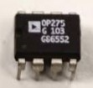
The Analog Devices OP275 is one of the few opamps specifically marketed as an audio device. Its most interesting characteristic is the Butler input stage which combines bipolar and JFET devices. The idea is that the bipolars give accuracy and low noise, while the JFETs give speed and… ‘the sound quality of JFETs’.
That final phrase is not a happy thing to see on a datasheet from a major manufacturer.
Ie, the sound of JFETs (if any) would be the sound of high distortion.
The OP275 is a dual opamp and there is no single version is available. It is quite expensive, about six times the price of a 5532, and its performance in most respects is inferior. It is noisier, has higher distortion, and does not like heavy loads. The CM range is only about two-thirds of the voltage between the supply rails, and the bias is high due to the BJT part of the input stage.
Unless you think there is something magical about the BJT/JFET input stage, it is probably best avoided.
The THD at 10 kHz with a 600 Ω load is 0.0025% for shunt and 0.009% for series feedback.
There is some significant CM distortion in the input stage, which is almost certainly coming from the JFETs.
Far from adding magical properties to the input stage, the JFETs seem to be just making it worse.
The OPA2134 opamp.
The OPA2134 is a Burr-Brown product, a dual version of the OPA134. The manufacturer claims it has superior sound quality, due to its JFET input stage. Regrettably, but not surprisingly, no evidence is given to back up this assertion.
The input noise voltage was measured at 8nV/√ Hz, almost twice that of the 5532.
The slew rate is typically ±20 V/μs, which is ample. It does not appear to be optimised for DC precision, the typical offset voltage being ±1 mV, but this is usually good enough for audio work. I have used it a few times as a DC servo in power amplifiers, the low bias currents allowing high resistor values and correspondingly small capacitors. The OPA2134 does not show phase-reversal anywhere in the common-mode range, which immediately marks it as superior to the TL072. In the THD plots it showed the device working at a gain of three times in both shunt and series feedback modes. It is obvious that a problem emerges in the series plot, where the THD is higher by about three times at 5 Vrms and 10 kHz. This distortion increases with level, which immediately suggests common-mode distortion in the input stage.
Distortion then increases with even moderate loading.
This is a relatively modern and sophisticated opamp. When you need JFET inputs (usually because significant input bias currents would be a problem) this definitely beats the TL072.
It is, however, four to five times more expensive.
The OPA604 opamp.
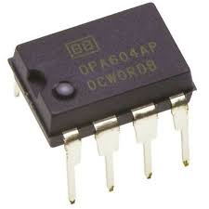 The OPA604 from Burr-Brown is a single JFET-input opamp which has been specially designed to give low distortion. The simplified internal circuit diagram in the data sheet includes an enigmatic box intriguingly labelled ‘Distortion Rejection Circuitry’. This apparently ‘linearizes the open-loop response and increases voltage gain’ but no details as to how are given.
Whatever is in there appears to have been patented so it ought to be possible to track it down.
However, despite this, the distortion is not very low even with no load and it is noticeably higher to the 5532.
The OPA604 is not optimised for DC precision, the typical offset voltage being ±1 mV.
The OPA2604 is the dual version, which omits the offset null pins. The data sheet includes a discussion that attempts to show that JFET inputs produce a more pleasant type of distortion than BJT inputs. This unaccountably omits the fact that the much higher transconductance of BJTs means that they can be linearised by emitter degeneration so that they produce far less distortion of whatever type, than a JFET input.
Given that the OPA604 costs five times as much as a 5532, it is not very clear under what circumstances this opamp would be a good choice.
The OPA627 opamp 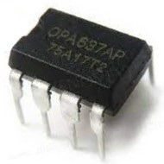
The OPA627 from Burr-Brown is a laser-trimmed JFET input opamp with excellent DC precision.
The input offset voltage being typically ±100μV. The distortion is very low, even into a 600 Ω load, though it is increased by the usual common-mode distortion when series feedback is used. The OP627 is a single opamp and there is no dual version is available. The OPA637 is a decompensated version only stable for closed-loop gains of five or more. This opamp makes a brilliant DC servo for power amplifiers, if you can afford it.
It costs about 20 times as much as a 5532, which is 100 times more per opamp section, and about 10 times more per opamp than the OPA2134, which is my usual choice for DC servo work.
The current noise “In” is very low, the lowest of any opamp examined so far, apparently due to the use of Difet (dielectrically isolated JFET) input devices, and so it will give a good noise performance with high source resistances.
Voltage noise is also very respectable at 5.2 nV/√ Hz, only fractionally more than the 5532. The series feedback case barely has a little more distortion than the shunt one, and only at the extreme HF end.
It appears that the Difet input technology also works well to prevent input non-linearity and CM distortion.

For many years I avoided using Op Amp’s in my audio power amplifier circuits, (different in preamps), as I never found a reason to use them over traditional LTP’s or Borbely Twin LTP’s made with good transistors. In the earlier days, the transistors ruled, and this was for a few good reasons.

Firstly, Opamps did not have the ability to be used easily in 20W+ amplifiers as their operational voltages were fixed to +/- 15V and this required Zener’s or Regulators to be added.
The output voltage swing was +/- 10 to13V max and at that time and the overall performance was not great, see above LM741.
Then there were issues with Oscillation if the pcb and tracks were not well designed, and/ or decoupling capacitors were not fitted close to the IC of the supply rails.

Secondly, the cost of Opamps was not cheap relative to making a good LTP circuit. Especially anything from Bur Brown ! Back then the cost of a BC550C or BC560C was 0.08 cents each and these could be run up to 50V while a basic op amp was $0.65 and needed a second stage.
Although it does not sound like much, a good LTP was very formidable, and it’s still used to this day by many manufactures.

Updates: Spelling and wording 2024

