Lazer Mains Filter – 3A

Warning: This circuit is wired to the mains and as such it requires some experience with mains wiring.
Do not attempt to build this project unless you have experience and are capable to do so.
Precaution must be taken at all times…

For learning about mains filters and what they do, this project is very useful and is easy to build.

There are many different types of filters used in “Filter” and “Soft start” circuit designs.
Generally based on the application but the underlying concept of them all is the same. That is to remove unwanted noise signals, and although it cannot be completely removed, this circuit helps to lower the amplitude of the noise and offer some other features as well.
The Circuit and PCB is built with components readily available off the shelf in most places,

The Circuit:

As mandatory, for mains connection, it has a fuse in the event of a catastrophic failure.
An NTC of 5-6 Ohms is fitted to allow a small “soft start” to the appliance. I generally use these for my power amps, and most of our SMPS supplies. This helps to reduce the initial inrush currents at first turn on, especially where there are Toroidal Transformers in use, as well as filter out HF noise.

It has an MOV (Metal Oxide Varistor) to prevent damaging large voltage spikes entering the power line and it has the Mains Choke/Capacitors combo, used for filtering out line noises.

The inductor used here is rather special and is called a ‘common-mode choke’.
The two windings are made on a single core, usually ferrite, and the windings are in the same direction.
So for common-mode currents, that flow in the same direction in the two windings, the inductance is high, but for differential mode currents, including the supply current, the inductance is low,
The choke in conjunction with the capacitors attenuates high-frequency differential-mode currents as well. This part of the circuit together with the capacitors is called a Pi Filter. Pi filters are used for Low pass filter applications,

The below is based on the original circuit from the late 90’s with the updated mains choke made by
Wurth Electronics. This Choke is very widely used in High End SMPS and is one of the highest quality chokes we have seen.
This Circuit was made to suit transformers and/ or LED supplies up to 250Va or 250W.

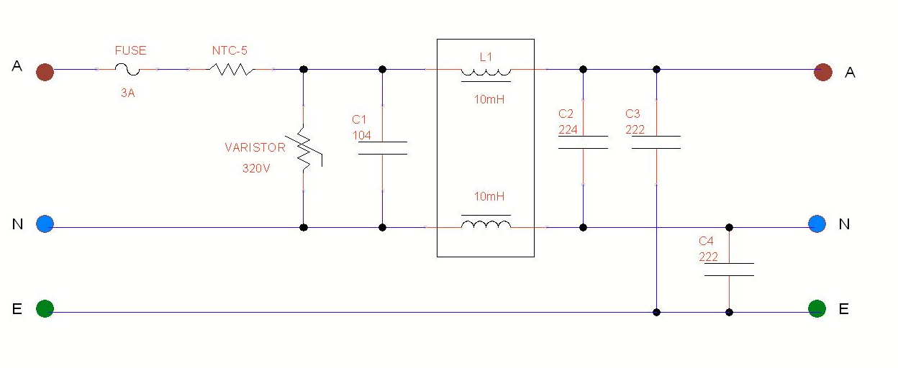

The Use of the two smaller capacitors (222M or 220pF) is fed to ground and this is done to help minimise any high frequency noise.

Assembly:
This PCB is double sided, and as such, it requires more heat to solder the pads and components.
You will need a good hot soldering iron, it needs to be 40W or more.
Wipe it often on a wet sponge or cloth, to keep it clean, and then apply a little solder to the tip, to give it a wet look. This is called 'tinning' and will help to protect the tip. It also enables you to make good connections. When the solder looks dirty on the tip, it needs cleaning. Use thin resin-core solder. Do not use any flux or grease.
Firstly Inspect the PCB for any shorts or cracks that may have been missed by the testing machines..
Place the components on a clean surface area and familiarise yourself with them.

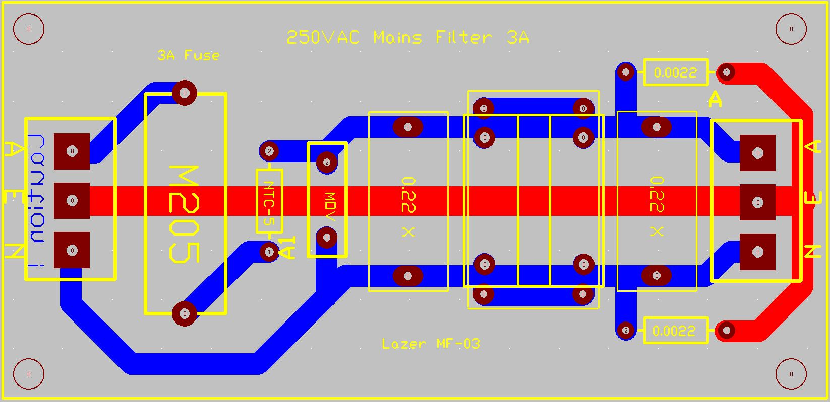
Next:

Install the PCB choke and solder the install the capacitors, 1 x 0.1uF, 1 x 0.22uF and the 2 x 0.0022uF capacitor’s.
These capacitors are X Type and Y Type AC mains types, they can be installed either way around.
Then install the other parts, the MOV and the NTC and then the connectors.

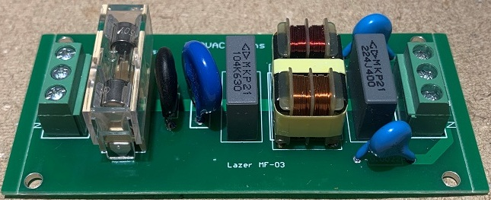

Components supplied in the kit are a combination of Brand New and “Removed parts”.
These are new parts that were removed from products that never reached the market place, never sold and/or used.

The “Removed parts” are supplied free when you purchase the kit from us,

I do not believe we should throw away NEW parts into land fill, so we spend a lot of personal time removing them safely, and checking them to be 100%.

The BOM below is provided with prices in AUD and based on the use of “decent parts” and average “street prices”.
These prices are given in general terms but can vary a lot in shopping around.
My intentions, are to get great parts and at decent hobby prices.

BOM | Part | Does | Cost
CHK-WH-10 | 2 x 10mH Mains Choke | Mains Filter Choke | $ 2.00
NTC-5 | NTC Mains 5 Ohm- 12mm | NTC Mains 5 Ohm | $ 0.15
MOV-474 | S10-320V Metal Oxide Varistor | 320V Metal Oxide Varistor | $ 0.40
104-630V-15 | 104-630V-X2-15 Mains Capacitor | 104-630V-X2 Capacitor | $ 0.80
224-630V-X | 224-630V-X2-15 Mains Capacitor | 224-400V-X2 Capacitor | $ 1.00
220PF-400V-Y | 222M-400V-X1Y1-10mm Ceramic | 222M-300V-10mm | $ 0.40
Con 1 | 3P 5.08mm 2 Pin PCB | Terminal Block Connector | $ 0.40
Con 2 | 3P 5.08mm 2 Pin PCB | Terminal Block Connector | $ 0.40
M205 3A GF | M205 3A Fuse | M205 3A Fuse Holder | $ 0.15
M205 PCB FH | M205 Fuse Holder | M205 Fuse Holder | $ 0.80
PCB | Lazer Mains Filter – V3 | Mains Filter –V3 PCB | $ 2.00

Revision 2.1 , Spelling updated

