Lazer 5W Entry Amp
This little amplifier circuit was designed over 30 years ago. When I made them around 93-95, I used them in a commercial application, gaming machines, and they worked very well. Back then, it was a busy time.
But as the 90’s progressed the “bigger chip amps” came along and most people wanted the higher power.

Before this period, there were many IC amps available. The TA7205P, the MB3730, LA4440, HA1377, uPC1182/1183, STK series etc. these IC’s were popular and widely available, but the majority of which were used in ‘automotive’ stereos, cheap amplifiers and in mass production. They used quite clever designs to get the maximum power available from a single 12V supply, especially when they were run in bridge mode.
Over the years most of these have been dropped from production and are no longer available. (as originals). While they worked well, they did not have the best noise and distortion figures.
If you shorted the speaker you were guaranteed to hear them pop!
While most Hi Fier’s wanted lower distortion figures and a cleaner sound.

Until recently the cost of most opamps generally exceeded that of using basic transistor circuits, that’s why you see so many amplifiers still built with transistors.
Basic transistors circuits offered lower cost, lower distortion, much higher power and could withstand more abuse over the op amps or the chip-amps.
This Project uses a combination of a Mosfet Opamp and some discretes that can be made up easily enough,
It is low in cost and performs very well.
I have brought it to life and made it available online. It’s a very good kit for beginners and for those who only require 5 to 6 watts of power with a good set of efficient speakers.
It’s built with components readily available off the shelf in most places, with the exception of the LF351N.
It seems to have become an EOL (End Of Life) product and now is hard to find.
So it has been replaced by the later version, the LF356. This Op Amp is better in all aspects of performance.

For fun and learning, very easy to build, and to get the “Real Amplifier Look”, this kit gives, one must try it.
The Circuit below is based on the original circuit from the late 80’s with the updated LF356 and the 2.2 Ohm resistors.

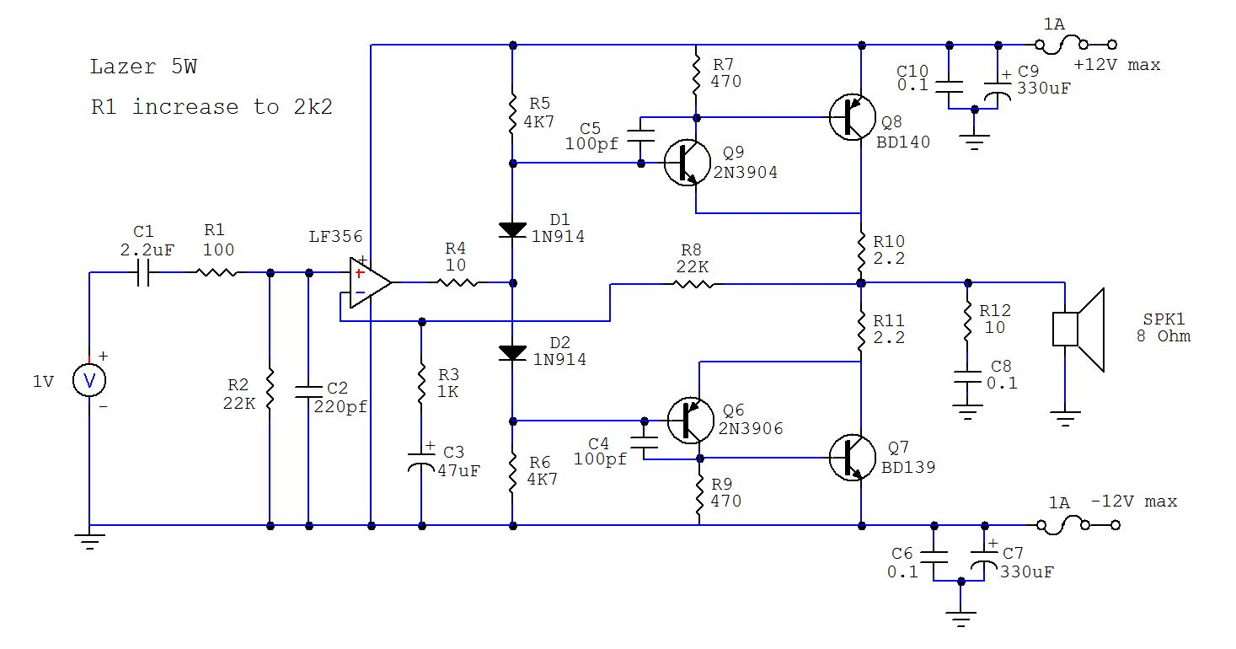
Note:
The circuit above used a potentiometer of 10K at the input to control and set the input’s volume.
That is why it has a 100 Ohm resistor as R1.
If you find the gain is too high (e.g., using it with phones, Ipads or iPods) this should be increased to 1K.

Assembly:

This PCB is double sided, and as such, it requires a little more heat to solder the pads and components.
It needs to be 40W or more.
Wipe it often on a wet sponge or cloth, to keep it clean, and then apply a little solder to the tip, to give it a wet look. This is called 'tinning' and will help to protect the tip. It also enables you to make good connections. When the solder looks dirty on the tip, it needs cleaning. Use thin resin-core solder. Do not use any grease.

Firstly, Inspect the PCB for any shorts or cracks that may have been missed by the testing machines...

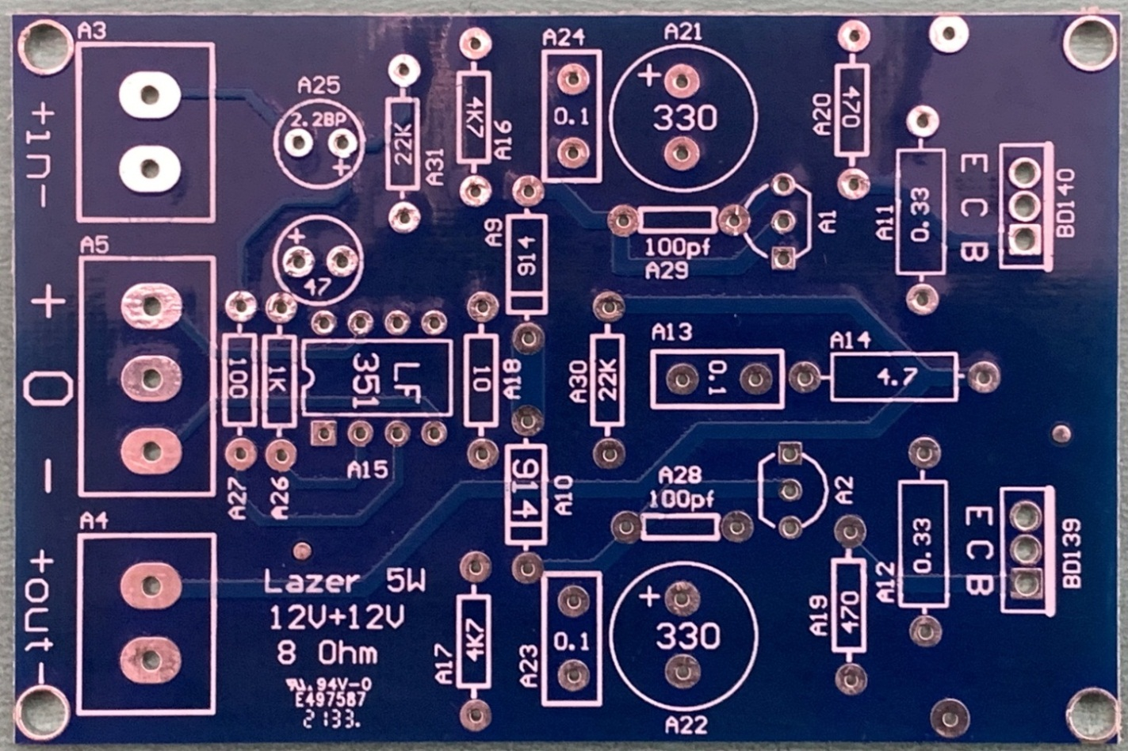

Place the components on a clean surface area and familiarise yourself with them.
Install the resistors and diodes first, bend the legs at 90 degrees, the 2 x 1N914 diodes will need to be bent around 4mm from the body, install in the areas labelled and solder. Note the line on the diode, it is the cathode.

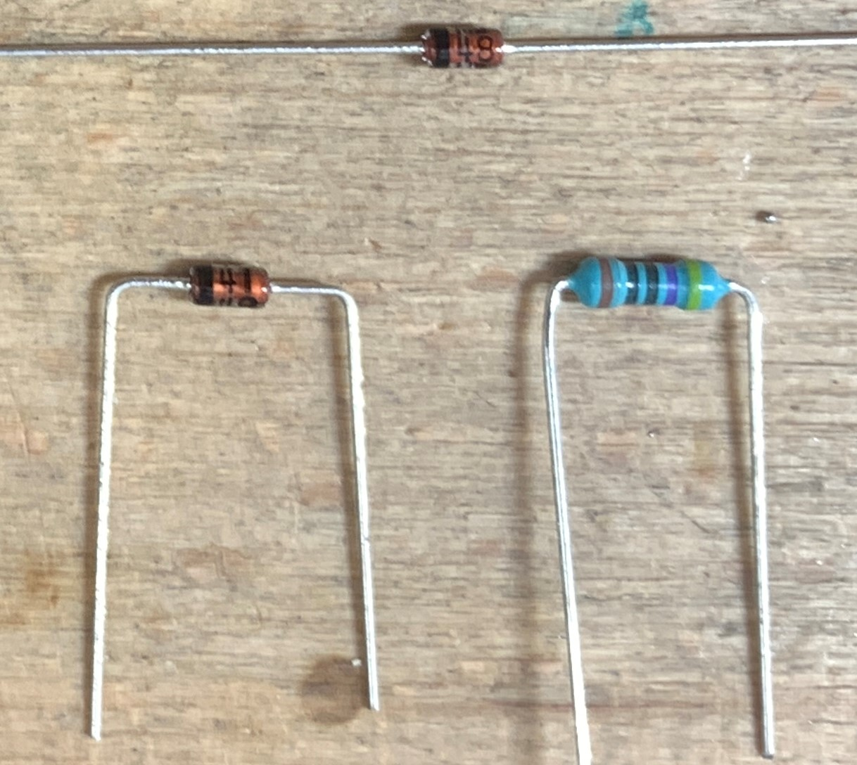

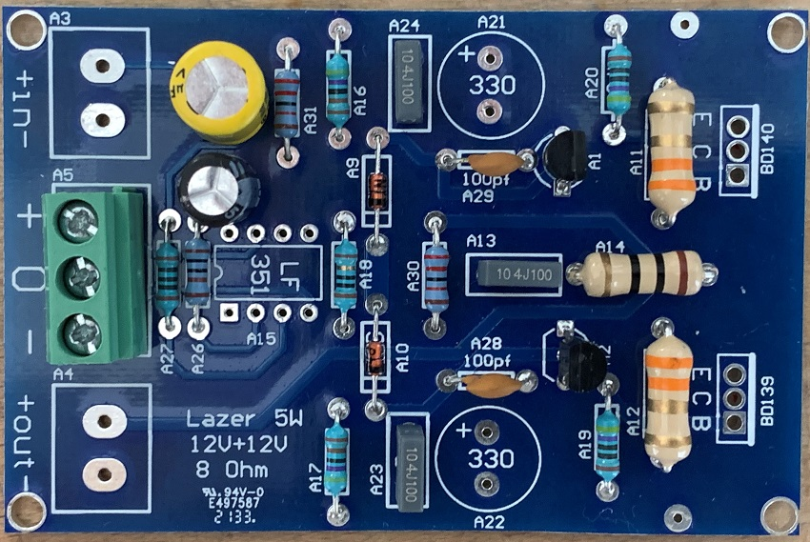

Check with your multimeter that the resistors you have fitted are the correct values and the 2 x diodes are installed, in place, and the correct way around.

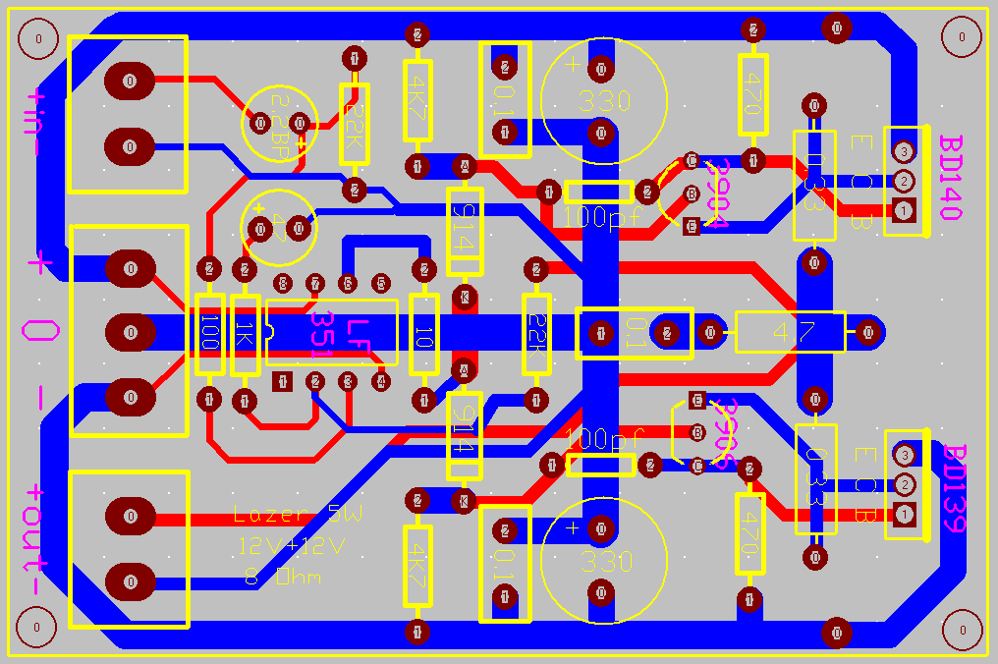
Note 2:
The PCB circuit shows 0.33Ω.
We have supplied these kits with both 0.33 and 2R2 resistors and a 10R in the Zobel Network.
Use the 2.2Ω in the amp, for use over a wider range of power supplies, up to+/-15Vdc.
Or use the 0.33 for fixed +/-12V supplies.
This was done to give us some variation of Amplifier versions and keep the Bias similar between the different types.
The emitter resistors and the 10R resistor do not fit all the way down, they do NOT sit flush on the PCB.
This was made to hold them around 1-2mm above the PCB. (This adds to cooling, when they get hot).
All good amps will have this feature.
Next:
Install the capacitors, note the 2 x 330uF 50V and the 47uF /50V capacitor’s polarity.
The input’s capacitor is a bipolar type, which means it can be installed either way around.
It sets the frequency of the incoming signal required to be amplified, this low point cut off is set at ~ 32Hz by the 2.2uF, with the 22k. This can be changed to 4.7uf (15Hz), it works to roll off the lower frequencies.

Then install the other parts transistors, connectors.
Note the orientation of these transistors and their position. Do not mix them up.
The two main output transistors, BD139G and BD140G, are fitted onto the heatsinks supplied.
Add a smear of “decent” thermal paste, not that white 1970’s stuff, and screw them down with the M3 screws.

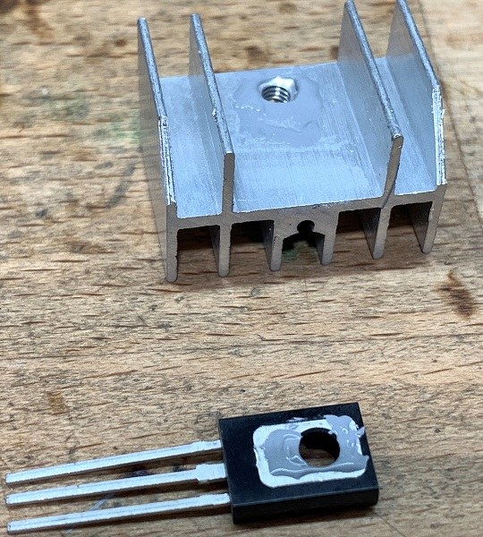

As the output is fed to the speaker at the front of the PCB, this circuit employs a “Zobel Network”.
These circuits are added to ensure stability with reactive loads. They typically employ a 4.7 Ω to 10 Ω resistor and 100nF capacitor.

The Completed PCB: 2018 onwards series:
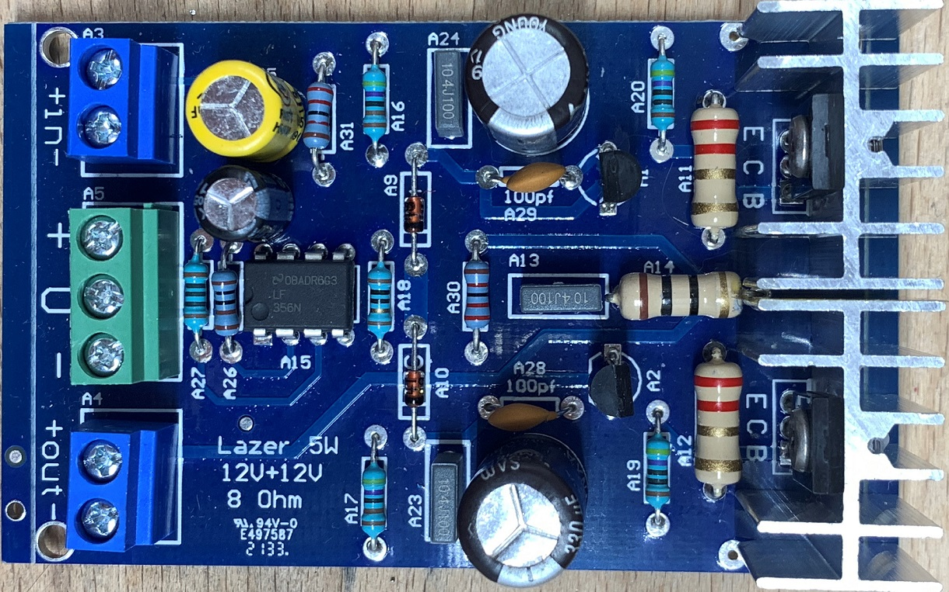
Note, the heatsinks will change in general production. They will be smaller in width but taller, so the output transistors/heatsinks do not touch the emitter resistors and the Zobel resistor, so the corners of the heatsinks don’t need to be cut down. But you can ask for this type I used them as I had them and they look good. I still have some in stock. (Quote M PCB-5W Heatsink when ordering).

Testing:
The kits come supplied with 2 x 82 Ω Test Resistors. Install them into the + and the – side of the power connector.
Connect the centre pin terminal, marked O v, to the power supply,
Do not connect anything to the input or the speaker yet.
Then connect the +12v and the -12V to the resistors, this will help to safeguard the amp parts should there be an issue with your wiring and/or if you have incorrectly installed components,
Connect your multimeter across either of the 82 Ohm test resistor, Power up and observe. If the reading is above 200mv then there is a problem,
Quickly turn off the supply and check the components are in the correct positions,
check there are no bridged solder connections under the PCB,
check the3904 and the 3906 transistors are installed correctly and the “right way around”.
Check that you have not mixed up the positions of the BD139 and BD140 transistors.

If all is well then remove the 82Ω resistors, connect your speaker and line inputs and away you go, Enjoy.

Components supplied in the kit are a combination of Brand New and some “Removed parts”.
These are new parts that were removed from production that never reached the marketplace, never sold and/or used.
The “Removed parts” are supplied free when you purchase the kit from us,
I do not believe we should throw away NEW parts into land fill, so we spend a lot of personal time removing them safely and checking them to be 100%.
The BOM below is provided with prices in AUD and based on the use of “decent parts” and average “street prices”.
These prices are given in general terms but can vary a lot in shopping around.
There are No Fakes here!
My intentions are to get, great original parts and at decent hobby prices.

BOM | Part | Does what? | Cost
R1 | 100 Ohms-1/4 W M/F | Input Limit | $ 0.05
R2 | 22K Ohms-1/4W M/F | Input Shunt | $ 0.05
R3 | 1K Ohms-1/4W M/F | DC shunt | $ 0.05
R4 | 10 Ohms-1/4 W M/F | Stop Latch Up | $ 0.05
R5 & R6 | 4K7 Ohms 1/2W M/F | Bias Set | $ 0.10
R7 & R9 | 470 Ohms 1/2W M/F | Tr on Set | $ 0.10
R8 | 22k Ohms 1/4W M/F | Gain Set | $ 0.05
R9 | 4.7-10 Ohms 1/2W C/F | Zobel Shunt | $ 0.08
R10 & R11 | 0.33 Ohms 1W C/F | Emitter Limit | $ 0.08
R12 | 10 Ohms 1W | Zobel Shunt | $ 0.08
C1 | 2.2μF-Bipolar 5mm | Input Signal & DC Block | $ 0.30
C2 | 220pF 5mm | Optional HF Cut | $ 0.05
C3 | 47μF-25V- 5mm | DC Feedback & blocking | Removed
C4 & C5 | 100pf 5mm Ceramic Disc | Miller Stability | $ 0.10
C6, C7, C10 | 0.1μF-250V- 10mm | Noise & Decoupling Shunts | $ 0.60
C9, C10 | 330μF-35V- 5mm | Line Decoupling Capacitors | Removed
D1 & D1 | 1N914 Diodes | Bias Control | $ 0.08
TR1 | 2N2904-NPN Transistor | Genuine On-Semi | $ 0.80
TR2 | BD140-PNP Transistor | Genuine On-Semi Driver | $ 1.00
TR3 | 2N 2906-PNP Transistor | Genuine On-Semi | $ 0.80
TR4 | BD139-NPN Transistor | Genuine On-Semi Driver | $ 1.00
IC1 | LF356N Op Amp DIP8 | TI-Op-Amp, front of amp | $ 1.50
Con 1 | 2P 5.08mm 2 Pin PCB | Blue Screw Terminal Block Connector | $ 0.30
Con 2 | 3P 5.08mm 2 Pin PCB | Green Screw Terminal Block Connector | $ 0.40
Con 3 | 2P 5.08mm 2 Pin PCB | Blue Screw Terminal Block Connector | $ 0.30
HTSNK | 20mm x 18mm Heatsinks | 2 x NEW Heatsinks | $ 1.00
PCB | Lazer 5W Amp | PCB | $ 3.80

All “National Semi” parts are now made by Texas Instruments. Texas Instruments retains manufacturing of many factories and products under their original brands, On Semi ( ex-Motorola) is same. We have never had any issue with their products, they have always work very well.

Revision3.3 Spelling and Grammer

