Lazer Single Linear Supply PS1-SMD

The Linear IC Supply was designed a long time ago, and has been a true winner over the ages, especially for, National Semiconductor, for DIY’s and production by millions of others.
This version is using an LM1117AJG Adjustable, in an SMD format. The 1117AJG is also a low drop out type.

When I made these around the late 90’s, I used it in Pre-amps that I was making at that time,
Then I used it elsewhere for LEDs, small amp circuits and such.

Since then, I have spent many years in developing switch mode power supplies (SMPS) for LED lighting and LED strip. The SMPS supplies are great for their small size, high power, low costs and good efficiency, but they are Not the best for use in clean sounding audio in amplifiers, near AM radios, and many other RF circuits. They do generate some RF Noise. Despite what others say, there will always be some form residual noise emission from these types of supplies.
We might make them to pass “standards” but the noise figurers below and above 30 MHz are still present!

So, after seeing a lot of rubbish on the web, I decided to bring back this linear supply design and build it on a newer board, with the parts I have.

For a simple, clean and reliable source of DC power, you simply cannot go past the LMXXX series of IC’s.
Although it uses SMD components, it can be made up very easily. These are for sale now on the web site,
Or if you have parts lying around, then we can supply the PCB only.

The LM1117 regulated power supply has < 0.18 mV noise, well below the Power Supply Rejection Ratio (PSRR) of many operational amplifiers. So it’s well suited for amplifier use. I use this in the preamps we build and in the
5W Camp Amp when detuned to 1W for Headphones.
The Circuit: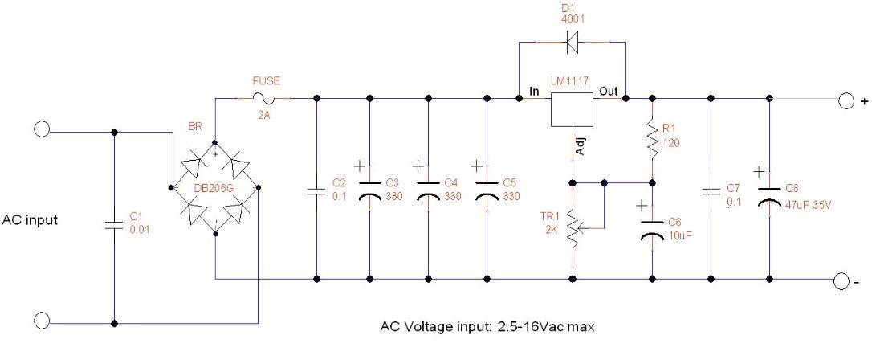
This circuit diagram shows the power supply, as used in previous productions, it does not show the LED which has been added later.

How it works:

C1 dampens the inductive spikes that occur when the power switch is turned on/off. This capacitor is also often present in audio systems to help reduce unwanted noise. The AC waveform is then rectified by the DB206 Bridge Diode to produce DC. This is then fed to a bank of filter capacitors consisting of a 0.1uF 50V and then 3 x 330uF 25V Electrolytics. I use Panasonic Capacitors so know the quality of the parts used here is excellent.
The rectified DC then passes through to the Regulator IC. This IC, LM1117AJG, is the Adjustable Version, and will then regulate this voltage on the values chosen by R1 and the setting of R2.
The output then goes to another 0.1uF capacitor and the final 47uF cap to stabilise, improve the transient response and further filter any unwanted noise.
The limit of this part is 800ma although I would not recommend it unless the PCB is bolted to a heatsink with thermal Pad.
We run these up to 500ma in open air scenarios without heating issues.
PCB Overlay:

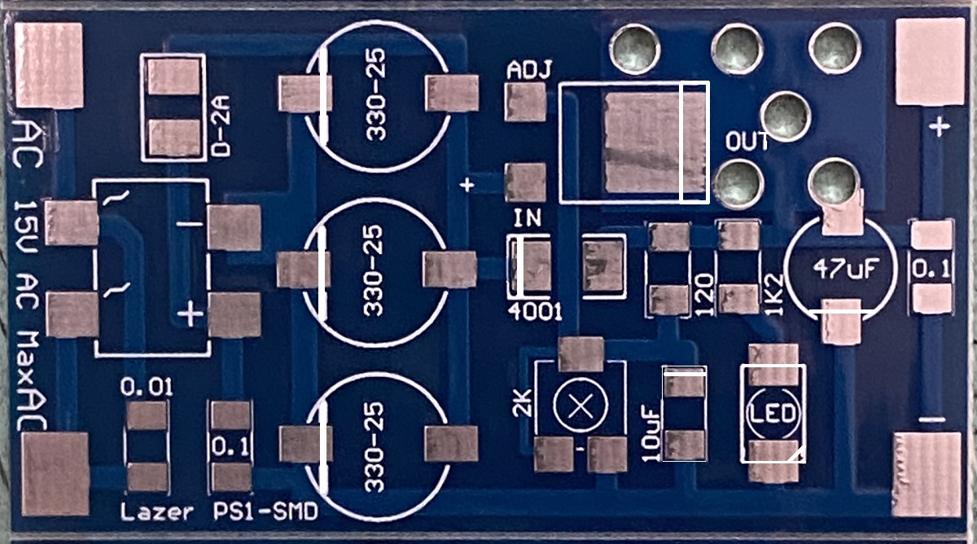
Construction:

As this PCB is double sided, it will require more heat on the pads and to solder the components. You will need a good hot soldering iron, it needs to be 40W or more. Wipe the tip often on a wet sponge or cloth, to keep it clean. Then apply a little solder to the tip, to give it a wet look. This is called 'tinning' and will protect the tip, and this will help you to make good connections. When soldering looks dirty on the tip, it needs re-cleaning. Use thin resin-core solder. Do not use any grease type solders. When Soldering SMD you need to use fine solder. Mine is 0.5mm and Shenmao brand from Taiwan. I use 2mm on each pad then 2-3mm sections when soldering each of the smaller SMD parts.
Ensure the solder has flowed into the part and the pad.

Firstly, Inspect the PCB for any shorts or cracks that may have been missed by the test machines.

Then, solder only one side of the SMD parts pads.
Start with the SMD resistors and then the 1N4001 diode, and then the Fuse.

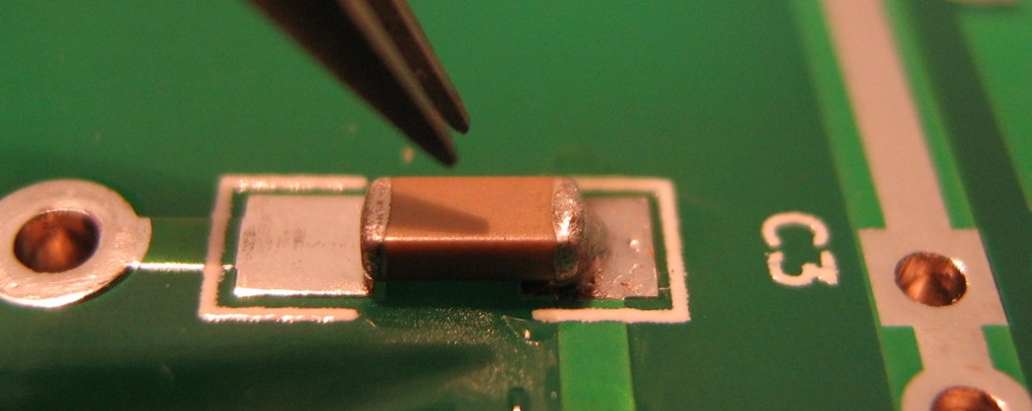
Next add the Trim-pot, the 10uF capacitor and then fit the LED.
Note the orientation of the LED, the “corner section” or a “small line” goes towards the negative side.
Make sure these parts are installed the correct way around and solder. Then turn the PCB around and solder the other side’s pads.
Check with your multimeter that the resistors you have fitted are all correct values, and the Bridge + Diodes are installed in place, the correct way around.
Then,
Install the 0.1 and 0.01 Capacitors, then install the Bridge rectifier, the capacitors, 3 x 330uF, the 47uF capacitors, and after that the IC. At this point you will have some idea of SMD soldering.
Caution, double check the polarity of the Electrolytic capacitors is correct.

The regulator IC will need a dab of solder (5mm x 0.5) on the Main Pad, add some Solder flux to aid with soldering.
After aligning this part, solder the PCB pad then the Tab of the IC together as you move this part onto the Pad. Ensure the solder flows though this thick pad. (3-4 Seconds on Hakko set to 455°C).
Turn the PCB around and solder the other two legs to the pads, IN and ADJ.
The Completed PCB:
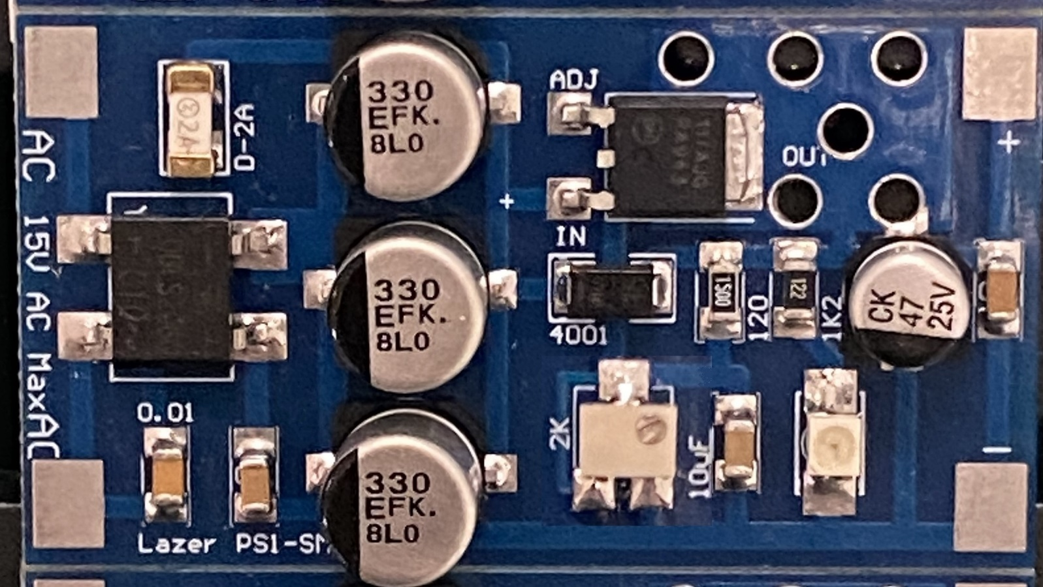
Testing:
Do not connect any load yet, Connect the AC output wires of your transformer lead to the AC input terminals.
Solder some wires from the output pads and connect your multimeter across the Output Terminals,
Power up and observe.
The LED near the Trimmer on the PCB should light up and you should get a Voltage reading on your meter,
the reading will depend on where the Trimmer was previously set.
If the Voltage is at less than 1.5V or 0, then there is a problem, quickly turn off the supply and check:
All components are in the correct positions,
Check that the Bridge Diode and the 1N4001 Diode are fitted the correct way around
Check your soldering for shorts between any of the parts….

I have provided pricing in this BOM, but it will vary from supplier to supplier, it is intended to give you a rough guide to current market prices (2015).

BOM : LAZER-PS1-SMD
Part | Specification | QTY | Does what? | ~ Cost
R1 | 120-150 Ohms 1206 1% | 1 | Feedback for Trim V Set | $ 0.02
R2 | 2K trim pot-3324 | 1 | 2K Trimmer Adjust V | $ 1.00
C1 | 0.01uF 1206 50Vac Cap | 1 | AC Input Filtering | $ 0.10
C2 | 0.1uF 1206 50Vac Cap | 1 | Filtering Capacitor | $ 0.10
C3,C4,C5 | 330uF-25V-105C-7.5mm | 3 | Filtering Capacitors | $ 3.00
C6 | 0.1uF 1206 50Vac Cap | 1 | Output Stability + filtering | $ 0.10
C7 | 47uF-25V-105C-7.5mm | 1 | Output Stability | $ 0.50
F1 | 2A 250V 1206 Fuse | 1 | 2A fuse | $ 0.50
D1 | UN4001 Diodes | 1 | 1A Protection Diode | $ 0.10
BR1 | DBLS206-SMD | 1 | 2A Bridge Rectifier | $ 1.00
LED1 | Lazer – PLCC 2-OR | 1 | Orange LED | $ 0.20
IC1 | TI-LM1117-IC REG | 1 | POS ADJ Linear Regulator IC | $ 1.50
LZR-PCB-PS1-SMD | Lazer PS1-SMD PCB | 1 | PS1-SMD-PCB | $ 1.00
Kit | Premade and tested | 1 |  | $10.00

Components supplied in the kit, is made up of New & Genuine Components, they also have a full 12-month warranty.
This product is available in kit form or ready-made, please see the website for further information.

Note 1: Line and Load regulation are guaranteed up to the maximum power dissipation of 2.2W for a TO-252 package.
Power dissipation is determined by the input/output differential and the output current.
Guaranteed maximum power dissipation will not be available over the full input/output range.
Note 2: See thermal regulation specifications for changes in output voltage due to heating effects.
Line and load regulation are measured at a constant junction temperature by low duty cycle pulse testing.
Load regulation is measured at the output lead ~1/8” from the package.
Note 3: Dropout voltage is specified up to 0.8A load. For currents over 0.8A dropout will be higher
Note 4: Minimum load current is defined as the minimum output current required to maintain regulation.
When 1.5V ≤ (VIN - VOUT) ≤ 12V the device is guaranteed to regulate if the output current is greater than 10mA

Updates: Spelling and Wordings 12-17

