This product was designed and made to suit several products I used for LED lighting in vehicles, 1995-2010.
As most single chip LED’s have around 3V DC to operate they cannot be connected directly the power supply of a car battery of 12V, it would blow it apart. So, caution and correct connection’s must be made and used.
Based on the popular LM range of IC’s, the LM1117 runs in current limit mode, which is perfect for this application, This IC is a low drop out Linear regulator.
Although it is not as efficient as switch-mode module, there is no noise generated, its simple and it’s very reliable. When installing say 3 x LEDs in series its perfect for car use.
The voltage of 3 x Leds in series is around 8.8V -9.5V under load, add 1.3V required for the regulator and you are at 10.8V. The bonus of the circuit operated in this fashion will start to drop off at around 10.5V so the car battery will not be discharged. And the LED’s will be turned off.

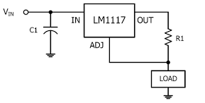
C1 and C2 are required to filter out spikes , D1 is fitted to allow any voltages to return in one direction and feed back into the power line to protect the IC.

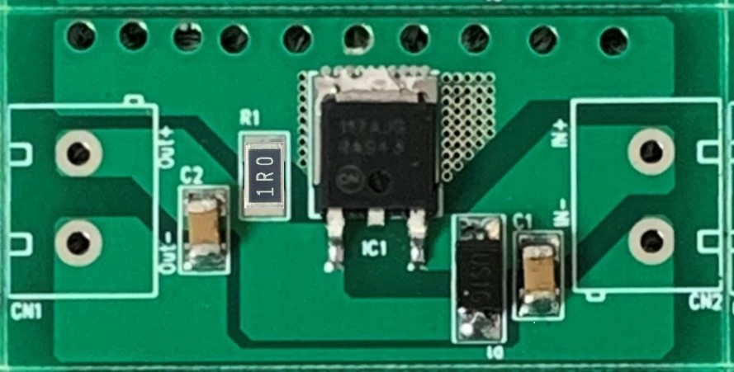
12V IN
LED

R1 sets the current limit for this device, I call this “Rset” and it is now used in many other devices.

Example: If you need
50ma then Rset = 25 Ohms
100ma then Rset = 12.5 Ohms
200ma then Rset = 6.3 Ohms
300ma then Rset = 4.2 Ohms
400ma then Rset = 3.1 Ohms
500ma then Rset = 2.5 Ohms

I would not recommend going past these values as then the Heat dissipation will become an issue and the PCB will need to be Heatsinked. The absolute limit of this device is 800ma.

