Complementary feedback pairs (known as a Sziklai output stage) are often used in the output stages of power amplifiers due to their advantages both in linearity and bandwidth when compared with more common “Darlington emitter follower type output stages”.
They are especially advantageous in amplifiers where the intended load does not require the use of many parallel devices.
Complementary feedback pairs, Sziklai, can also have the benefit of superior thermal stability under the right conditions. In contrast to the traditional Darlington configurations, the quiescent current is much more stable with respect to changes in the temperature of the higher power output transistors vs the lower power drivers.
This means that a Sziklai output stage in a class A or AB or B amplifier requires only that the bias servo transistor or a couple of diodes to be thermally mated to the lower current supplied, Pre Driver transistors

That way they do not (and should not) be placed on the main heatsink. This potentially simplifies the design and implementation of a stable class AB amplifier, reducing the need for large emitter resistors and significantly reducing the number of components which must be in thermal contact with the heatsink as well as reducing the likelihood of thermal runaway.
Optimal quiescent current in an amplifier using complementary feedback pairs also tends to be much lower than in Darlington-based output stages, on the order of 10mA to 50ma vs 60-100mA+ or more, for some emitter follower output stages.
This means that idle power consumption is on the order of a few watts versus tens of watts for the same performance in many cases.
This is a very compelling reason to use the Sziklai pair in cases where output power is moderate (10W - 80W), where fidelity is critical and relatively low idle power consumption is desired.
How does it work?

Most of us have seen the classic Darlington Pair in which two transistors of the same type are connected as shown below. It was invented by Sydney Darlington and patented by Bell Labs in 1953.
This arrangement behaves like a single transistor with a current gain given by the product of the gains of the two transistors.
Gains of a couple of thousand are easily achieved, this is really useful when driving high-powered loads such as in audio amplifiers and the like or where you have a small signal requiring to drive say a relay.

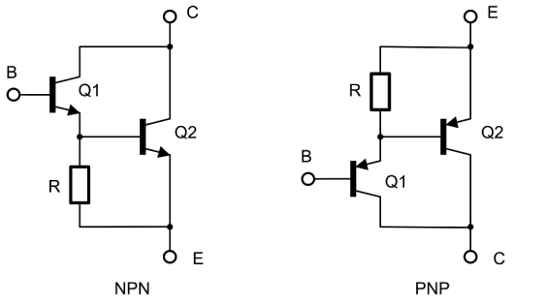

The classic Darlington Pair uses two NPN (img left) or PNP (img right) transistors behaving as a single transistor.
The resistor (R) is not necessary but helps with then turn-off speed and stabilization of Q1’s collector current as described in the text.
Firstly, the Darlington transistor cannot fully saturate further that one V_{BE} drop (about 0.6V) no matter how hard we drive it. This is because Q1’s emitter must always be one V_{BE} above Q2’s emitter, (or below in the case of the PNP arrangement), and even if Q1 could saturate to zero volts, the Q2’s collector can never fall below this.

What does that mean? There are two transistors here so the total Vbe is between ~ 0.6+ 0.6V.
So that means the base-emitter voltage of the Darlington will be the sum of Q1 and Q2’s V_{BE} or around 1.2V. Further this V_{BE} will change significantly as the collector currents of the two transistors changes.
(In 1954, Jewell James Ebers and John L. Moll introduced their mathematical model of transistors and to be able formulate equations.
The “Ebers-Moll” model tells us that V_{BE} changes by about 60mV per decade change in I_{C (current).}
This modelled theory allowed them to work out the values of the collector I_{C} and I_{E} emitter and I_{b} base junctions as well as the base currents for an NPN transistor.
Here, the Ebers-Moll equations will be most significant in Q2’s V_{BE} as it varies from virtually zero to the full load current.

Enter the Sziklai Pair as shown below, sometimes called the “complimentary pair” for obvious reasons.
This set up, was invented by George Sziklai around the same time as the Darlington.
It too behaves like a single transistor with a current gain equal to the product of the gains of the two transistors. Similarly, the Sziklai can’t saturate further than V_{BE} for the same reasons as the Darlington.

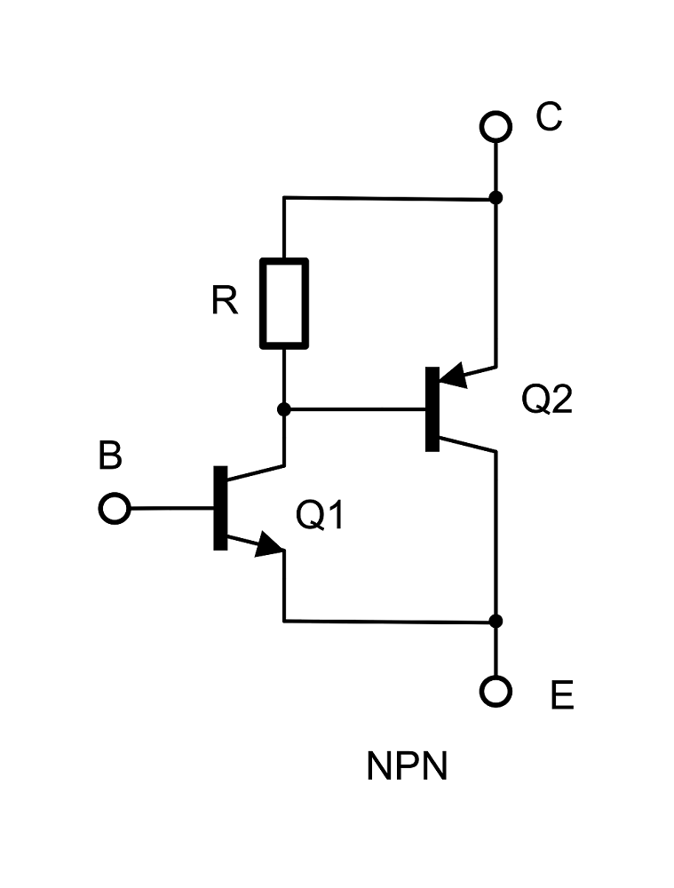

But as the Sziklai Pair uses its transistors in a “complementary polarity” to achieve a similar gain as the Darlington Pair, it has an improved Vbe characteristic. The base-emitter junction of Q1’s is more relative,
And so the overall V_{BE} is equal just to Q1’s V_{BE} or 0.6V.
So the Sziklai pair does not suffer as badly as the Darlington in terms of V_{BE} requirement.

The Sziklai’s V_{BE} is also more stable with load variations than that of the Darlington. This is because the overall V_{BE} is not impacted by Q2’s collector current but defined only by Q1’s collector current, which does not vary nearly as much.

Additionally, Q1 will typically operate over a lower temperature range since it does not see the same level of current as Q2, further improving V_{BE} stability.
Here, the Sziklai pair has an advantage over the Darlington in terms of both the level of the V_{BE} in its stability of its V_{BE}. This also gives us a slightly wider bandwidth in audio stages.

This effect is often exploited in the push-pull output stages of simple Class A, AB & B audio amplifiers where the lower and more stable V_{BE} makes biasing much easier.

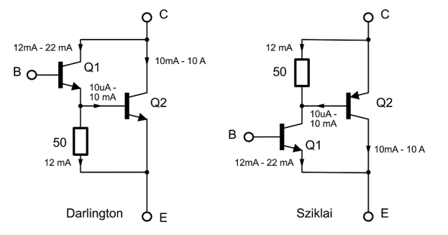

Let’s take a look and see how this works in practice, but note this is a hypothetical example.
I have rewritten this section in voltages for those to attain a better understanding.
Most of the analysis is identical for the Darlington & Sziklai cases. We want an output current that varies over the range of 10mA to 10A and have transistors with current gains of 100 and base resistors of 50 Ω.
The total gain becomes 100 x 100 or 1000:1

The Darlington, both Q1 and Q2’s V_{BE} are in play, so the overall V_{BE} will change by 195mV over the 10mA to 10A range.

In the case of the Sziklai, only Q1’s V_{BE} matters, with a variation of only 15mV over the same load range—more than an order of magnitude and better than the Darlington.
Why ?
In the case of the Sziklai pair only Q1’s Vbe (0.6V-0.7V) contributes to the overall requirement of flowing the 10ma- 10A, While the Darlington’s will require 2 x 0.6V-0.7V to flow the same current.

The Down Side:

As with all things and circuits, there are positives and negatives to each configuration.

The Sziklai Pair has around 3-5 % less total gain compared to a similar Darlington pair.
The Darlington pair can be bought as a single package offering a Single High Gain Transistor,
but there is no Sziklai versions.

The Sziklai Pair is more prone to oscillation then the Darlington’s.
This is the case, where the load being driven, is of a higher impedance, so care must be taken in circuit design and its implementation.
The Sziklai Pair’s don’t like many being paralleled and parasitic oscillations is easier to occur whereas the Darlington’s do not.
Paralleling the Sziklai Pair requires more work to keep them stable. So don’t skimp on the “pf” values when using “miller” capacitors to stabilise any oscillations that may occur in circuit designs.

The Darlington pair can be paralleled to offer Higher Power and with less stability issue.
If you are intending to build a simple, lower power, high grade amplifier, <100W, then the Sziklai pair has the advantage.
If you are intending to build an amplifier with heaps of “Raw Power” >100W plus, then Darlington’s,
ie multiple paralleled BJT’s or Mosfet’s are the best and most reliable way.

There are many of these types of amplifiers around now.
I suggest you listen to both types if and where possible.
Good reading is available all over the internet.

A special thanks.
RCA application notes, Motorola, Philips, National Semi,
JLH to Hiraga, to Borbely & Lender, Cordell and Self.
PE/Elektor/ETI/EA/SC magazines
Rod Elliot’s Amps, to Build Audio Amps, just to name a few.

Updated wording and spelling 11-2024

