This document has been written to try and dispel many of the fallacies found on the internet these days.
While scouring, over many hours, through the internet, I found a lot of the circuits for amplifiers are based on, copies of a few, then have added a few extra 0’s in “Watts” ratings and some circuits are modified in such ways that they will simply NOT work, and I do not feel it is fair to the original authors to have their work copied and published with complete disrespect by some, as well as to use fake output figures to make a sale!

For Example:

This circuit below was devised by RCA and has been around since the late 60’s and early 70’s,

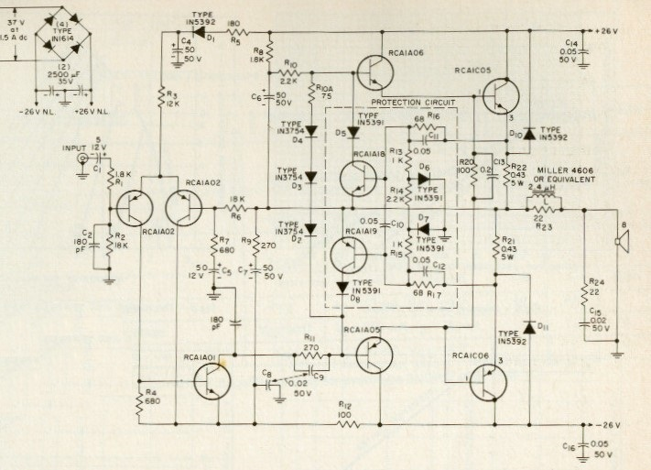

This circuit has worked well for many in the past, millions of amps were made based on the design, with some changes by different designers to suit their needs. But it clearly shows the seller that posted this one below, has no Idea of the basics. He/she is advertising this schematic and rated it as a “300W amplifier circuit”!

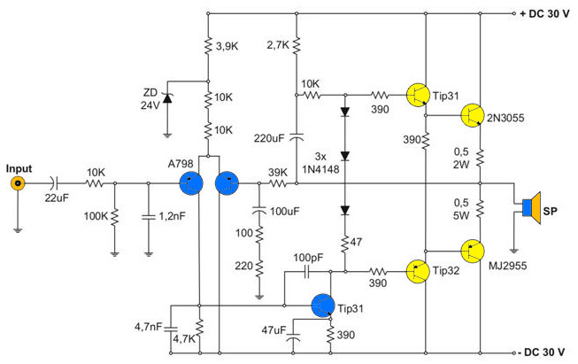
Don’t be fooled: A “300W” amplifier requires a minimum voltage across the speaker of V²/R = 300W and this assumes there is no sagging or loss from its power supply. From the voltages shown above, we have +/- 30V.
Only one half of the voltage is used in calculation as it is the peak voltage of the wave form, measured to either high +30V or down to -30V. If we place these voltages into our equation then we get, 30V x 30V / 8Ω = 112.5W! That’s taken from Ohms Law and under perfect conditions. Then, generally there are losses in the power stages and the circuit used. For a Class A/B amp it has an efficacy ratio of 45 - 65%. So, when you take your 112.5W then multiply x 50% (a good and simple rule of thumb for older parts) we get 112.5W x 50%= 56.25W.

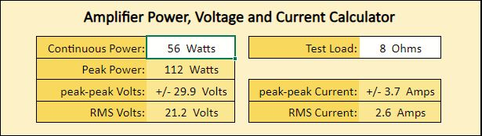 Courtesy Geoff

Or to calculate it: Vpeak x 0.707 = Vrms, or 30V x 0.707 = 21.2Vrms across the 8 Speaker, and that’s a DC component, but our amplifier plays AC wave forms……this is where it gets more complex, so I won’t baffle you with it here.
Either way, this is clearly, well short of 300W! Please note that “Watts” is a “squared component”, it measures the consumption of a product, the old school terminology is Output Gain, and it is expressed in dB (decibels).
But using “decibels”, for most, is a difficult “term” to understand.

Circuit Issues:

This Circuit is still a popular amplifier configuration,
It uses the older 2N3055 and the MJ2955 transistors. These were a great transistor in their day, 1970…
Thousands of amplifiers and power supplies were made, including my many older ETI 480 Modules and a few hundred 13.8V / 20A power supplies, but that was in 1978-1983!
These transistors have a voltage limit of 60V so pushing them past +/- 30V is asking for trouble….there are now many newer types around including the cheaper TIP35C and TIP36C @ +/-35V, These are ideal for this voltage or you can use the popular 2SA1943 & 2SC5200 @ +/- 40V. Both types are easier to mount to a heatsink and are way cheaper than a pair of current & genuine, “On Semi 2N3055G/MJ2955Gs”!

Looking deeper, There are also issues with the two resistors “here and there” in the LTP circuit, has someone copied this fudged diagram? In the LTP section, what’s wrong with using a single 20K or 22K resistor?
Maybe one of the 10KΩ resistors was supposed to be a “Trim Pot” to “help” adjust the voltage offset?
Then, the 10K resistor in the bootstrap circuit is simply too high, this should be 2K7 to 3K3.

So if you do wish to use this at +/- 30V then,

A Zener diodes, nice products but inherently make some small noise, so add a 0.1uF/100V capacitor across it.
B Fix up the 2 x emitter resistors and both should be 0.5Ω 5W types of same type.
Note: The Transistor combo used is a good solid performer when they are used inside their SOAR parameters. The Emitter resistors can be dropped safely to 0.22/5W types for a few extra watts.
C Ensure the 3 x 1N4148 diodes are touching the Output Transistors Housing or mounted on the heatsink, they need to “feel” the heat generated to adjust bias to the output transistors.
D Check the amplifier is drawing a safe value of 50 – 60ma in the bias when powered up.
If not, some adjustment will need to be made to the 47Ω Resistor.
E The gain of this circuit is determined by the 39K resistor / the 100 + 220 in the feedback loop….
F If the gain resistor is 39K then you should also match this to the 100K on the input side, otherwise you will get some voltage offset reading at the output...
G The input resistor at 10K seems rather high, OK for some old school CD players but it will be too high for a modern iPhone or pad. 1K should suffice here.
E The 1.2nF capacitor on the input is high so the cut off frequency will be low, I suggest a 220-330pf capacitor here.

The heatsink should be the size of your shoe! A Size 10” !! Not smaller, otherwise the output transistors will cook to death, especially if the amplifier is used under heavy loaded conditions ( like 4 Ohms) or in a hot environment!
If your heatsink rises above 75°C then you have a serious cooling issue.

Another piece of rubbish:

This Circuit below is a typical circuit now seen a lot on the internet, full of errors and BS.
This one, is seriously flawed.

A The transistors in the output stage are incorrect and mostly wrong.
B The Output Power Transistors should be a matched pair of NPN and PNP types.
You cannot mix BD139 with TIP145 in the output stages.
TIP145 is a darlington, it does not have a proper partner in this circuit below ….
So here I would use the reliable TIP35C/TIP36C up to +/-35V or the 2SA1943/2SC5200 up to +/-40V.
C In the bias chain, the 82Ω resistor should be joined in the diode string not to the output Line.
D The end point of 3 diodes sould be joined to the “collector” of the VAS transistor BD139,
E The lower pre-driver labelled BD139 Transistor, and it should be a PNP, a BD140 (not a BD139) !
F Then there is a 10Ω 5 W resistor, inline with the speaker, what is that for ???
Or did we forget to add the “Coil-choke” for the Zobel network ?
G 300W ?? Well that’s debatable ! Try ~100W with +/- 40V line voltages and 2 x 2SA1943 + 2 x 2SC5200
In the output stages.

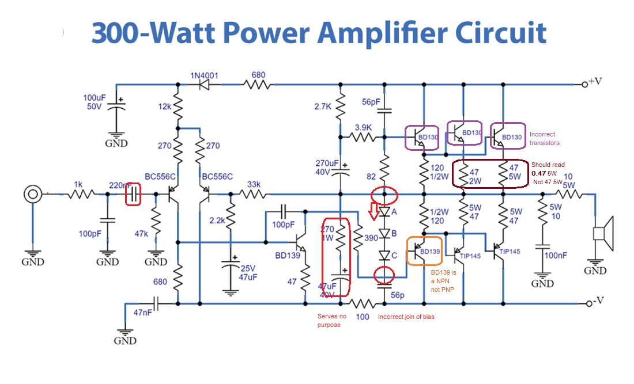
Do not make this amp circuit , it is completely wrong and rubish

And fine another example …

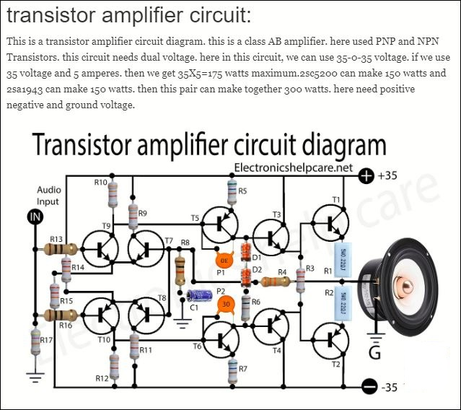

While the overlay looks nice and simple, I can see there is some translation issues but the circuit is a basic Symetrical 75W amplifier. Some how its output got rated to 300W! Don’t bet on it.
Again use the same formula, 35 x 35V / 8Ω = 153.12W then multiply this x 50% = 76.5 Watts, at best!
In the circuit above, it has no protection for any DC component on the input line, so add a 3.3uF-4.7uF/25V
“Bipolar capacitor” (this isolates any dc from either the input side or the amplifier) for safety.
You cannot biuld these things and simply really on “Hope”.

Note: 75.6W output from any amplifier is sill a very good value.
Most people with good speakers would be very happy with that and it would be loud enough to be heard…… next door.

Then, we have “the copiers” who copy a circuit made with the mistakes, this circuit below has a mistake in that R17 is labelled as 5.6Ω. Clearly this is a simple typo, but both Resistors R17 and R18 should be the same in value of 5K6, but even these two resistors are too low in value for a “+/- 40 V” rail voltage and should be around 10K
( 80V-1V T1, / 10K = 7.9ma),
There is also no reference to the “opamp’s” power supply. So if you made this, as is, and connected it to the power rails (+/-40V), your fuses (3A) would have poped, if not first the op-amp and the T2-BD139 transistor!
Note: Most “Op-Amps” have a maximum of +/- 15V, some have +/- 18V and a few go to +/-24V dc.

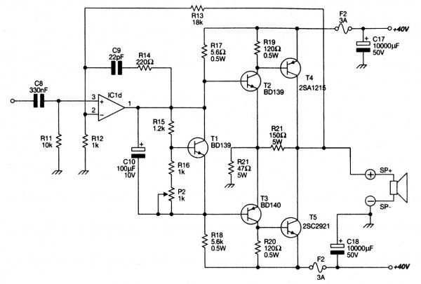

We can go further into it.
If you make this amplifier based on the circuit above, then, ensue the Op Amp is powered between +/-15Vdc (most audio opamp IC’s) to +/-24V, depending on the op amp you use. (safe and proven).
When you power up this circuit do not go to the full +/- 40V rails. Set your supply to stop at +/- 18V until you check the bias <20ma and look for any high frequency oscillations.
Check none of the components are heating up. Then allow the amp, time to warm up.
If all is ok, then you can continue to head towards +/-38V, ( although not recommended, +/-35V is safe) then set your bias to 50-60ma when the amp has had time to warm up.

The 2SA1215 & the 2SC2921 Transistors were a gun pair, awesome product in their day but these have been superseded now and the rest are generally “fakes”.
Another issue is the BD transistors are at the maximum limits of 80V and they are running high which will require mini heatsinks. They also appear to have no “Miller Caps” between the C’s & B’s of the BD Transistors.
So with this circuit as it is it may oscillate at that voltage.
Make sure your main heatisnk is large enough to dissapate the heat, again a size of a 10 -12” shoe, minimum!
As a +/- 38Vdc input voltage and with an 8Ω Speaker this would equate to 38 x 38V / 8Ω x (50%) = 90W.
Again, Not the 200W as advertised on that site.

Another dangerous circuit:

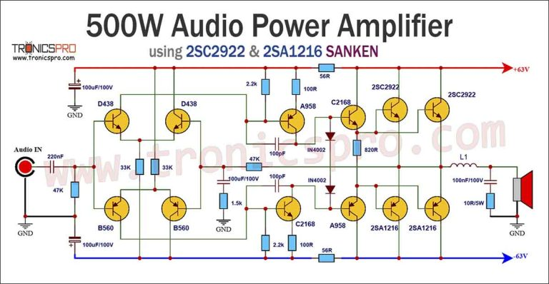
Wow, 500W of audio power ! Sounds great but the reality is, I don’t think so.
Below are some charts from the manufacturer (Sanken-JP) showing the “absolute maximum ratings” of these main output transistors. These were made in a Silicon Epitaxial Planar process, a favourate with me. These transistors were a great product and they worked very well, but that is when they are used within their SOAR limits.
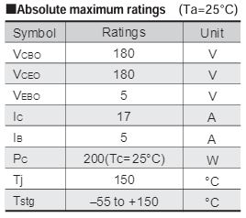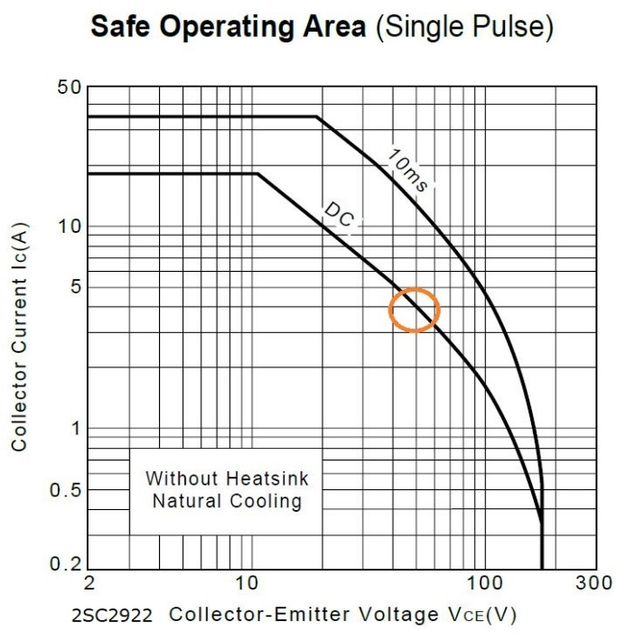
These charts show the limits of the Voltage and Current in both directions, and you need to find the sweet spot in between.
Here we can see the transistors “absolute maximum” power rating for this transistor is 200W, read @ 25°C.
If you follow it, it is the Safe Operating Area as shown in the 2nd figure,
That is the maximum limit, it is a balance between the voltage and current used.
From above we have 50V and 4A. that is 200W, Still this is a very good rating for any audio power transistor.
In Practice, you use should never pass 70% of these values.
Start off with amplifiers of around +/-30 to +/- 40V, these are easy to get going.
When you have gained some experaince then proceed to bigger things as well as spending more $$.

There is a basic rule of transistors that we use, it is ~70%. That means you do not run them past this point for reliabilty, heat dissipation, as well as secondary breakdown. So by rule of thumb, 70% x 200W = 140W.
A balanced approach of voltage and current into the speaker is required, by any amplifier circuit.
When looking and checking the SOAR charts, you need to stay min 30% below these “Black line” limits or the transistors could blow up under demanding loads and in a heated temperature environment.
Specifications in Data Sheets are quoted at 25°C, but the reality in a working circuit is 65-75°C !!!
There are two other main issues to understand.
- There is a thing called Secondary Breakdown when pushing transistors near their limits,
but this is for another chapter.
- Speakers of any value in Ω’s will drop when in use, an 8 Speaker may be 6Ω at 400Hz.
A topic on its own.
- For the circuit above, do not go past +/- 50Vdc !! as the front end transistors will also pop.
Their limit, 2SB560 and 2SD438 is 100V max and you have 63+63 or 126V...(A lethal Voltage)

Note: There is no Emmitter Resistors in the main output transistors.
Pairing Output Transistors requires emittor resistors, so one pair does not do all the work (and over limit) while the other pair does little. While you can get away with this approach with some Mosfets, Bipolars do not.
Use Hope? So add 4 x 0.22Ω x 5W, recommended.
There is another issue, this diagram only appeared in the last few years, but these transistors have been obsolete for 12+ Years! Are these transistors copies ? fakes ?
That said, this is a decent basic design amp, although I would use a proper Bias Circuit (add a BD139 + Trim + resistors + 0.1 250V Cap) instead of relying on the diodes, especially at this voltage and level of amplifcation.
A safe value of +/- 50V dc / 8 Ohms speaker will give you (50 x 50 / 8 ) x 50% = 156W ! and that’s very good.
So how does one get 500W ??

Here is another beauty !
Wow. A 300W Subwoofer Amp,

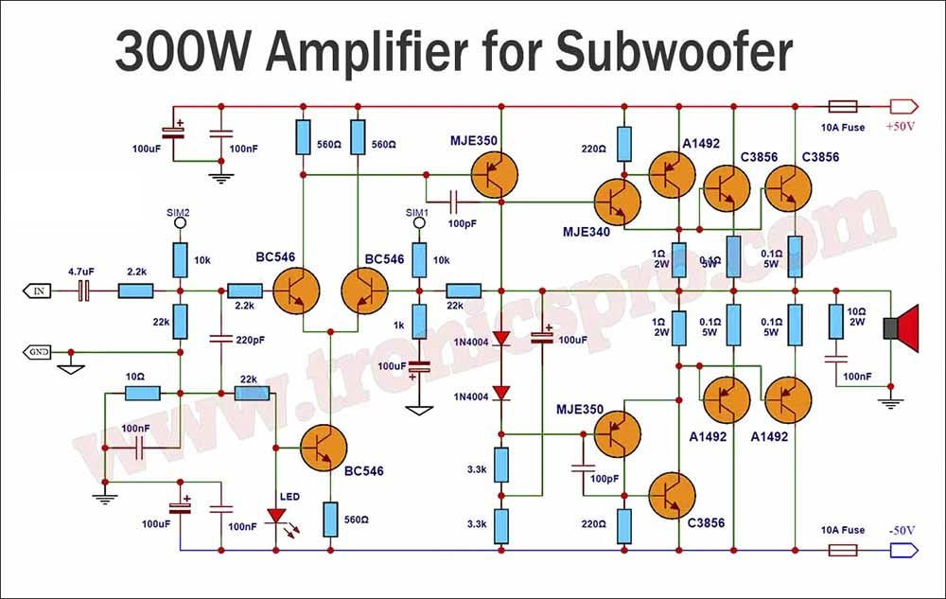

A The LTP circuit consisting of the BC546 Transistors is very good, but their safe limit is ~ +/-35V.
The Vce limit of these transistors, BC546, is 65V! You need to understand that at +/-50Vdc rails there is 100V across the top and bottom voltage rails. Although many would tell you that the transistors “only see the top half or the bottom half of the wave form “this is partly incorrect”, at first turn on the transistors may not balance as quick as you think and these could pop faster than a bullet, (use 2N5501 & 2N5401 minimum or better, MPSA42 & MPSA92).
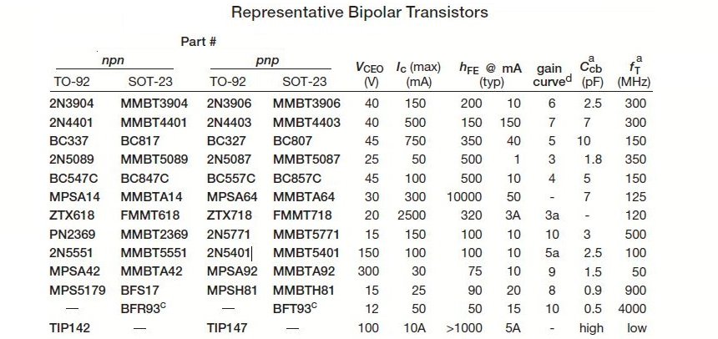
B The MJE350 has been around for a long time , like 2N3055 and is not the best choice for audio amps
these days, use a MJE15031/32 or a pair of 2SA1837/2SC4793 or the newer TTA004B/TTC004B.
C The Emitter resitors below the 2SA1492 and above the 2SC3856 should be 3.3 or 4.7 Ω not 1Ω.
D Limit the voltage rail to +/- 45Vdc and the fuses to 5A each for saftey.
E Do not connect the Diodes to the output line … as shown above , this is wrong,
The Bias Diodes need to sit next to the output transistors and be thermally bonded to be effective in reducing the Bias as the Amp gets hotter, The “Bias” must be checked when the amp is powered on for a while and measured to be around 30-80ma per main output pair of transistors (a safe value).
F As above use a proper Bias Circuit ( BD139 + Trim + resistors + 0.1 Cap) instead of relying on the diodes.

Again someone has taken a simple circuit, based on RCA designs and changed the parameters to suit his ego!, Although this one is an ESP circuit. Rod gives you all the info required and its free !

This one is new.

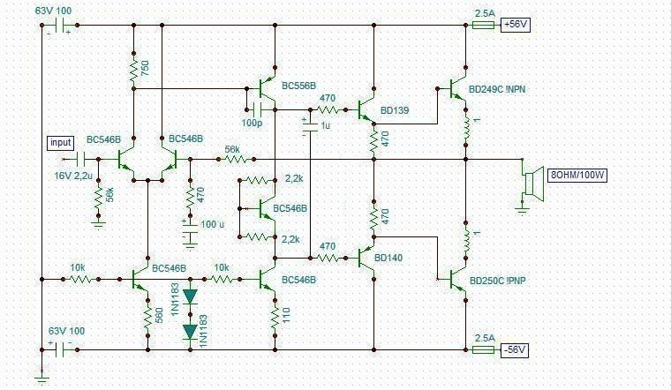

A 56Vdc + 56Vdc is lethal !
B All the transistors are well over their limits for this much voltage, use +/-35Vdc. Max
C There is no way to easally adjust or trim the bias in this format.
Remove the 2K2 resitor in the lower section and use a 2K MT trimmer.
D The 470Ω Resistors feeding the bases of the predrivers is high , reduce these to 47Ω.

This design will work and work well, but with a few suggestions:
The Vas Transistor could be changed to a 2N5401 or better a newer TT004B.
KSC3503 works very well too if you can find them.
The Feed Back resistors would be better at 22K-33K from 56K, a little lower gain but wider bandwith.
The 10K resistor feeding the Vas Limit section, BC546B should be no more that 1K
The Diodes cannot be 1N1183 these are High power Stud Diodes…..they should be 1N4148 types or a standard green LED.
Once you have the issues then you can also reduce the “Re” emmitor resistors at the BD249/BD250 stage to 0.33- 0.22 , these will work well in general and give you some more power in the output.

And another circuit:

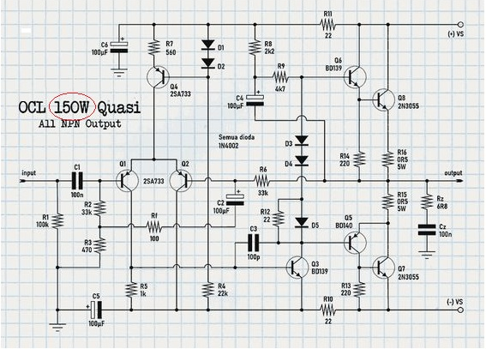
This circuit uses the older 2N3055 transistors in a quasi complementary topology. While these circuits were popular in the late 60’s through to the mid 70’s and were great in their day (1970). Again 2N3055’s are rated to a maximum of 115W….that is the maximum power of the transistor and is not the final output power. Go back to the formulas, If use 30v x 30V / 8Ω that = 112W, which is the absolute limit of this transistor !
Most modern power amplifiers use + and – voltages in their power supplies to provide an even swing of signal between the voltage rails. The BD139/BD140 is a great transistor and well used by millions.
These BD Drivers have an absolute limit of 80V, so that is +40V and -40V so you must stay below this level. Again If we run this circuit at +/- 30V ( a safe figure) we will get up to 55W. Which is still very reasonable and reliable.
Although many say that using the amp above, into a 4Ω load, will double the output power, that’s in theory only.
The power supply would drop voltage under the higher load of 4Ω’s. Advertised as 150W ?? Remove the “1” from the front and your at a good 50Wrms.
As you can see our amplifiers above, have in some way, failed to provide what they claim.

The above circuits are just a few of 1000’s now on the internet and this is not healthy for learning, building and/or understanding!
As a safe and basic rule of thumb, most modern pairs of output power transistors work reliably, in the 60W-100W range, per matched NPN /PNP pair, so if you need 200W then you will need parrallel 4 x 60W types or 3 x 100W types and use the voltages shown in the chart below.
This chart repesents the voltages required across an 8Ω Load
Power W | 10 | 20 | 30 | 40 | 50 | 75 | 100 | 200 | 300 | 400
V Speaker | 8.9V | 12.6V | 15.5 | 17.9 | 20 | 23.63 | 28.3 | 40 | 49 | 56.5
V Amp -/+ | 12.5V | 17.8V | 22V | 25.3V | 28.3V | 34.5V | 40V | 56.5V | 69V | 80V
Rec Fuse | 1.1A | 1.5A | 2A | 2.5A | 3A | 3.5A | 4A | 5A | 6.2A | 7A

To work out the output wattage, you will need to get these voltages (shown above in V speaker) from the output of the amplifier across the speaker.
To work out the actual wattage of the amplifier, you need to measure the voltages of the wave forms coming out from your amplifier and measured across an 8 Ohm Load.
Most, commonly use a 1Khz sine wave. This sine wave is placed at the input and then its viewed on an oscilloscope, the input is driven up to the point where the wave form, at the output, starts to clip.
That is your measuring point and the realistic limit.

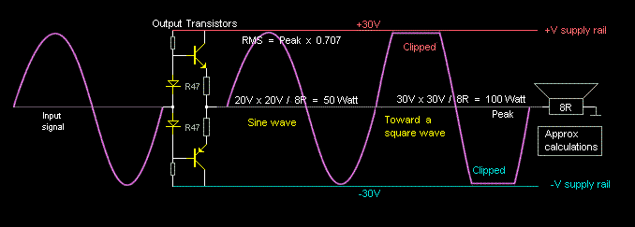

Stick to building your amp for a balance of sound quality and reliabilty over “raw power”.

Mosfets are a little different, they can run at higher currents for their given voltages, switch at higher frequencies and can supply a more power and these require some PCB space for capacitance to stop them from oscillating.
For Audio use, a safe limit on these is around is 70W -120W per pair of matched devices.
And remember, you need to cool all these devices or there will be No amplifier parts left to amplify anything !

Notes:
At 200W of audio power will need to dissipate a lot of heat very quickly through very large heatsinks.
An example of some cases for 200W is shown below. Yes they are big, 200W is 200W!
Although many use smaller heatsinks and “Fan forced cooling”, that is generally used in commercial areas, where its not heard. At home you may hear it purring along… so using a bigger heatsink is still the best choice.
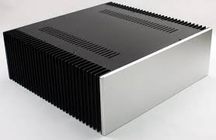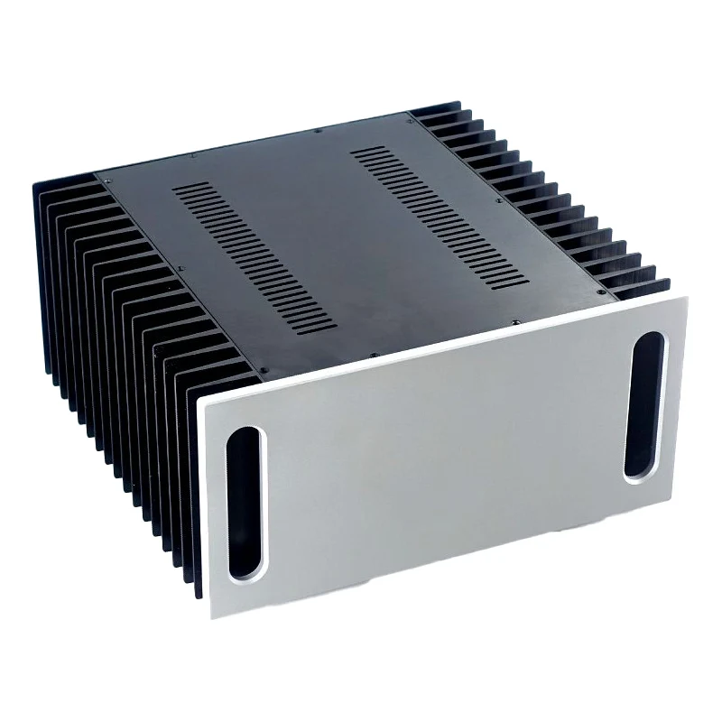
The Industry has standards. In any of the above amplifiers, being made, sold and quoted, they must be factual.. So when these people start quoting figures you should check these basic concepts before any purchase.

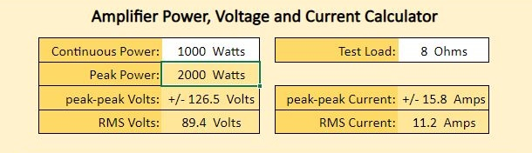

Firstly, I would want to check the Circuit, next are the parts used, are they what they should be?
This was not an issue many years ago but now it has grown into a big problem now!
Then the rest you can control, The Case, Heatsinks, Transformer, Power supply and a list of many other smaller items, including quality, flexible wiring. Shielded cables for the input, thick cables for power and speakers, connectors etc.
If you are buying the PCB, then Check the printed circuit board, to see if they are even capable of even carrying 15.8 amps. Check the capacitors are rated to the voltages or not, and if the transistors are Genuine or Fakes.

Although newer technologies like Class D are growing and becoming the norm, they still require the power supply to deliver the wattages specified.

The Power Supply:
This is by far most important part of an amplifier, without a good solid strong power supply, the amplifier cannot do anything. For the sake of many pages on this topic, I have limited to using the “simple types”, below.

Advantages:
Simple to construct and long term reliable,
Easy to build and with very low Interference and/or Harmonics.
The amplifier can generally deliver high power on peak demands, (due to the capacitors resorvior) which is just perfect for what is required.

Disadvantages:
The power into 4 Ω will not be twice that into 8 Ω, because the supply voltages, +/-Vdc, will fall (sag) with increased demands in current and hence reduce the voltage supplied in the amplifier circuit.
Not as cheap as PWM supplies, not as small in size, not as efficient.
Significant ripple maybe present on the DC output so your amplifier build will need careful attention in building it.

Simple Devices:

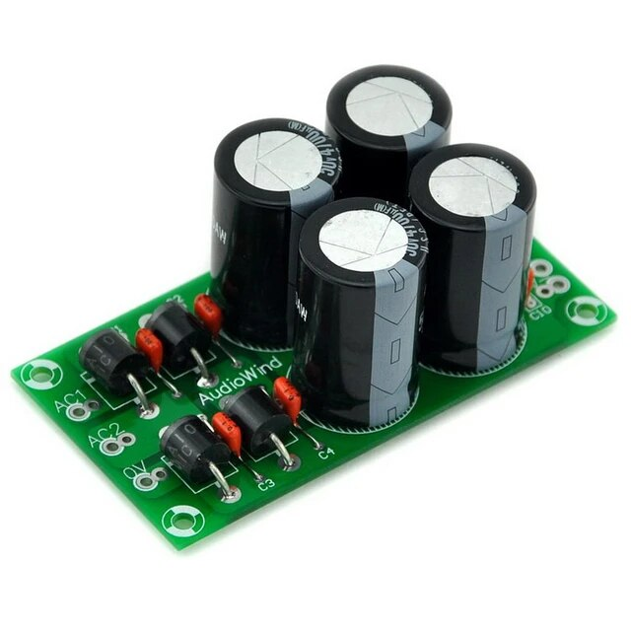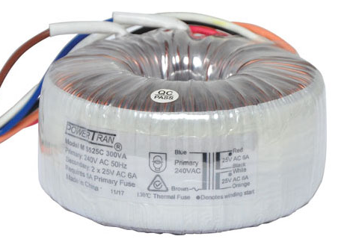

The mains transformer will be relatively bulky and heavy. You can use older transformers lying around if you can find them or use the newer Toroidal types. The Toroidal’s are better at regulation, but they will also cost a lot more to buy.
I do not propose to go through the all the details of designing a simple PSU at this point. Such detailed information can be found in standard Power Supply textbooks, but I offer below some hints and warnings relevant to audio amplifier design.

You will need a good quality transformer, a large bridge diode or bank of 4 x Big Diodes, some large capacitors and some smaller value types for HF filtering. Then you will need a PCB as well all the connections and good quality flexible wire.
All these parts will determine the amplifiers total output power and its quality of build.
A colleague of mine uses a rule of 200uF per 1 watt as his rule of thumb in Amplifiers.

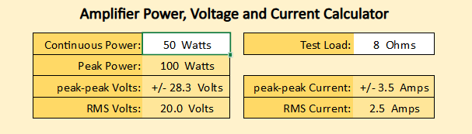

That equates to 200uF x 50 watts = 10,000uF. I use 2200uF per 1A required, as I build more power supplies than amplifiers, this is my general rule. So for 50W, 28.3V / 8 Ω = 3.5A then 3.5A x 2200uF =7700uf, and this is the minimum. If you add the 20% tolerance of electrolytic capacitors, then you get 7700 + 20% and that is 9240uF so its close to 10,000uF. That is per side of the voltage rails.

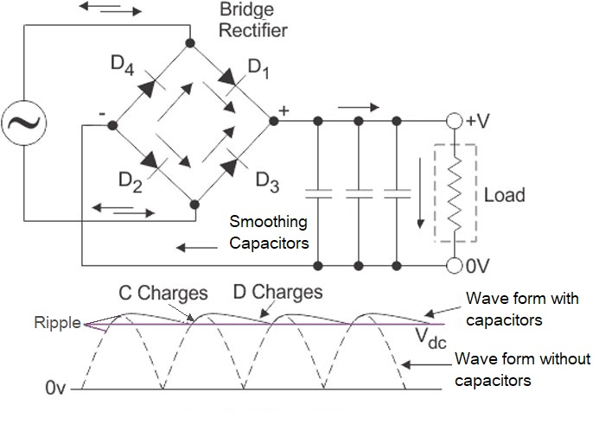
It is often claimed that large amounts of reservoir capacitance give a 'firmer bass', in listening tests. This can be true during large transients of deep bass notes or sudden solid drumbeats.
Jean Hiraga used batteries in some of his amplifiers at shows! Imagine, 24V and 50A of clean DC…
But this is a little difficult to steal a Woolworth’s trolley and have them carted all around the place for charging!

One of the main reasons for output power variations between many amplifiers, is based on the qualities of these parts and products used.
In mass production, the reality is it’s the price saved in $$ on each component and this is usually the case.

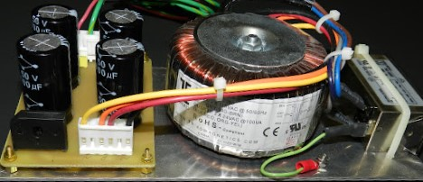courtesy of BAA

This type of basic power supply has inherent loses, the transformer and its regulation, the rectifier and its voltage drop, Capacitor quality and tolerances, temperature derating, life time in hours, all these play a part.
The good side, in a way, is the voltage will start to drop when driving the amplifier to its peak, it adds some safety into the overall equation. It does its job, and it does it well.

There are many transformers and parts to be found, so look around.
Most end up in rubbish tips which is a pity, as Transformers do not exactly “biodegrade”.
This is where there are other uncertainties. These arise in the voltages supplied to your home.
In Australia the voltage can fluctuate between 220Vac to 250Vac. I sit at 238Vac-246Vac in Sydney while in China,
I never saw it below 228Vac and never above 232Vac @ 50Hz… But this is not in all areas, they have issues too.
A good transformer will have no issue to manage these voltage variations (they simply run hotter at 246V),
These changes the final output voltage will have a difference in your amp’s total output power.
Note: Many transformers are made OS and rated at 220Vac-230Vac as opposed to the Ozzie ones at 240V.

Example:
A transformer is rated at 240Vac Input and an output of 2 x 30Vac, so your transformers transfer ratio is 8.
That means at a 220Vac input, it will give you ~ 2 x 27.50Vac output, or if the voltage rises to 253V, the output will rise proportionally to ~ 2 x 31.62V. This does not sound a lot, but it does add up as when it is rectified and filtered by the capacitors. At 2 x 27.5Vac x 1.414 = +/- 38.8VDC or at 2 x 31.62ac x 1.414 = +/- 44.7VDC so that is nearly +/-6Vdc and this is where some issues, can occur. Especially in a Large Class A amplifier or where you are running your parts at near maximum voltages. This has introduced another uncertainty into “Exact Calculations”.

There is another growing concern here of fake products, even the humble capacitor is now being tarnished!

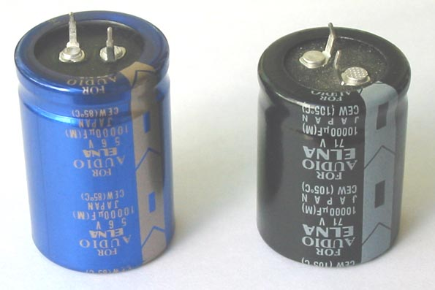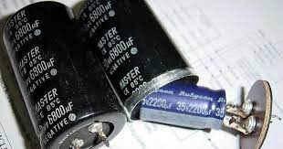
So please be careful at what you buy and check each part thoroughly. Buy from reputable suppliers.

I use a good twin power supply for testing amplifiers, although a +/- 120Vdc and 5 A can get expensive, or you can use a Variac with your transformer- based power supply. You must always start at a low voltage then adjust your voltages up to check for any issues before placing the full +/- voltage into the amp board you built.
That’s a challenge.

We need to continue to learn. Fuses is also an issue to look at.

They are a “dum product” but they are also a last defence of some form of protection from a catastrophic failure. “Dum” means they are not exactly what they say they do or how they even operate.
Example, a 5A fuse does not pop at 5A through it, Why ?
“A standard fuse may require two to three times its rated current to open in one second”.
That is a lot of current (in amps) flowing through your speakers if one or more of the transistors shorts out!
It’s rare but it can and does happen.
This happens a lot in automotive stereos, where speakers are and were driven by big amps to their limits.
From experience, the smaller ones, 4”, 5”, 6” or 6 x 9” used to short their voice coils to the speakers frame and as it was bolted to the car’s body/chassis, it caused an instant pop of the amplifier’s IC.
While the larger ones were driven to the point where they would burn their internal coils!
The fuses on the amplifier? Unfortunately, most had not popped…
I had replaced 1000’s of ICs (in head units) and Transistors/Mosfet’s (in Amplifiers) in the old days of car audio.

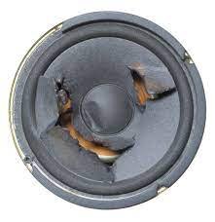 Ooopps ! 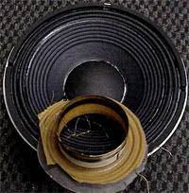

So, this is a contentious issue.
What size fuse do I use in my amplifier build. Use the chart above to get this information.
From good practice in the past, you will need 5 x fuses.
The most important one, is, and must be, placed between your mains power line connection to the mains plug,
i.e. on the mains side of the power transformer.
The other 4 are normally placed on the PCB’s of each of the amplifiers, in line with the power supplies voltage rail’s or wiring. Some good examples are shown below.

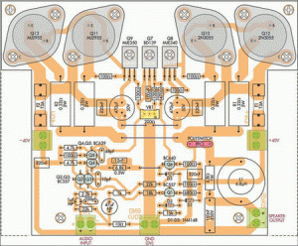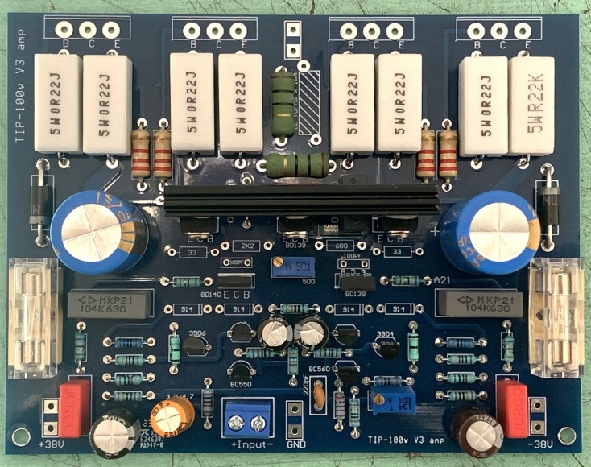

So here we use the formula Vpeak /R = Ipeak to give the peak current drawn by the amplifier board.
i.e. A 100-Watt amplifier will use around +/- 40Vpeak / 8Ω = 5A, although this figure allows the amplifier to drive the speaker to its peak rating, there are some factors here that need could be “challenged”. The “peaks to peaks” are bunch of sine waves formed across the load (the speaker) and this could well be into the “distorted zone” before anything happens with a fuse. Then shorted transistors will give raw DC from the power supply, across the 8Ω Speaker which gives us a “maybe” it will blow. And this can be affected if the power transformer is not able to deliver more that 5-10A under a short circuit.
Then we have the 8Ω Speaker… This is generally a “Nominal Rating”, that means it maybe 6Ω at 400hz…which also changes the equations. Again follow the chart below to give you a good and general idea.

Power W | 10 | 20 | 30 | 40 | 50 | 75 | 100 | 200 | 300 | 400
V Speaker | 8.9V | 12.6V | 15.5 | 17.9 | 20 | 23.63 | 28.3 | 40 | 49 | 56.5
V Amp -/+ | 12.5V | 17.8V | 22V | 25.3V | 28.3V | 34V | 40V | 56.5V | 69V | 80V
Rec Fuse | 1.1A | 1.5A | 2A | 2.5A | 3A | 3.5A | 4A | 5A | 6.2A | 7A

Fuses fitted in the speaker line.
This was old school thinking, may work, but not well…… At very low frequencies the audio signal can heat up and cool down the fuse element within a single cycle, causing the resistance of the fuse to vary as a function of the signal’s amplitude. So it’s not recommended.
So finding the correct value is not as easy and should be done in a measured environment after you have decided on your amplifier build and size. Here one must buy a quality fuse. Many fuses are not made well anymore and they can fail from poor solder connections inside the cap ends!

I use fuses in the amplifier’s power rails on the PCB, and I add a separate speaker protection circuit. Remember, someone out there may use your product in a church…..with pipe organs….or a Disco, where heavy loading of the amp maybe required and safety needs to be taken into account.

These values of wattages and the power levels I have given you above are all based on peak values, then take away by my basic, rule of thumb, 50% for class AB efficacy, this is done to get more realistic figure/number from the idiot circuits above. There are other variations that must be known.

An amplifier needs to provide power to frequencies between 20Hz -20Khz and into speakers of a 8Ω “nominal”
rating. “Nominal” means they go down be 6Ω, at their lower frequencies, this sort of throws the figuers out, which is why we leave some tolerance in our calculations.

In the old days we used RMS. This was/is a more realistic way to measure an amplifiers perfomance.
RMS or Root Mean Squared is the calculated figure given where the power rating is a constant, this is geneally
“the power peak” x 0.707. For example, 100W Sine wave gives peak power, x 0.707 equals 70.7W RMS.

RMS is still a good way to measure an amplifiers power performance and it still gives you a good and general idea of what you are getting. Rather than “Watts Peak or PMPO” !
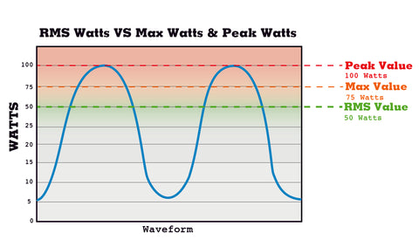
Many years ago I built many and sold amplifiers based on their RMS values, while the majority of other sellers sold them as PMPO. This was another “sales” and “marketing” falisy.

PMPO: Is an acronym for peak momentary power output. This term refers to the maximum power output achieved for a system under maximum and perfect conditions and probably just after the amp has exploded!
This is a simple marketing term with no real measuring standards.
The term was used to the extreme by car audio boof heads and by many early Chinese amps to make sales of their products. A 50W RMS amplifier was then rated as 500W PMPO ! What bull shit ..

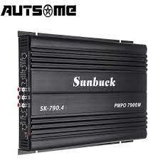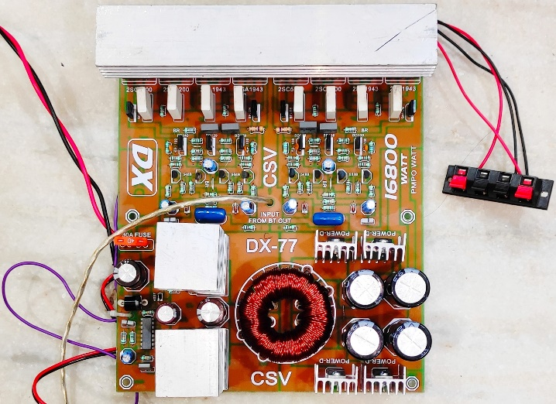

When building or designing electronic products, one has some “lee-way” into the design but the BS above, must stop at some point, so people do not get, mislead, ripped off, and/or supplied products that are built to blow up in your face! While these idiots like to brag about “an amplifier circuit with 1000W”, do they know what’s required to get 1000W ??

There is a simple and cool calculator on Geof’s the grey geek’s, web-site. It can help to give you some simple maths and understanding of an amplifier’s output, relative to the voltages and currents used and required.

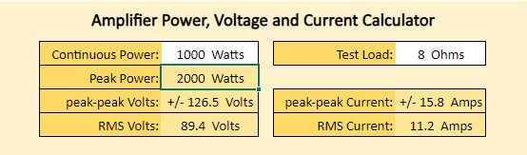

Please also note that +/- 126.5V is leatahl !! it can kill. So do NOT start at this level until you have built many amplifiers a attand a good experaince and understanding.

These circuit examples below have been around since the 80’s & 90’s. Note their voltages, these are around +/-35Vdc to +/- 40Vdc. They will deliver around 60W-100W of genuine power ratings. These are still availble in kit form.

The Velleman

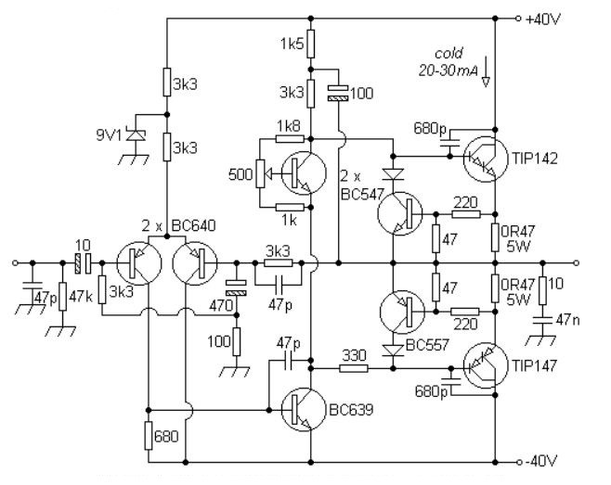

The PA-3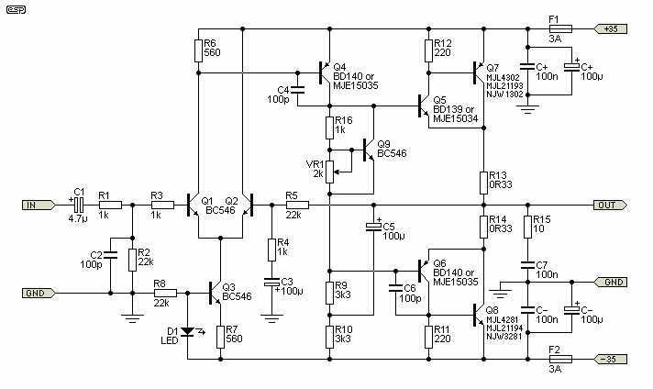

The SC 480 V2

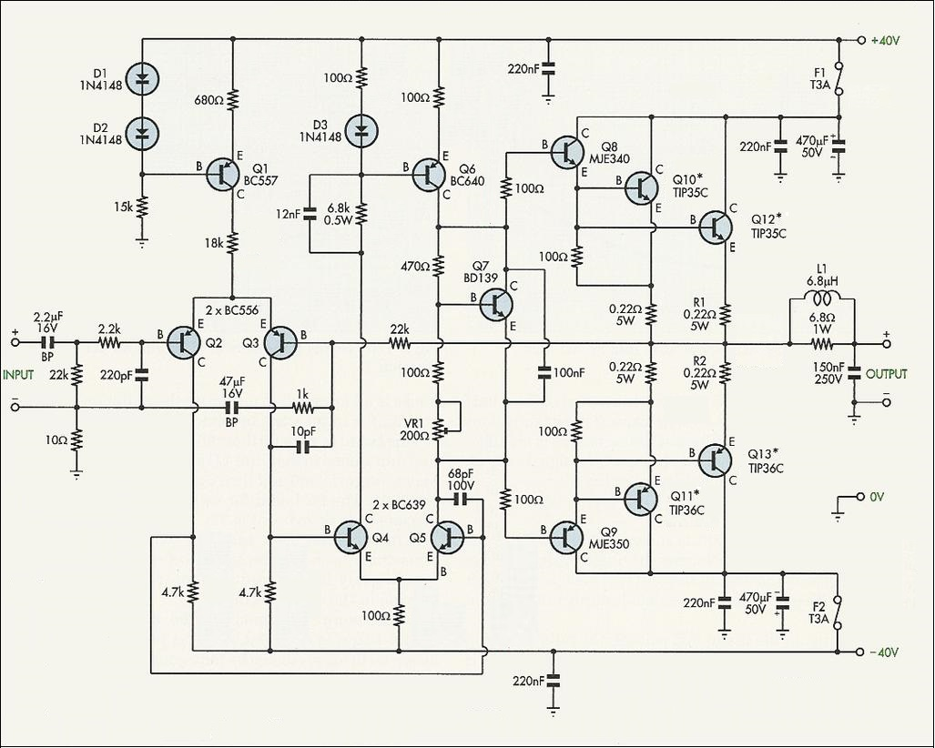

The three circuits above and their kits are very basic, but they work well and thousands have been made and have proved to be reliable.

A Basic Layout :
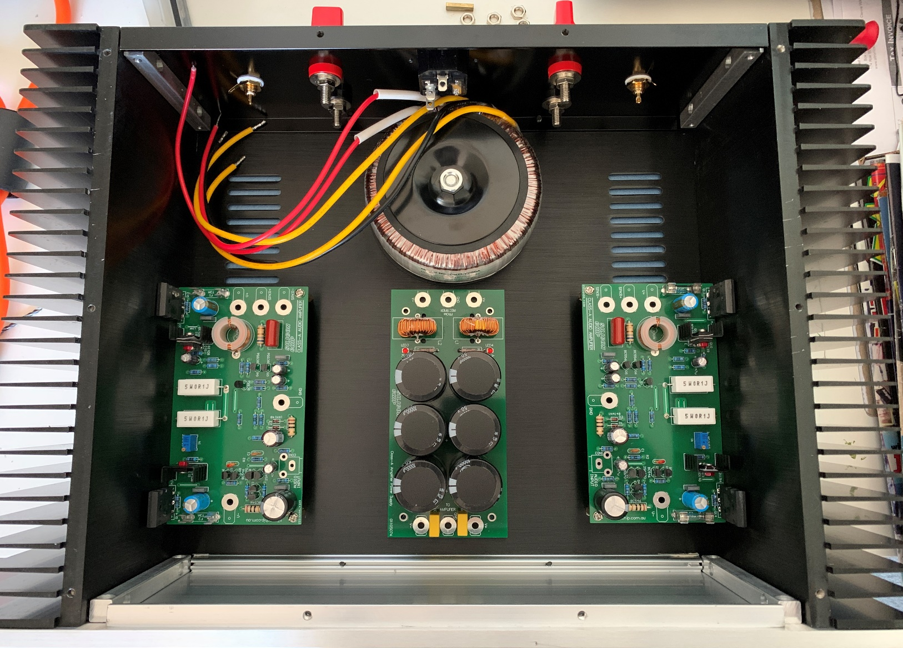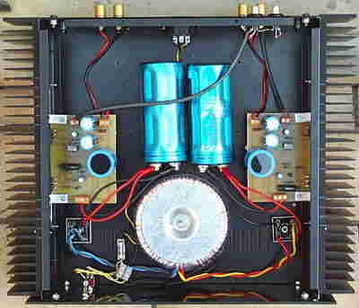
All good amplifiers don’t only need good quality parts but also to be made with a well laid out design.
I grew up during the 80’s, that’s many years ago, well before Internet, and it was all learnt from reading magazines, text books, buying parts, assembling kits, building the amplifiers and speakers.
These books were the building blocks of electronics and audio back then, and there were a great many kits made and sold during those years. Building your amplifier should be fun and provide you a great learning experience.
I started with simple amps of 25W then 50W to 65W then some 100 Watters (into 8Ω).
I lived and did the car audio scene, from the beginning, 20W+20W, 50W+50W, 200+200W and later 3000W+ during the late 80’s and 90’s.

So I suggest you read some of the better articles well before you buy or build any DIY type audio amplifier.

Many books and articles have been written by authors such as Paul Horowitz (the electronics bible), Douglas Self, Walter Jung, Bob Cordel, John Lindsay Hood, Erno Borbely, Nelson Pass, Bod Carver, James Bongiorno, Randy Slone, Jim Marshall just to name a few the bigger ones, these guys have spent their lives in theory and in practice.
Or see the many magazine articles from the kit magazines, like Elektor’s-Ton Giesbert, Electronics Today International, Practicle Electronics, Electronics Australia, Silicon Chip, Popular Electronics and the list goes on.

If you want a simplistic internet approach then look for Rod Elliott.
Rod’s site is down to earth, its simple and accurate, without “too much” theory.

If you wish to see higher power amplifier circuits, that have been made and tested with full test results,
then go to EG’s site. It is called BuildAudioAmps.com
EG, has spent his years in developing, building and testing many of these amplifier designs, their circuits and their parts used. He has also made modifications to some of the original circuits to improve the quality of the amplifiers, and its all there in colour, Free!

There is also Geof the grey geek, He has a lot of information on his web site which can help you through the hurdles of buying and/or building yourself a great system.

For me, I now reside in an appartment, I still have a Proton D1200 and its Preamp and I have several other amps and speakers, but I prefer to use my modified 25W Class A’s. “Clarity” over “Raw” power!

From Toshiba:
It is important to note that reliability is defined as a characteristic of a product and is expressed as a probability which includes three independent concepts:
[1] Lifetime,
[2] Spatial factors such as operating temperature and environmental conditions, and
[3] Evaluation parameters for determining whether or not the product performs as specified.
(i.e., the definition of failure).

This article is written to try and dispal the many myths that are entering a field of commercial, professional and the “do it yourselfers”, where people have devoted millions of hours developing, testing and writing information. I have no affiliation with the people above, other than they are to be treated with respect as they are all mentors to most of us in the industry.
People are obliged to be fair and honest in their claims of products made and sold. whether its sold in a shop or through the internet and especially to those who are not technically minded.

Updated spelling & wording V3.9-2025

