14/06/2026An Overview of Audio Amplifiers.

In the early days around the 1900’s, valves, were first invented. These devices were large and drew a lot of power, but they were also very good for what they did, and that was in audio and through to RF frequencies.
Through the 1920’s and to the 1960’s many amplifiers of all types and electrical circuits used them.
They were used by broadcast and recording studios, in TV stations and in TV’s, Stage productions, Rock bands and continue to this day.
Midway through the century, and as technology advanced, Transistors were invented, with germanium, but they were still in their infancy. Bell Labs and Texas Instruments pioneered develpment during this time while Sony in Japan “shrunk them” to create radios…
While they “worked” they were not strong enough to power large speakers and high amplification. For a while the valves still ruled.
Technological advances in the labs and production from the 50’s through to the 70’s was imense.
These transistor semiconductor devices progressed rapidly.

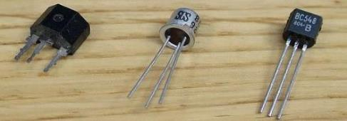

Audio transistors for TV, radios, RF sets, amplification, were changing daily. Increasing in reliability, quality and performance. Through the 70’s music and stereos in all its forms, grew into a frenzy of “must have” by the many.
Companies like RCA, Philips, Sony, National, Fairchild, Toshiba and many others, built their own products and became houshold names.
Philips EU had made many transistors for all market segments and examples like the BD131 and the BD132 were a good matched pair (NPN&PNP) for audio amplification. They were widley available as a set. But they did not have the power to drive more than 6-8Watts.
The original horse power 2N3773 NPN Transistor was a gun! It found its place in many power supplies but it did not have a good PNP version until later on when the 2N6609 came along, but these were still expensive.

During this time, the introduction of lower cost transistors like the 2N3055/MJE2955, 2SA627/2SD188 japan in their TO-3 Pakages, made it possible to build audio amplifiers with as much power of their counterparts, Valves. With the added benefits of lower prices and reliabilty.

As this market trend continued, many circuit designs became available in transistorised formats, making them easier to build, more reliable, more efficient and more power.
Magzines were very popular during this time of strong growth, and these devices were used to build many projects and kits for the DIY’s.
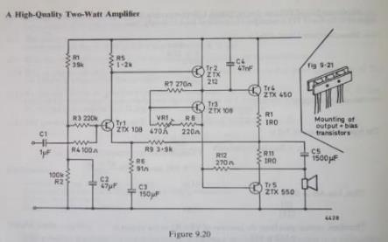
The big players like RCA, Motorolla, Philips, National, were offering many application notes and some were even offering home study couses. Manufacturer’s’ were proud to show off all their new products and designs in their “Application notes” sections of their books. Hundreds of circuits were devised by many to get some decent sound from a good set of “loudspeakers”. There were Electronic Bibles for anything you wanted to know!

Amplifiers: In a Nut Shell:

The first section shows the basic transistor amplifying the input, although it works “OK”, but its limited...

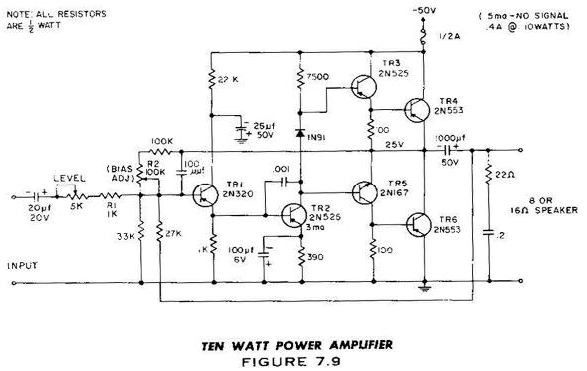

R Lender took this basic idea and added a second transistor (mirrored) to the first. He used it to help to balance the circuit utilizing feedback and in turn help reject unwanted noise We call this an LTP stage. This then feeds the signal into another transistor. This transistor then amplifies via a larger voltage swing, its called the Vas. Above the VAS transistor sits Mr Miller’s capacitor. This is important as it controls the gain at higher frequencies and inturn reduces the chances of the circuit “oscillating”.
But if this part is too large then it has an effect of the amplifiers “Slew Rate”.
A voltage is then required to keep a certain amount of current flowing through TR3 and TR5. This part is the Bias Stage. The two transistors require 0.55V-0.65V each to turn on and work, although some relied on just signal (Class B) it can add to distortion. As this circuit above has two transistors to be feed, you would require 1.1-1.2V, this is normally set by 2 x diodes or with a Bias Transistor. The single diode shown above may have had a higher voltage than many current types now, but too much voltage would result in too much bias.
This pushes the output stage into Class A (transistors are biased fully on) but if you keep going then this would cause the outputs to draw too much power, create a lot of heat, and will eventually burn out…
So its very important to balance all these parameters.

Then we have the Pre-drivers and the main outputs, connected in a quasi complementary stage, these were popular in the early 70s as matched NPN and PNP transistors were not yet “equal”.
As this type of circuit would have some offset voltages appearing on the output, they used a capacitor to “isolate” the DC from the speaker.

Later designs like the one below shows the transformation as time progressed. By using a + and – voltage they could lower the DC offset and balance the amplifers output to the speaker without the need of a large capacitor.

Below is a good example of an early circuit using Lenders LTP, balancing the Input transistor and supplying feedback to the first stage, or LPT. R6 is returning voltage back to the LTP to create this “balance”.
This is also known as “feedback” and also makes the circuit more linear in operation.

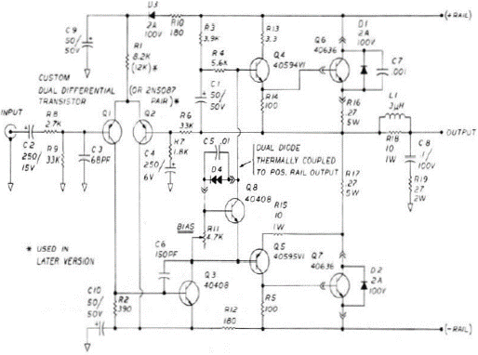

Below, Bob Cordell explains some of the basic parameters required, in each stage. and its still used to this day.

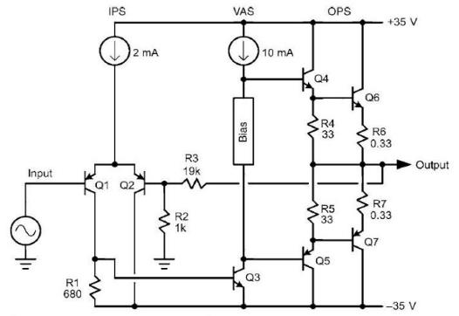Bob Cordell

In this diagram you can see as to where the currents required are flowing for each section.
There is 2-3ma required for the LTP, 8-12ma for the Vas stage, and the OPS stage requires a “Bias Level” set to turn on that stage. This would be set to around 30-60ma for good operation through the Outputs, Q6 and Q7.
The Output Stage:
This section of transistors are what actually drive the speakers, They must be made very robust as they have to handle different and varying speaker loads, as well as high voltages and currents of power.
This creates Heat and this Heat needs dissipation, hence the Heatinks you see on Amplifiers.
Here we have another group of different topologies used.
The most common in amplifiers now is, EF and CFP and a lot of arguments from all sides on this topic.
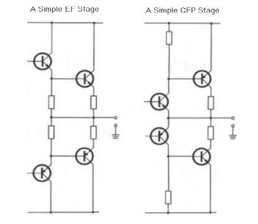

The Output transistors must be strong enough to power (voltage x current) into 8 Ω speakers and down to 4 Ω.
2Ω or 2 Ohms does exist but that used more in automotive systems to extract more power.
An example of say +/-35VDC, these output transistors need to handle 35V / 8 Ohms = 4.375 A (peak)
or 35V / 4 ohms = 8.75A (peak)
(That equation is worst case and assumes no losses like the Vdrop across the transistor or the emitter resistors).

Some circuits use 3 x Staged Outputs. This was done to boost (and push) the power into each transistor for higher output. Each power transistor driving the speaker may handle a couple of hundred volts OR 10’s of amps but they cannot do both and don’t have the Gain (Hfe) under hot conditions and high demanding loads.

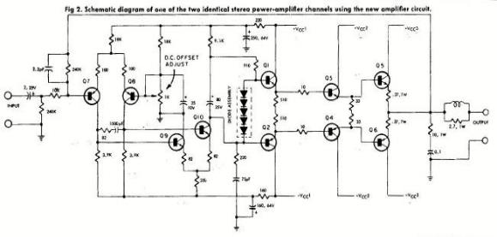

These trends of designs continued as music became a very popular and building your own was a great “pastime”.
There were many electronic magazines growing into market as more people wanted to learn and build... Designing circuits, building kits, selling parts, making PCB’s, and everything in between.
You also had a growing industry of Live bands who loved their Valves (sound & headroom), Stage Performances,
TV and Movie productions. While the discos wanted High Powered amps to 1000’s of watts!

This circuit below is from ETI ‘76 was as basic yet full amp. It was one of the first amplifiers I built as a kit. It could deliver around 25-30Watts with a power supply of +/- 28Vdc. It generally worked well, but when it felt like it, it popped the output stage… I guess it was more about learning the, “How it works” fundamentals. If the VAS and the Darlington’s used, did not have proper or sufficient “Miller capacitors” these could or would oscillate!
At that time of 14 years old, I did not have an oscilloscope to see it or even understand it…
The transistor output stage in this amp were Darlington types, with drivers BD266 and BD267.

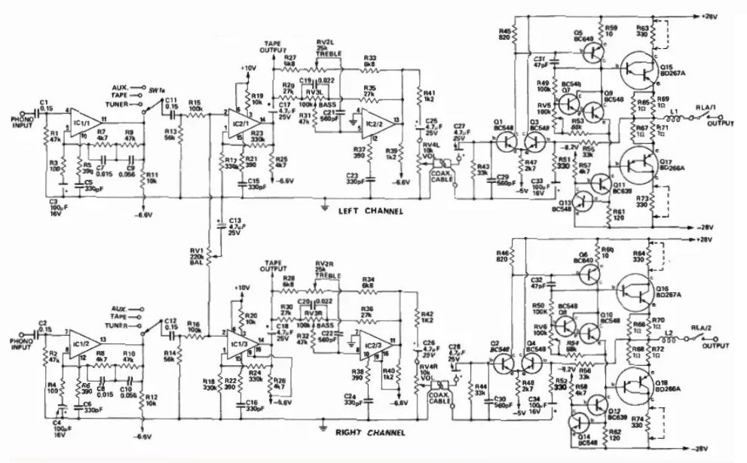
In those early days, I built many kit amps and speakers, used at home, on stages, then later got into car stereos, as a full-time job. It was a great time, of growth, learning and change.
Since then I have collected 1000’s of circuits. Some I have made and used, others changed and modified, and a few that made production.

Now, I am offering a some of the better ones, in the hope that the next generation can build upon the subject of learning, a basic understanding, and building good simple or complicated DIY amplifiers.
To experience and appreciate the qualities of building things electronic and enjoy the fun of “I built this” and “it works better” than most.
These days with decent and efficient speakers, a target of 50-65WRMS is considered plenty, especially in a home.

While, this design below, by RCA, was built into an IC Chip!
It featured a quasi complementry output stage and it still holds in own against many to this day.

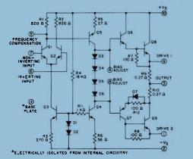 Courtesy RCA’74

Some of the well known audio circuits were devised by manufacturers in many of the product offerings from RCA, National Semi, Philips, Hitachi, Motorola, and the many other designers.
One of them, like Douglas Self, studied in depth the theories behind many of the designs, and descibes how they operated and provided a way to build very simple and reliable circuit. Hence a basic “amplifier circuit template” was made. He calls it the “blamless amp”. Thousands of amplifiers were and still are made based on this basic “template”, with alterations and additions done to suit each persons own design, reduce distortion levels and /or use different parts as well as, to boost the output power.
Below is one of these basic designs.
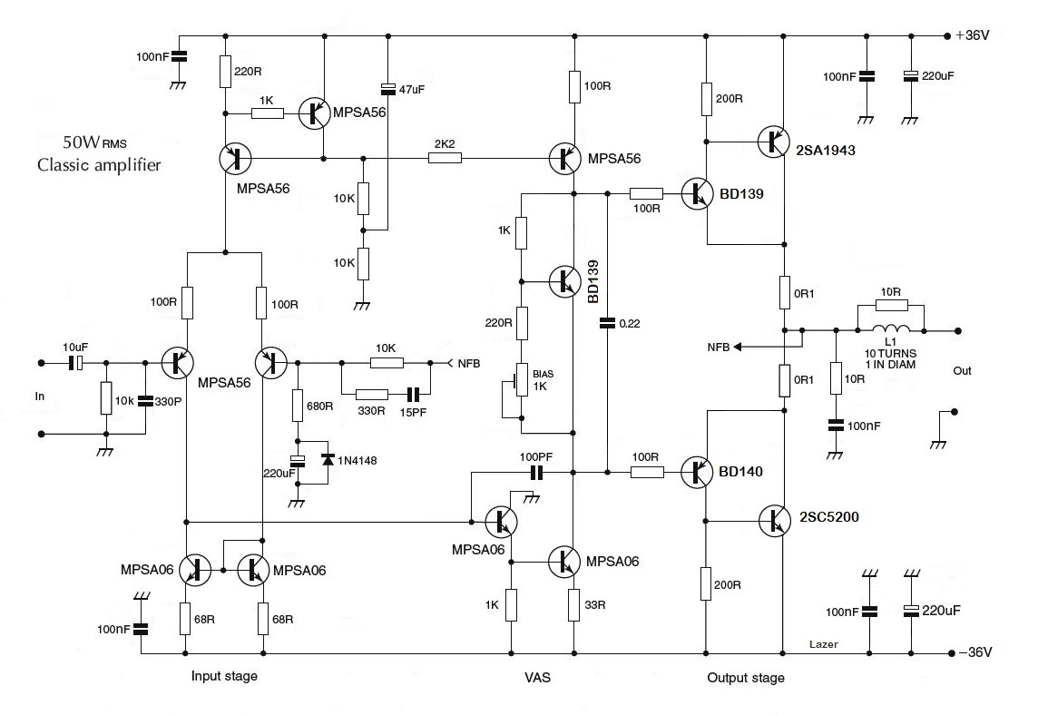
Here, there are different amplifier classes, the popular types are Class A, Class AB, Class B and Class D.
Although there are more than this, I wont go into details as this requires a lot more info.

Class A has its roots from the beginning of the valve era. The transistor or transistors in a class A amplifier conduct for the full 360° of the AC cycle. The Q-point is set at the middle of the transistors load line, so that the AC signal can swing through a full cycle.
In practice, this is the done by the Bias Setting and is normally set so the output devices conduct around
1 to 2A per pair. It is also for each, set, of output transistors.
The best sound is said to be achieved through this method, but it’s the lowest efficiency and these amps run Hot.
Example: A +/- supply of 24V = 48V. Multiply this by 1.2A of bias set current, will give you 57.6 Watts of continuous power, making a lot of heat as these transistors are always ON.

Class B is the opposite, only runs the minimun bias, if any, and signal passes through to the outputs, this is the most efficient of the big 3, but this does cause some distortion as the transistors may or are not switched on through the full 180° Cycle. i.e. Most transistors require 0.55V - 0.7V to turn on and work.

Class AB is a combination of both and the most used as it offers a preset amount of bias current to keep the transistors on, without the heat made by Class A. This is usually set between 30-60 for Transistors while Mosfets like 80-100ma.

Class D.
This class of circuit was designed to appease the new era of digital electronics. After 60-70 years of massive developments, there was no other way to move forward and to produce products with more efficacy.
Manufacturers needed to fullfil the advancement for smaller sized gear, cooler running devices, more efficient and yet retain some sort of high power.
Cutting through the blab blah, Class D is made of an amplifeir circuit used to switch the signal into higher frequencies using PWM (pulse width modulation). It uses Internal Mosfets to switch at high frequencies then it converts and filters these back down into the audio bandwith.
The “artifacts” are controlled internally, but the distortion is and can be slightly higher than the say class A.

It has the same effects as a turntable did (Anologue Sound) to a CD (Digital sound). But it is the most efficient way use the electronics inside a intergrated circuit to achieve the proccess and retain a very reasonable sound quality.
There is always some trade off in sound between the Class’ of amplification.

An example of an basic digital amplifier (Class D) is below.
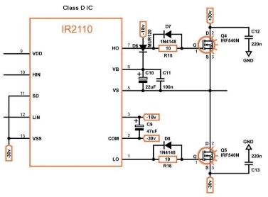
Class Diamond!
In the old days when everyone tried making amplifiers “every which way” they could.
There were many arguments to the topologys used and the sound “characteristics” achieved.

Jean Hiraga designed a very basic amp based on the Diamond topology. It became very popular as a DIY project. It worked in Class A, had very few parts and sounded great, even though the distrotion was not the lowest.

Now it gets, theoretical, subjective and everybody has their own view.

I like using single LTP stages for up to +/- 35V, then dual LTP’s with CFP stages up to +/- 50V.
CFP is also known as a Tziklai Output stage.
In smaller amps I personally find these generally offer slightly better performance in sound quality, as this type of stage topology gives very good bandwidth and with a tad less distortion.

But these can be unstable if not designed well and too many transistors are parralled for more power.

If you require lots of power (100W +) the EF stages with parralleld transistors is easier to build and control than say, a CFP stage of same. The reality here is really “power” with a small % higher in distortion over “bandwidth”.
Another issue that people don’t realise is that “ Oh 20W ? is not enough”, well in most places it is, and its actually better to have a clean and pure, low distorting sound amp than a 100 w (double loudness) with hiss and noise …

The “Power” that marketing uses is a little misleading, “100W power” is a consumption value and not the actual Loudness level what you actually hear! That’s another chapter all on its own…
Fast forward to 1995 and we have internet, growing everywhere around the world. Circuits and PCB designs,
new parts coming online, sales boomed.

The internet, as great as it is, has given rise to many scammers, copies, fake parts and idiots in between.
Modifications to circuits and changes made to “sell” their products, without actually building and testing any of their copied and modified circuit ideas, have flourished. And some of the circuits that are just plain rubbish.
All I ask is that you do your homework and use some common sense in what you choose, source and build.

The circuits below are basic amplifier circuits designed to work without the need to query a lot of the rubbish on the internet.
This first one is a very basic design that works well off a simple 12V power supply.
Beefing up the BD136 and the BD135 to a TIP 31 and TIP 32 will add a 1W or so.

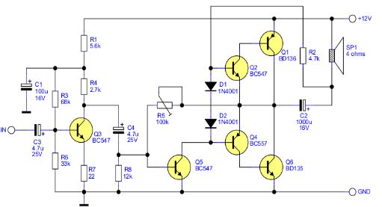

The Velleman 60W
This was as simple as it gets, it was a fairly reliable circuit in its day, provided the TIP’s did not have long PCB connections and the outputs never shorted…

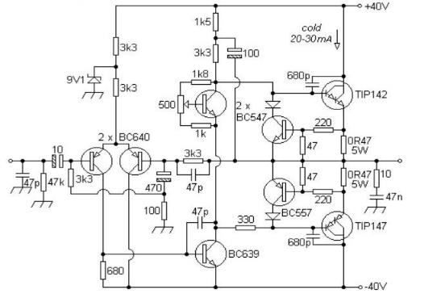
Although the Darlingtons above are popular there can be a lot of variations between them.
In this circuit, the TIP142 (darlington type) has two transistors inside it, the “Gain or Hfe” of these can vary a lot from 800 – 1500! and the same for its partner, the TIP147.
If these are not matched the amp can “slew” its output as they heat up.

This circuit below is from ETI ‘1976 and some App notes. This is another fairly basic circuit and can deliver around 40 Watts with a power supply of +/- 28Vdc. Using basic parts that are available anywhere and everywhere.
If you build it check the Bias is not over 30-50ma in your build.
R26 can be adjusted higher to reduce the bias level if it’s found to be high.
C14 would be better tied from the base of Q3 to the Base of Q7. It may also need to be higher in value if your build does starts to oscillate. Common values of 47Pf to 100pf are the norm.
Note: The BC639 and BC640 were the first versions, in a smaller package, of the BD139 and BD140 series, a very good and reliable product to +/- 33V …the BD’s could work to +/40V because of their lager package size and can be heatsinked for heat dissipation.

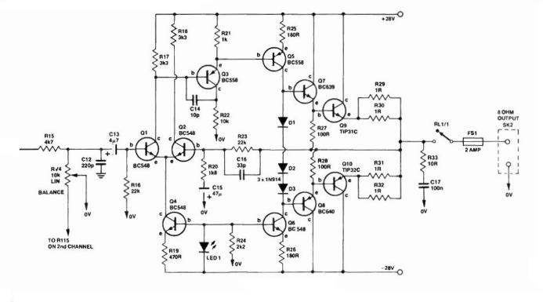

Remember, the 70’s and early 80’s did not have moblie phones, computors, laptops, Ipads etc,
So Turnables, Tape decks, Amplifiers and Speakers were the norm in a system. Expensive but Simple.

It was like a race to see who could design an amplfilier with highest output power and the lowest distortion figues. The Audio fraternaty was travelling in all directions of “this and that” can work.
Offering different opinions through to suggestions that others simply ignored.
While most used the output stages in a number of different configurations, they all chased power output followed by sound qualities and reliability.

There are many excellent topologies made by the likes of Locanthi, Lender, Dr Leach and Borbely, including Diamond front end stages, like the popular Jean Hiraga series.
Simple circuits like John L Hoods, Bob Cordel’s or Twin LTP’s like Blomley’s, have their own “Sound Signatures”

Self’s designs were based on Lenders theories, he liked to use this single LTP circuit and refined to the lowest distortion levels. While Mr Borbely liked using a Twin LTP system. It offered some enhancements to the front end of the amplifier stages feeding two VAS stages, as well as a nicer “sound stage”.

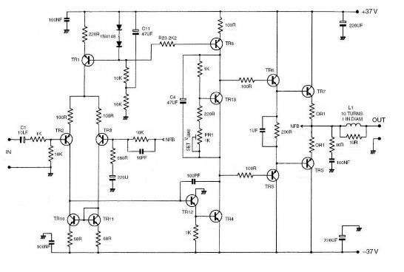
Many of the manufacturers took hold of these designs, and then built their own.
It really wasn’t always about the “best sound quality” as this still remains a personal and subjective argument
by all. It was about three main targets, set by manufactures in mass production.

A Repeatablity, the abilty to make the product same over time and in mass production.
B Reliability, the products must work well with 0 Failures or minimum returns.
C Cost, the total cost of building the product and sell to mass markets.

Some basic Template designs are shown below:

This type of output follows the EF principle in its output stages, while it works very well and is a solid perfomer.
I prefer the Tziklai Version (CFP) for all amps below 60W.
After building many and servicing many car radios, amps, and systems with exceptional Hiss and Noise!
I personally find a single pair of transistors in a Tziklai made output stage to give a clean, clear and excellent sound, but thats me.
What I found was the TIP’s had a great balance of high amperage, great price and an “even” gain between them (NPN & PNP) at the +/- 20V > +/-35VDC power supply level. I had used 1000’s of these transistors in car amps and power supplies during the 80’s and early 90’s and later in some home amps.
These were a great step up from the 2N3055/MJ2955 TO-3 Transistors I had previously used.
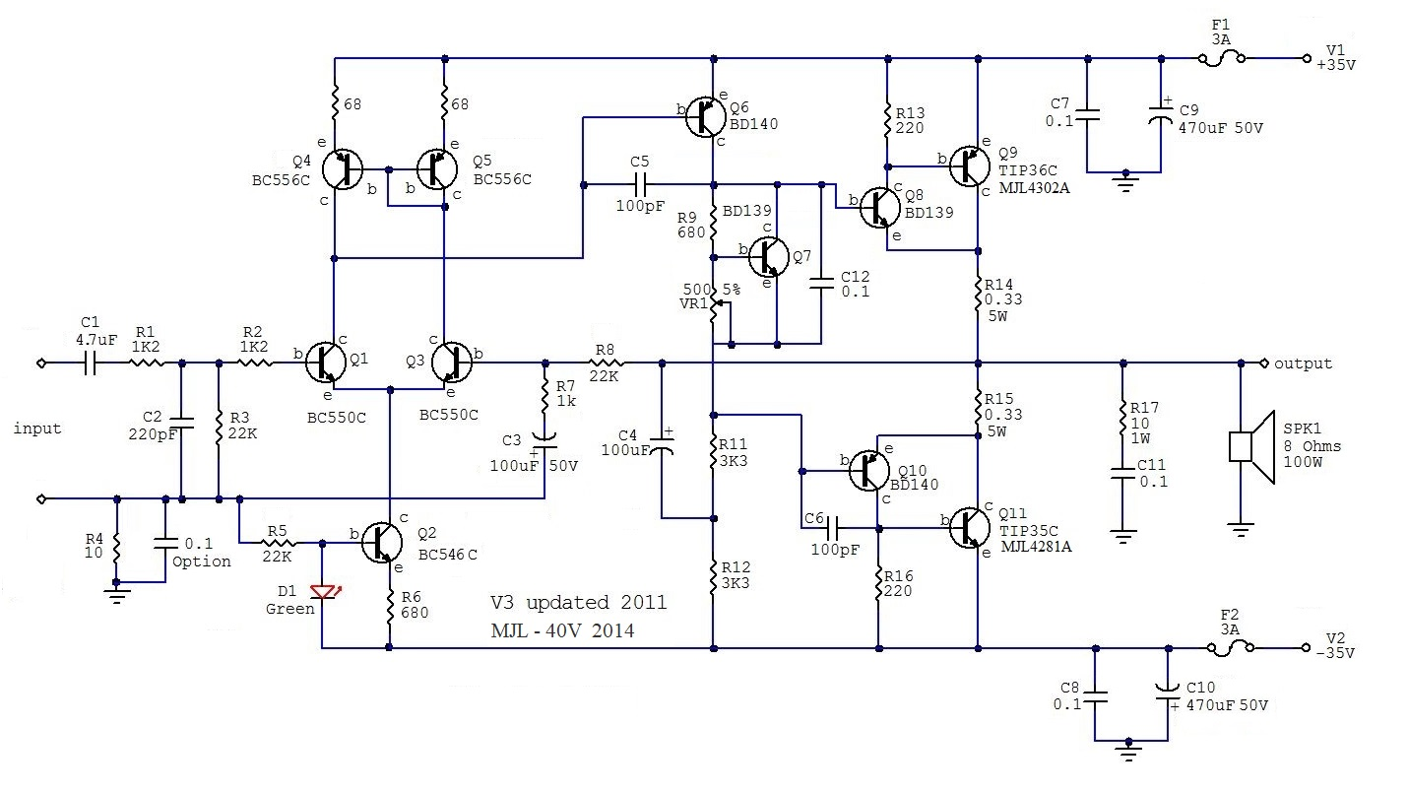
In this version you can go to +/- 40V rails provided the outputs are changed to the On Semi MJL4302A and MJL4281A. I did this with a few and had no issues. But I don’t advise to go any higher than +/-40V as the BC’s and the BD’s are on limits of their Vmax.

In 1985-1988 a lot of new SMD products became available, at the time transistors and IC’s were transistioning into SMD to be able to make products using much less materail in construction and smaller in physical sizes.
On the other side, it was for them to be handled by machines. But these came at high cost for a long time.

The circuit below was divised in the mid 90’s. At that time I did not release it as a kit, so not many made it. It was deemed too expensive and not easy to assemble. Only In mass production was it do-able. So it stayed in Duke Boxes and not for DIY. It actually takes more time to process the parts and package them, than to build it!
In Revision 3, I added the trimmer in the LTP to remove any offset voltages in the output. This was never really a problem at +0.018V to – 0.021V in this amp. But that’s “marketing”!

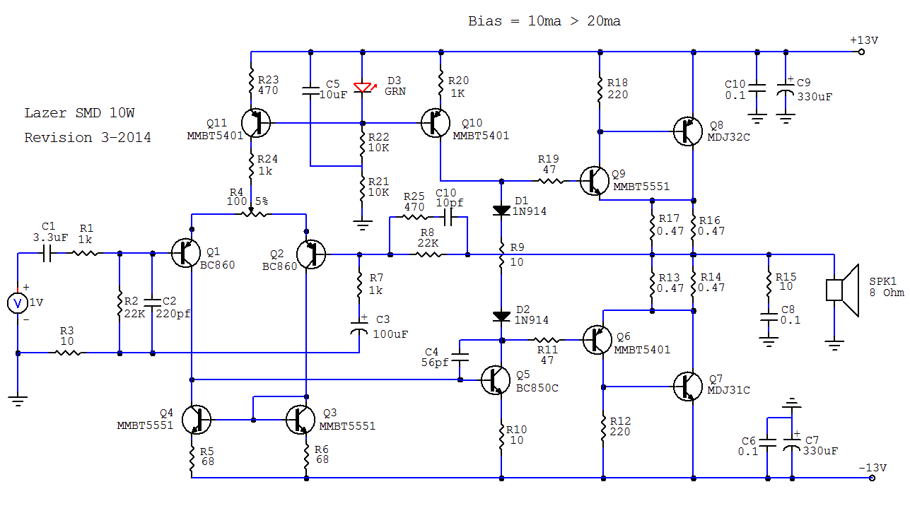
Based on the “Blameless Template” it works well and has proved reliable in many smaller projects.
These boast around 8-10W max which is sufficient for Computer and/or bookshelf speakers.
I still use them to this day…
During the 70’s Borbely took a different approach. He took the LTP design of R Lender (Motorola days) and made his amplifiers by using two of them. This offered a balanced symetrical input stage in driving 2 Vas transistors. Followed by a simple pair of MosFets.

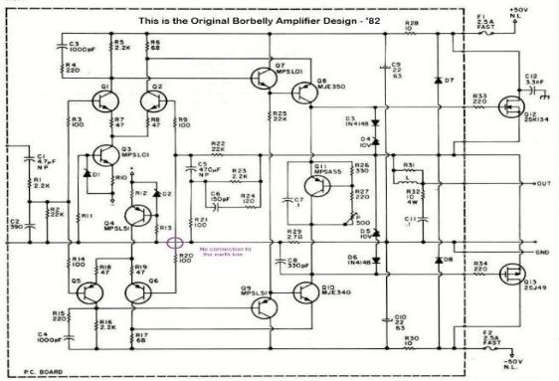
He saw and liked the new Hitachi Mosfets that arrived to market at that time and hence used them to great success. Mosfets don’t require the current of BJT transistors to drive them. They rely on voltage.
Don’t use the MJE 340/350 Transistors. These are good in power supplies but not as clean in audio amps.
Use the MJE15032 and MJE15033, or better, the newer TTA004B and TTC004B’s.

Below was a commercial version of a Borbely Circuit. It was designed for clarity and reliability over power, and it has worked very well. But looking back I wonder why I used 2 x Sets of Outputs when one pair would suffice!
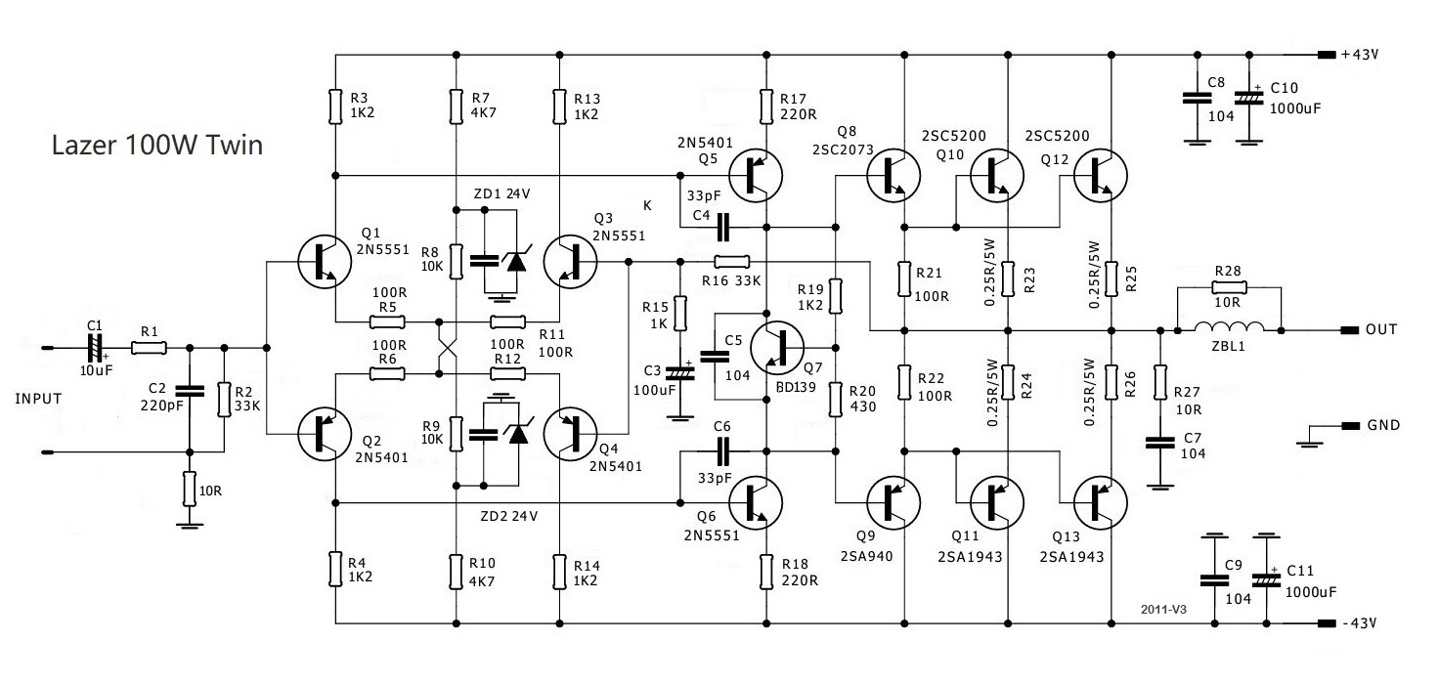In this one I used the Toshibas (2SA1943 & 2SC5200), these are a great part for any amplifier with voltage rails over the +/- 35V to +/- 40V for a single pair, then just add another pair, to be safe, at these higher voltages.
I also like the new range.. The Toshiba TT0002’s.
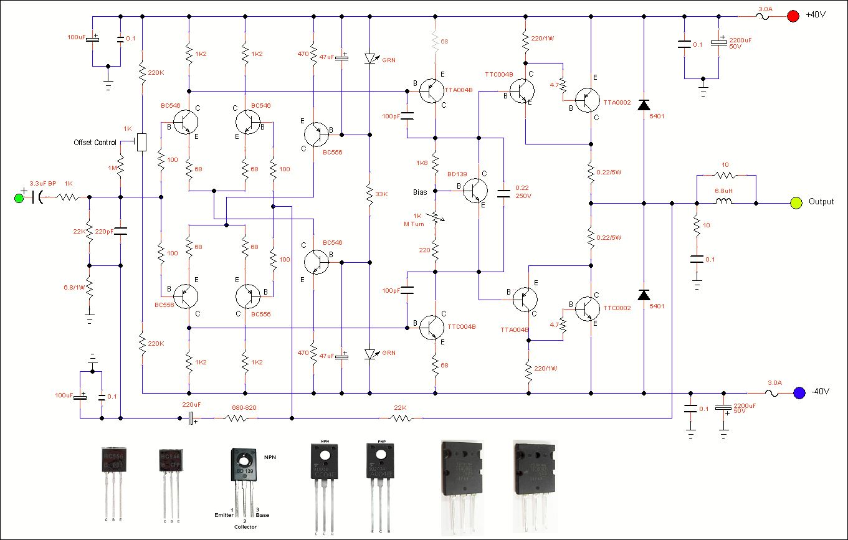
While the circuit below was one of my older production models. I had used the last batches of japanee transistors, any many copies started to appear, so I had replaced them with more common BC versions and then used the newer genuine Toshiba Transistors.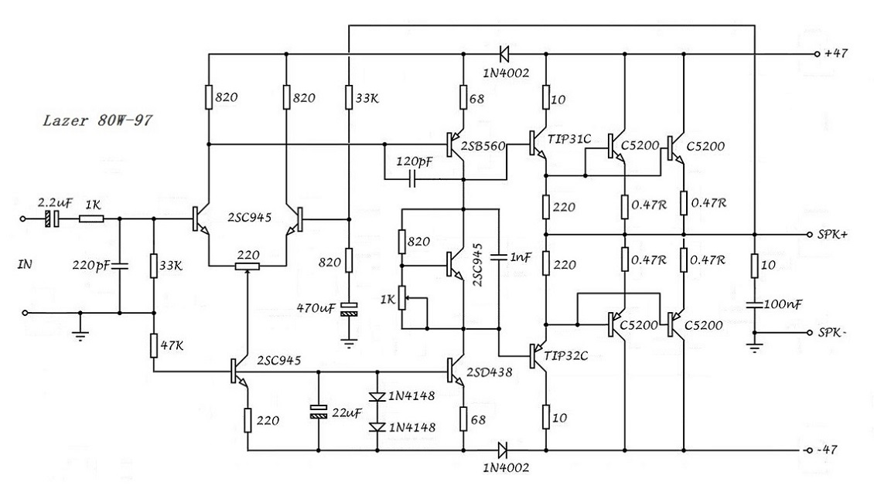In the early days, the Sziklai Formats were generally frowned upon by some as they tended to oscillate if the PCB tracks were too long and/or if there were no stabilising capacitors used in the power rails.

But many of us still preferred the sound from the “Sziklai Format” and hence these then became more popular.
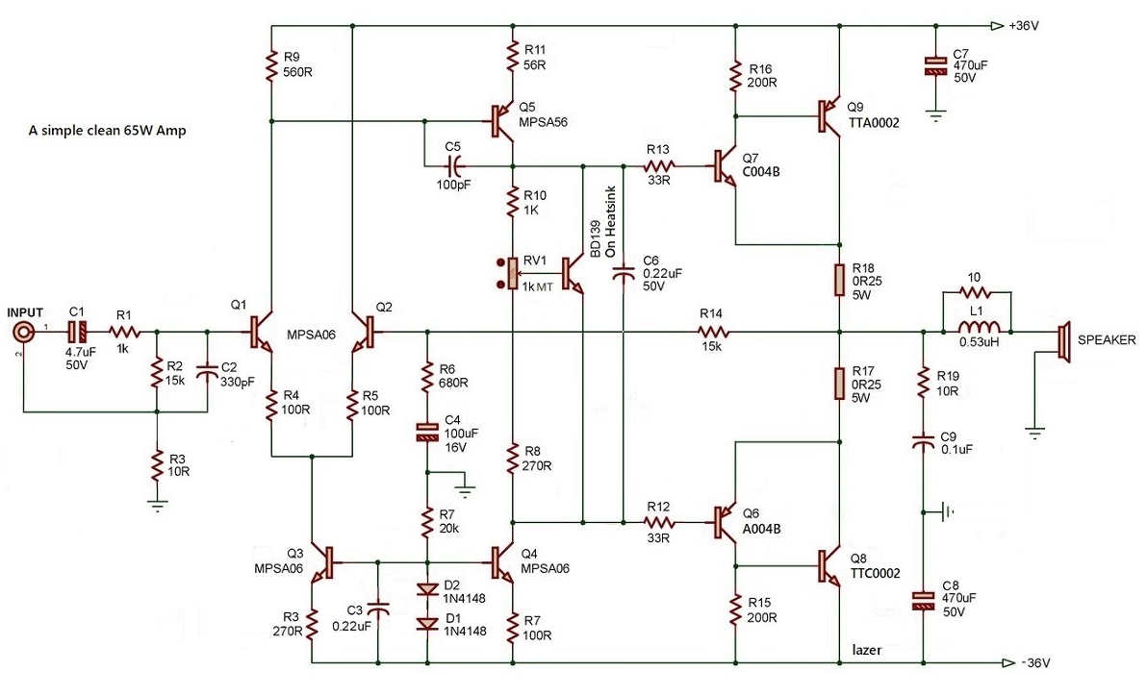
You can build a really nice clean amplifier with around 65 W RMS into 8 Ohms and with very low distortion figures.

From around 2008 and onwards I decided to leave the bigger amps as the market was now saturated with many and production was not sufficient to justify the costs.

The Diamonds

This one is a second generation Hiraga, he did very well back then too. The Diamond amplifier he made became an extremely popular Class A amplifier. It was and is simple to build and has a fairly pure in sound.

It relied on highest quality transistors and in matching pairs. But as with any Class A amp, it’s power supply is big and very costly….

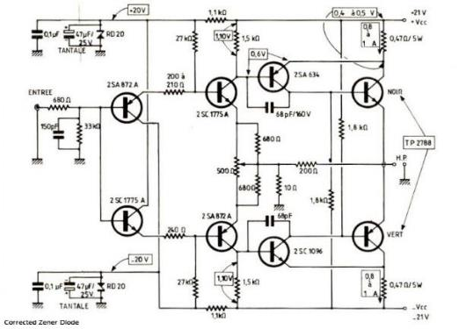

The circuit above is good for around 22W in Class A.
While this below one is another version of that era from Jean-Marc Plantefève using Mosfet’s at that time.

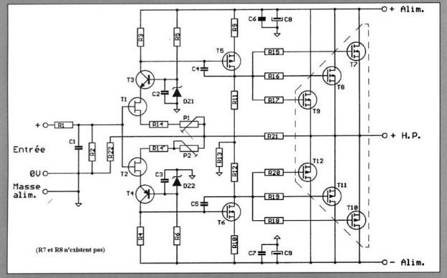

Here are some more files to play with, many have been updated and some have the rubbish removed.
The one below is a very basic amplifier from the 70’s, while it works I would not use a single transistor front end.
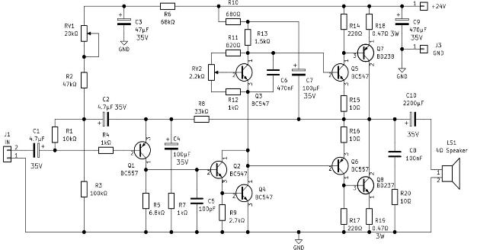The advantage of this type is the use of a single rail voltage, like 24v from two car batteries.

Another simple circuit, popular in the early 70’s using the 2N3055. These transistors were legends as they did work in power supplies as well as audio amps with great power in their day.

It’s based on the quasi complementry output stage, a popular in its day.
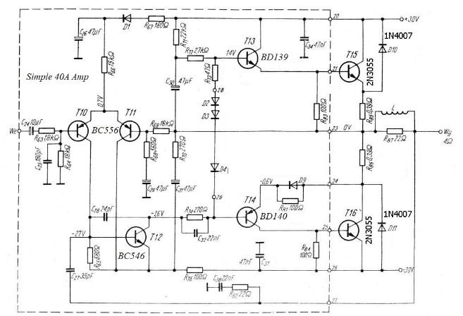
Mosfets were also a growing and a popular item. My first build needed some fixing as these sometimes oscillated and there was a lot of mucking around to add capacitors to stabilise them. They are a power based product.
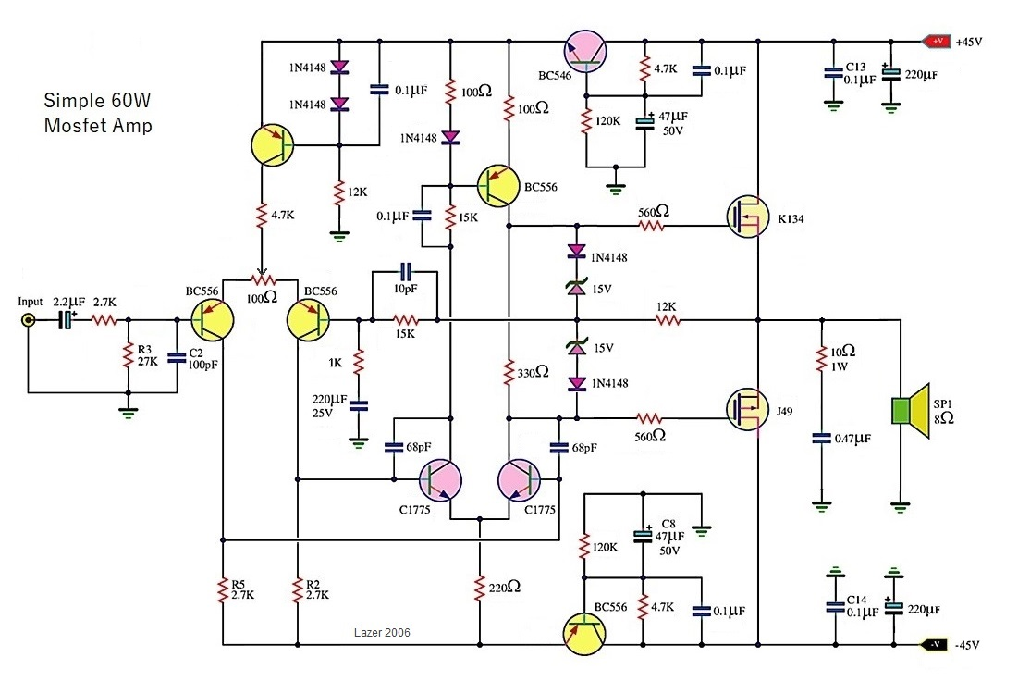
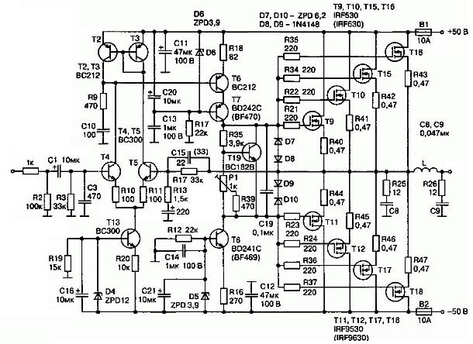
While this amplifier below has been used by others, I would once again follow the SOAR figures, I use TIP35 and TIP36 and would not recommend they be used much above +/-35V especially with a big toroidal transformer.
The BC’s and BD’s are some of my favourite transistors, they work excellent in amplifiers but pushing them above their limits is asking for trouble, The Toshibas and Hitachi’s work well and the bigger MJL’s

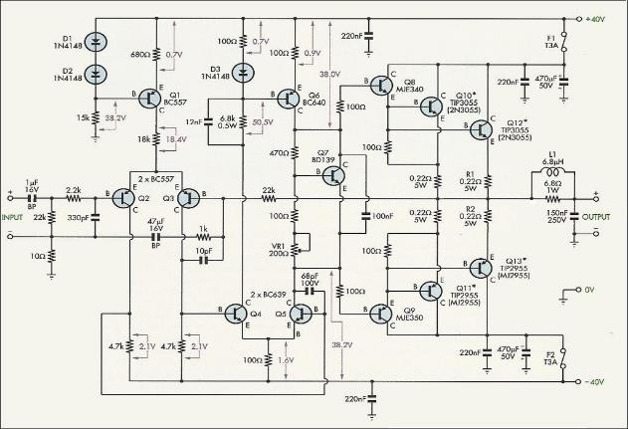
Note, this circuit was popular in its day, Note, these TIP’s are close to limits at +/-33V x current into 8 ohms.
As time passed different transistors became a good option.

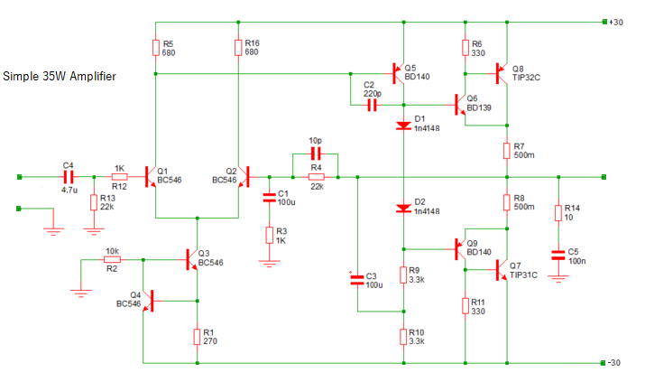

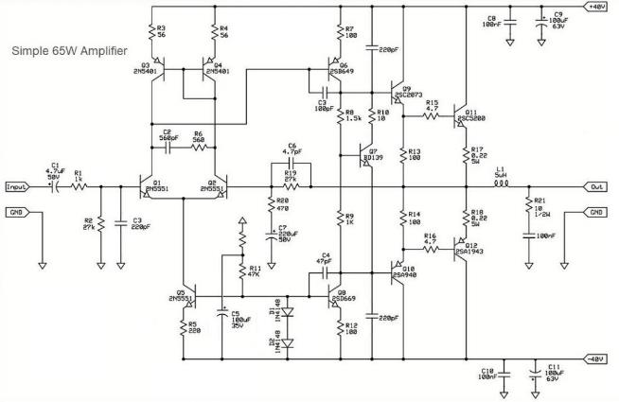
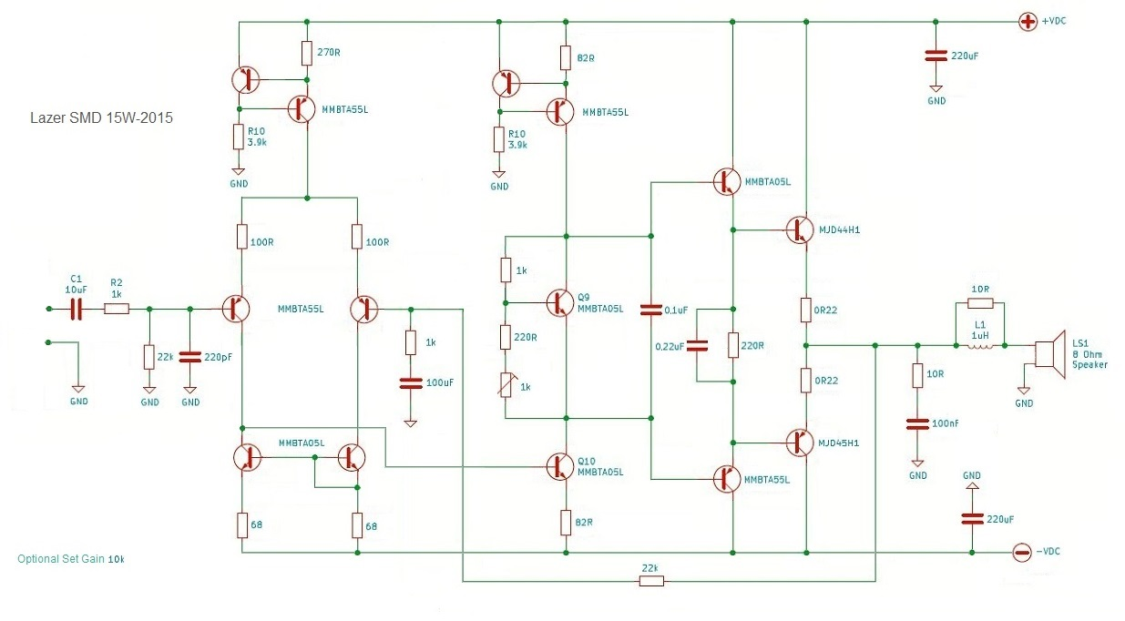As you can see from the diagrams certain patterns are forming between the different types of stages.
Op Amps:
I never played much with op amps for amplifiers back in the day, they worked well in pre-amps but weren’t really good at anything above 1W… then adding another stage to get up to their voltage limits of around +/-18V, helped alot.
The LF351 later LF356 changed my opinion, and the NE5534 went a step further in clarity!
This one is a basic 5W Amplifier. It uses an Op-amp, it is very easy to build and a no brainer to get working.
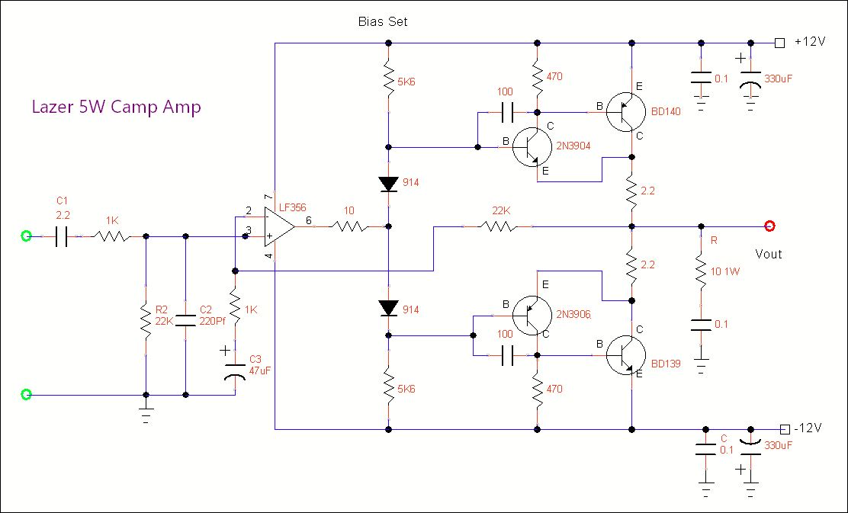
I still use these on my book shelf speakers where a few watts is ideal, the Clarity and spatial sound is still there.
Note: They run on regulated power supplies with LM317’s/LM337s.

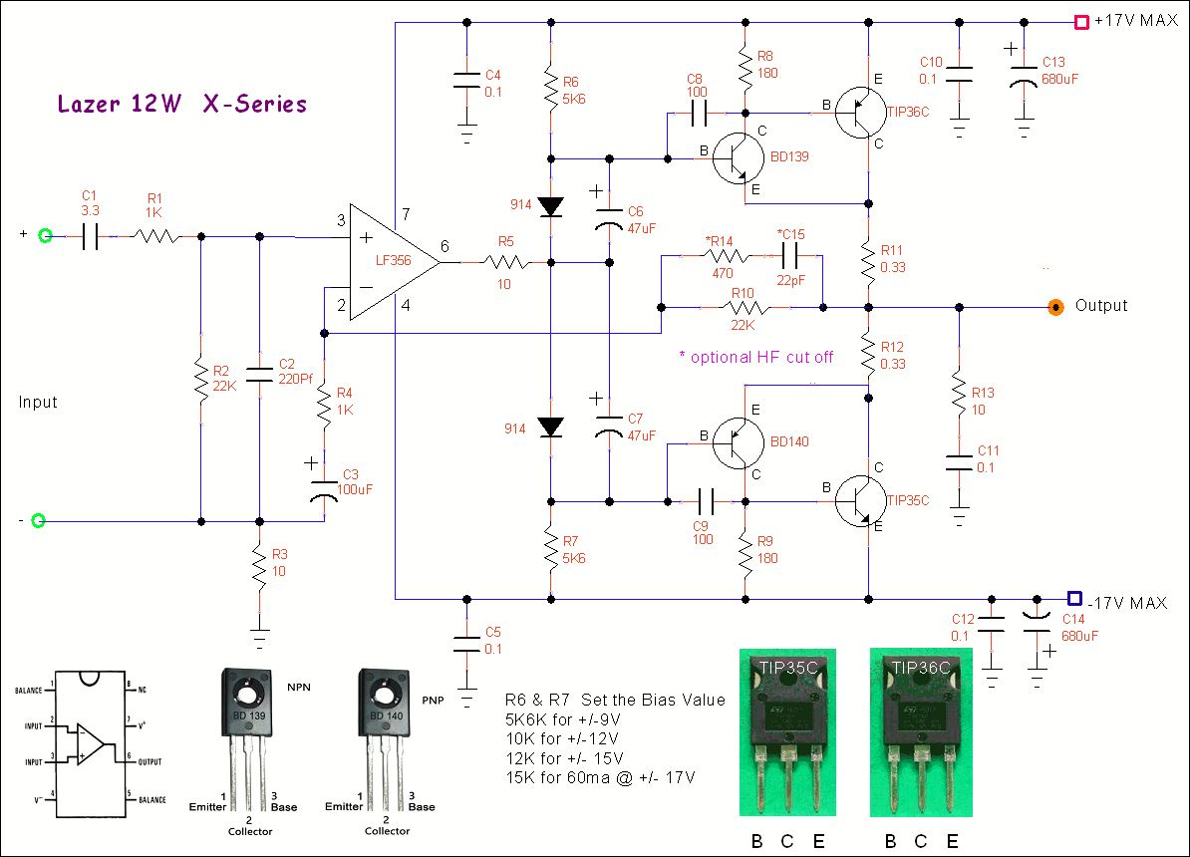

This is another simple and reliable amplifier, the Op amp can be the classic TL071 (very average) or (LF356 better) mosfet types or you can use *NE5534 for very good results.
Note: * these are chosen without breaking the budget…
There are many op amps out there now with different results, and by many with different opinions.
The output stage is a CFP with a power handling of 65W…although running at +/-17V you get ~ 18W.
It runs into 4 Ohms without a glitch, but not much more as the heat form the Heatsinks is close to Limit.
You need to learn and understand that building the amplifier is the easy part,
Assembling and building, the case with the transformer, power supply and the rest can get expensive.
On this one I use Linear 2 x LM350’s for the supplies, one set per amp.
Regulated, crystal clear and no hum. Note: all the earths should run to one point at the Transfomer CT Terminal.

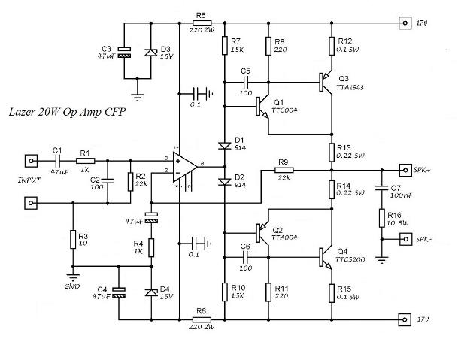

This one above was made before in the TIP’s version, there was no difference in sound
(Using the same LF356 Op amp) And the cost of the Toshibas was not justified.
If anything the TIP35/TIP36 Pair had a touch deeper bass! Where there is a differce in in the Op Amp used,
Production uses Transistors from the same manufactured batches of NPN + PNP x 500 Pcs = $$….

An RCA Classic:
These guys were way ahead in their day, they were also a big company, making components and world wide distribution. These were supposed to give around 120W output while using an op-amp.

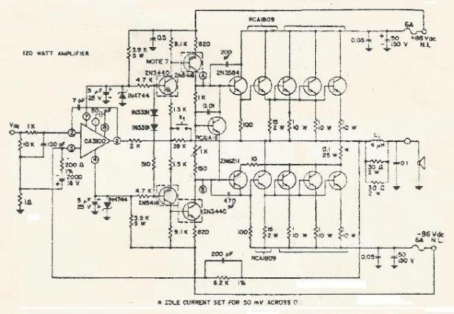
Back then transistors for production were much cheaper than a good Op-Amp and didn’t have the limitations of +/-15V supplies. A basic LTP and a constant current source only costed $1.00 and could be powered to +/-40V.
Now after many years they have finally reduced to “reasonable prices” and can be a good option.

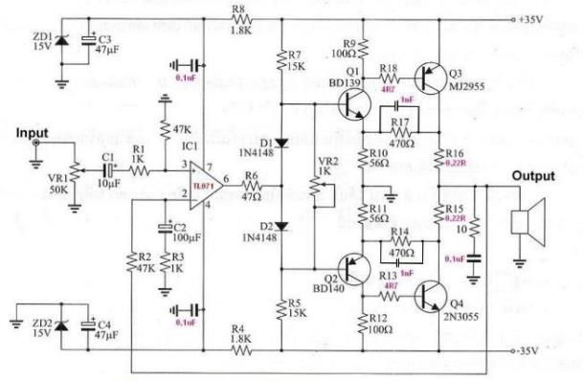
If you build this, then stick to +/- 18V supplies, reduce the gain R2 and the Input shunt resistor to 22K,
check VR2 as its there to stop too much bias from the low values of R7 and R5, 15K resitors.

An APEX Entry with a Mosfet Ouptut stage
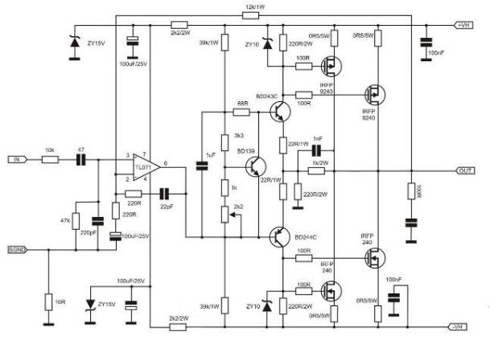
Two of the most important parts of these two circuits is missing.
Many Op Amps require 0.1uF caps close to the Op-amps power pin’s. That is pin 7 and pin 4 to ground.
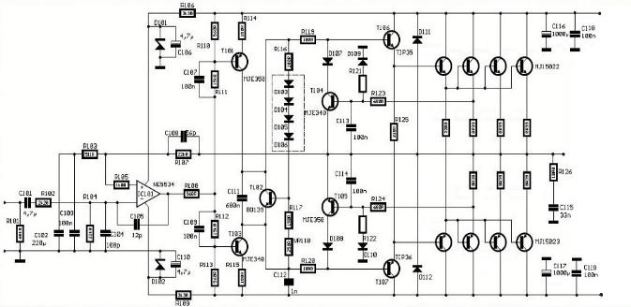
Most of these circuits are now old, while they are fairly simple to build and get working, the trade-off is that of parts availability. Newer components are better and cheaper to buy, than say the older 2N3055/2955’s.

The Mosfet Series amps
While these were similar to the BJT designs above they did have good punch in the lower bass regions I found they had a tended to be “Midrangy”, for me.

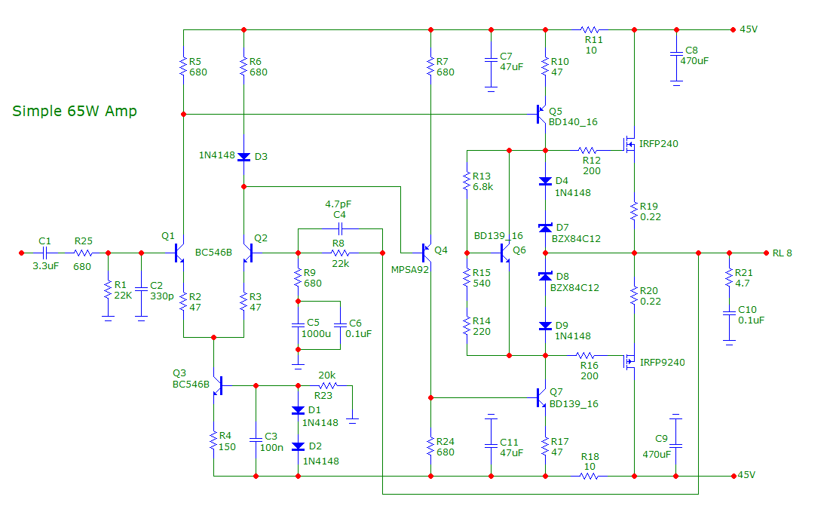

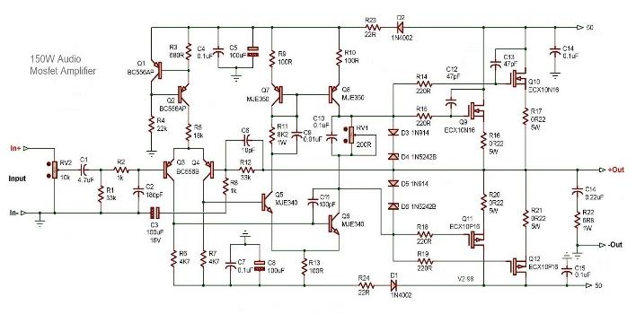

This was below was an old AEM design from back in the 80’s. It combines Mosfet’s in the input stage, while using a Twin LTP in the second stage and a Mosfet output stage. I have heard from friends that it worked very well, but they had spent some time debugging it.
It’s a little complicated for new DIYs.
I mostly avoided Mosfets, That was probably due to the kits I built young where I had some issues of oscillation, and it took me weeks to figure it out…but they were also priced higher than BJT’s until recently.

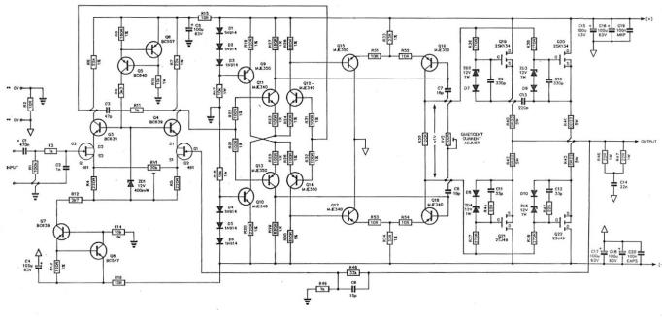
Listening to amplifiers is an art. Everyone has their own liking and opinions. Which must also be respected.
It’s the same with the speakers. The 80’s was a boom for speakers as many types by many suppliers were made and they were reasonably cheap.
These days they are much better, more refined, but also cost an extra $1000 in the price tag …

Big Op Amps

These came out in the early 80’s, automotive stereos required amplification of the speakers and IC’s to be able to fit inside the case! Many IC’s came to market as the sector grew.
Toshiba, National, Hitachi, NEC, Sanyo, Mitsubishi, ST Micro, were some of the big players.

The early ones like the TA7205AP became a very popular IC in early car radios and smaller amps.
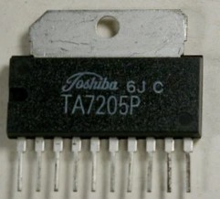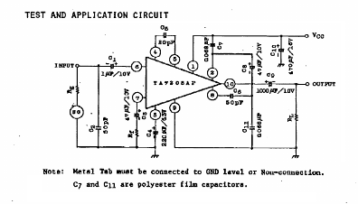
These were used early on, with 5.8W from a 14V power supply.
Many thousands of these were made and sold in their day.
And there were hundreds of types of IC’s as the boom in car stereo sales occurred.
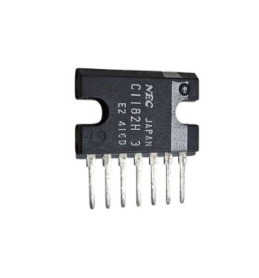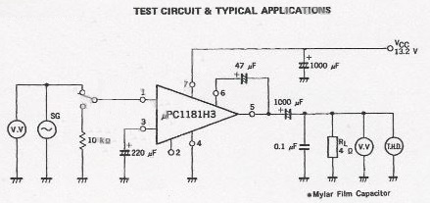

The TDA2003 was another popular IC later on

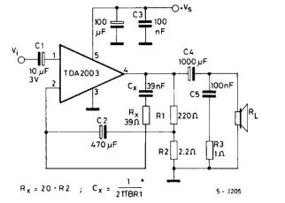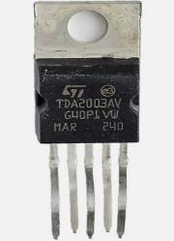

Although hundreds of IC’s came to market early on, they all suffered from average performance.
Their record was X amount of power @ 10% THD ….
The did work and were reliable until you shorted something…

Within a couple of years, two audio amplifiers were built into one IC !

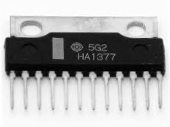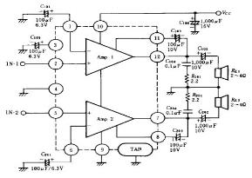

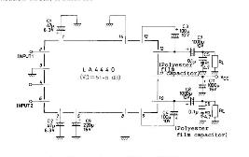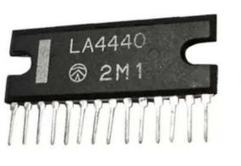
This gave rise to another idea, “what if we bridge the outputs” for higher power, this then became the next level in amplification for automotive. By bridging the output of the amplifiers would result in 4 x the power, so 5-6W become ~20W.
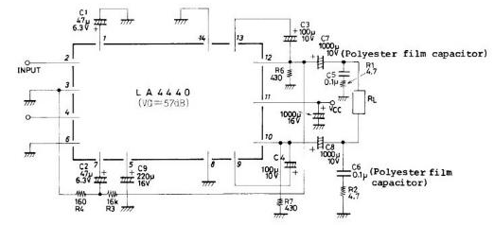
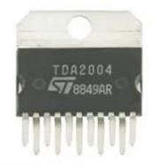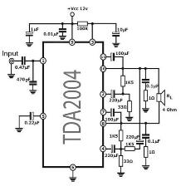

This became the new norm in car stereos for a while, but as these were pushed to limits they would not survive well. One small, short from a speaker or a wire to the body of the car made them migrate to another country!

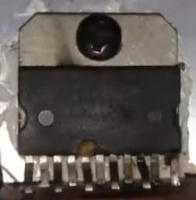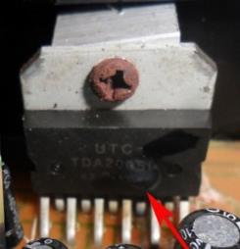

There was also a growing trend for separate amplifiers as more power was required, pushing the introduction of larger IC Chips to be used. Welcome the STK range. This range of Big Chip IC’s was used in many car amps and home amps in the early to mid-80’s.

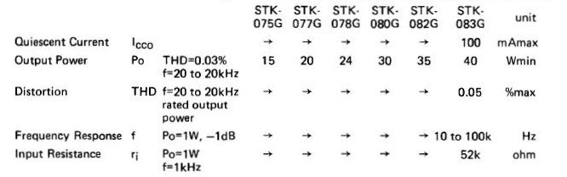

These were used a lot to boost power level up to 50W per side! Which was quite good for a car amplifier.

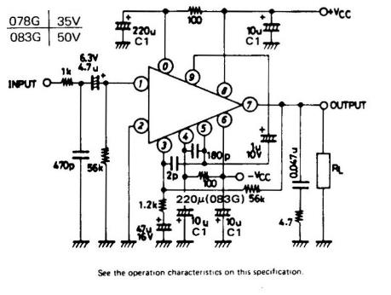
The trend continued but then they worked out how to build bigger power supplies and hence amplifier then needed to work down to 1 Ohm!! So it was a sort of “back to the future” of using the amplifiers circuits above with many Transistors in parallel.

In the Hi-Fi arena there was a few that gained real popularity.
The LM1875 and its bigger brother the LM3875 which was later upgraded to LM3886T,
The “F” symbolises the sealed case, or Plastic Package.

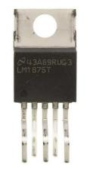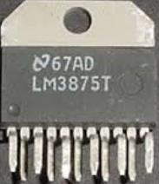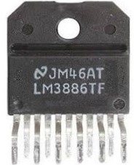

While from ST Micro came the TDA2030 and TDA2050

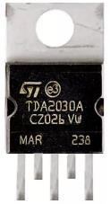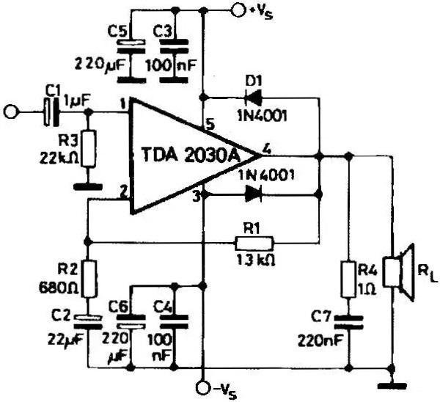

Still a very simple circuit and a popular IC
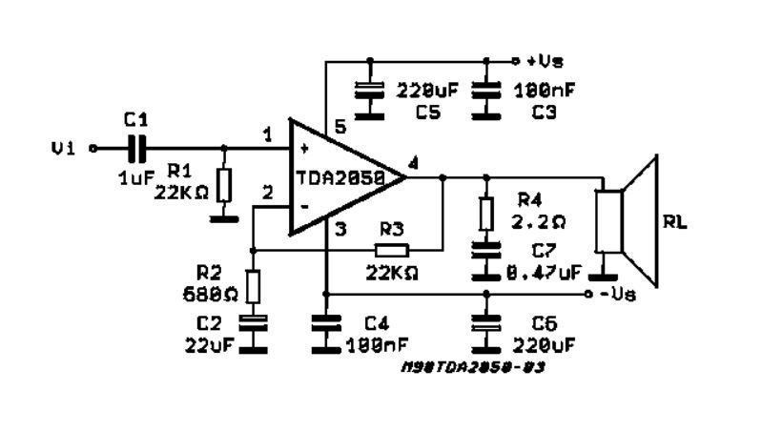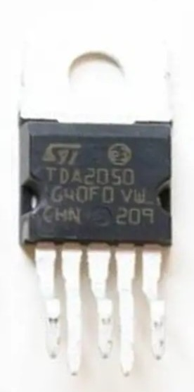

Although most of the radio head unit IC designs, worked generally well, they did not have the “shear balls” of a large home power amp and the specs were a little low on distortion figures, remember these were made to a price, for largescale production.

The separate amplifiers, like Kicker, Pioneer, Alpine, Clarion, Kenwood, JL Audio, MTX, Sony and 32 more others… did much better, but their prices also reflected this too.
After a while the copiers took over which helped keep “costs down” and by that time, in the mid 90’s, as well as the many who had spent $10K+, to build wild systems, the law got involved as it was all, “Too Loud”.

The IC’s Above were all analogue types and after 2000 as time progressed these changed over to Digital Chips Class D Chips could hold 4 x amplifiers in a single package and be more efficient the analogue types
Most of these digital IC’s are used now in most commercially made radios and stereos.

Updated 152023 spelling and wording

